Checking ignition system
Safety precautions
To prevent injuries to persons and/or damage to the fuel injection and ignition system, the following must be noted:
- ◆ Do not touch or disconnect ignition wiring when the engine is running or being turned at starter speed.
- ◆ Always switch off the ignition before connecting or disconnecting ignition system wiring. This also applies to HT cables and measuring instrument leads.
- ◆ To operate the engine at starting speed without actually starting it (for example, to check the compression), unplug the connector from the power output stage for the ignition coils and the connectors from the injectors. After completing the work, interrogate the fault memory.
- ◆ Always switch off the ignition before cleaning the engine.
- ◆ Always switch off the ignition before connecting or disconnecting the battery, otherwise the engine control unit may be damaged.
- ◆ For assisted starts with a rapid charging unit the maximum permissible voltage is 16.5 V and the maximum charging time is 1 minute.
Checking ignition system
Removing and installing ignition system components

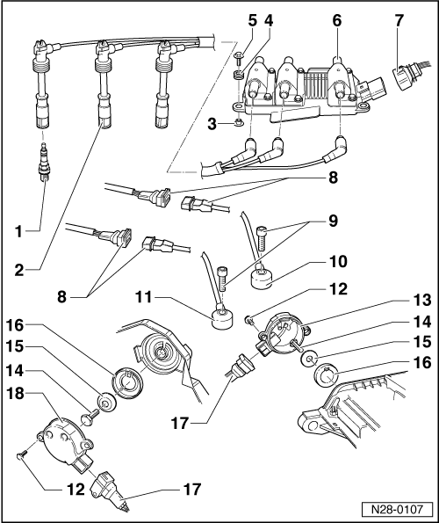
- Spark plug - 30 Nm
  - ◆ Use 3122 B to remove and install
- Spark plug connector with ignition cable
- Spacer sleeve
- Rubber grommet
- 10 Nm
- Ignition coils -N, -N128, -N158
  - ◆ With output stage -N122
  - ◆ With ignition cable identification, do not interchange

- Connector
  - ◆ Black, 5-pin
- 3-way connector
  - ◆ Gold plated contacts
- 20 Nm
  - ◆ Tightening torque affects function of knock sensor
- Knock sensor 2 -G66
  - ◆ Cylinder bank 2
  - ◆ Sensor and connector contacts gold plated
- Knock sensor 1 -G61
  - ◆ Cylinder bank 1
  - ◆ Sensor and connector contacts gold plated
- 10 Nm

- Hall sender -G40
  - ◆ Cylinder bank 2
- 25 Nm
- Washer
  - ◆ Tapered
- Rotor ring
  - ◆ For Hall sender
  - ◆ Pay attention to locating element on assembly
- Connector
  - ◆ Black, 3-pin
  - ◆ For Hall sender -G40/-G163
- Hall sender -G163
  - ◆ Cylinder bank 1

Checking ignition system
Technical data
Engine code letters |  | ACK (2.8 l / 5V / 142 kW engine)  ALG (2.8 l / 5V / 142 kW engine  with secondary air induction)
Ignition timing is determined by the control unit.
Ignition timing cannot be adjusted.
Ignition system |  | Twin-spark ignition system with three ignition coils
Spark plugs 1) |  | Tightening torque: 30 Nm.
Firing order |  | 1-4-3-6-2-5
Engine speed limitation by Motronic system  Cut off speed |  | approx. 6500 rpm

Checking ignition system
Checking ignition coils

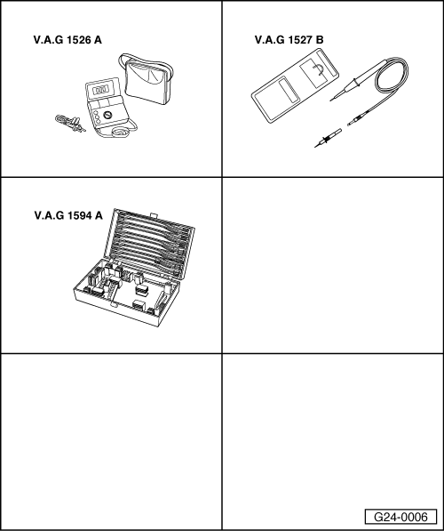
Special tools,
testers and auxiliary items required
- ◆ V.A.G 1526 A
- ◆ V.A.G 1527 B
- ◆ V.A.G 1594 A
Notes:
- ◆ Ignition coils and output stage form a joint component.
- ◆ Primary resistance of ignition coils cannot be measured.
- ◆ Secondary resistance should be measured first with ignition cables connected to ignition coils by way of spark plug connectors of respective cylinders (interference suppression resistances of ignition cables are also measured in the course of this).
- ◆ Fitting location =>Page 24-5.
- ‒ Unplug 5-pin connectors from ignition coils.
Checking ignition coils -N, -N128, and -N158
- ‒ Disconnect ignition cables from ignition coils.

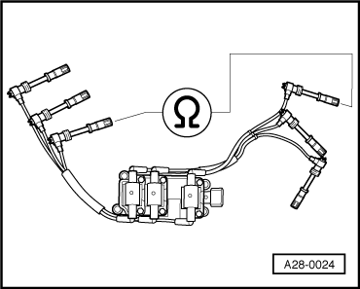
- ‒ → Connect up multimeter between the two spark plug connectors of the ignition circuit to be checked to measure resistance.
  - ‒ Specified value: 16 ... 27 kωin each case
- ‒ If the specified values are not attained, pull ignition cables off ignition coils and measure ignition cables/ignition coils separately.

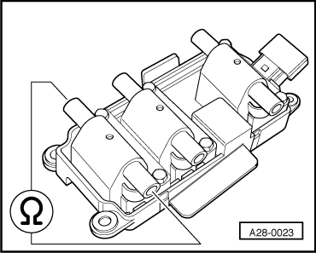
- ‒ → To measure resistance, connect up multimeter between the two ignition cable connections of the ignition coil that is to be checked.
- or
- ‒ To measure resistance, connect up multimeter between the two ignition cable connections of the ignition cable that is to be checked.
Specifications:
Ignition coils | Ignition cables
8.0 ...14.0 kω | 3.0 ... 7.0 kω
- ‒ Replace defective components if specified values are still not attained.
Checking earth supply of output stage

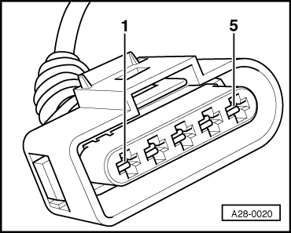
- ‒ → Connect voltage tester V.A.G 1527 B as follows:
Connector  contact | Measure to
2 | Battery positive
  - ‒ The LED should light up.
If the LED does not light up:
- ‒ Use current flow diagram to check wiring and rectify short circuit.
=> "Current flow diagrams, Electrical fault-finding and Fitting locations" binder

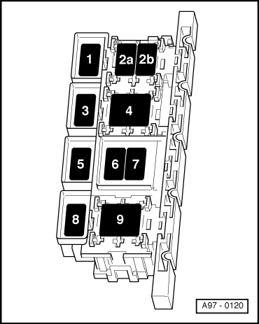
Checking power supply of ignition coils
Test requirements:
- ● → Fuse S115 OK (in relay and fuse carrier, electronics box, plenum chamber, position 9:
Test sequence

- ‒ → Connect voltage tester V.A.G 1527 B as follows:
Connector  contact | Measure to
1 | Engine earth
- ‒ Switch the ignition on.
  - ‒ The LED should light up.
If the LED does not light up:
- ‒ Use current flow diagram to check wiring for open circuit. Repair if necessary / check fuse.
=> "Current flow diagrams, Electrical fault-finding and Fitting locations" binder
Checking actuation
- ‒ Pull connectors off all 6 injectors. (then interrogate fault memory).

- ‒ → Connect voltage tester V.A.G 1527 B as follows:
Connector  contact | Measure to
3 | Engine earth
4 | Engine earth
5 | Engine earth
- ‒ Operate starter briefly.
  - ‒ The LED should flash.
If LED does not flash:
- ‒ Connect test box V.A.G 1598/22 to wiring harness for engine control unit =>Page 24-24.

- ‒ → Check for open circuit and short to positive or earth in the following wiring connections:
Connector  contact | Test box V.A.G 1598/22  socket
3 | 71
4 | 78
5 | 70
- ‒ Rectify short circuit or open circuit if necessary.
- ‒ If the wiring is OK, fit a new engine control unit => Page 24-26.

Checking ignition system
Checking intake air temperature sender
Special tools, testers and auxiliary items required

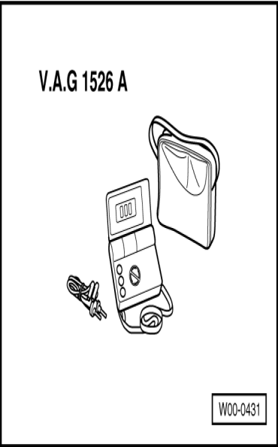
- ◆ V.A.G 1526 A

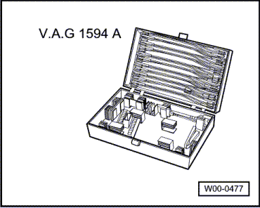
- ◆ V.A.G 1594 A
Notes:
- ◆ For checking function of intake air temperature sender, see also "Reading measured value block" Display Group 003, display zone 4.
- ◆ Fitting location of intake air temperature sender => Page 24-5.
Test requirements:
- ● Engine cooled to room temperature (approx. 20 °C).
Test sequence
- ‒ Unplug connector from intake air temperature sender.

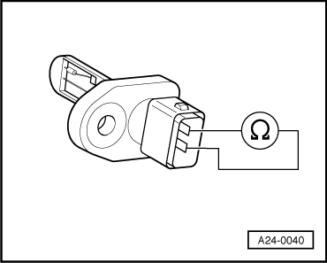
- ‒ → Connect multimeter to sender to measure resistance.
  - ‒ Specified value: 5.7 ... 6.7 kω
If the specification is not obtained:
- ‒ Renew intake air temperature sender.
If the specification is obtained:
- ‒ Connect test box V.A.G 1598/22 to wiring harness for engine control unit =>Page 24-24.

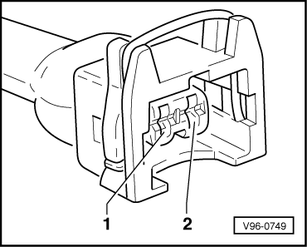
- ‒ → Check for open circuit and short to positive or earth in the following wiring connections:
Connector  contact | Test box V.A.G 1598/22  socket
1 | 54
2 | 67
- ‒ Rectify short circuit or open circuit if necessary.
- ‒ If the wiring is OK, fit a new engine control unit => Page 24-26.

Checking ignition system
Checking engine speed sender -G28

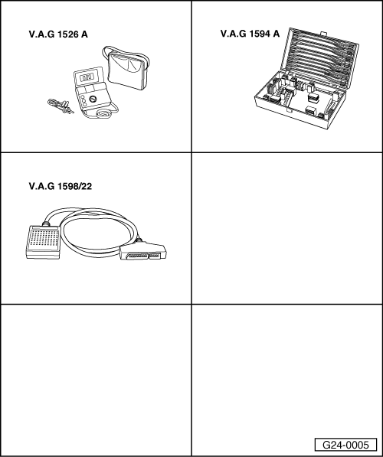
Special tools,
testers and auxiliary items required
- ◆ V.A.G 1526 A
- ◆ V.A.G 1594 A
- ◆ V.A.G 1598/22
Notes:
- ◆ The engine speed sender is a combined speed sender and reference mark sender. The engine cannot be started without a signal from the -G28 engine speed sensor. If the signal from the -G28 engine speed sensor fails while the engine is running, the engine will cut out immediately.
- ◆ -G28 is provided with a shim to obtain a defined gap between -G28 and the sender wheel.
If the engine speed sender is fitted without a shim, the sender will be destroyed by the sender wheel.
- ◆ For testing the operation of the engine speed sender, see also "Reading measured value block", Display Group 003, display zone 1.
Various engine speed senders, which can be distinguished by way of their connectors and contact assignments, have been fitted in the current series:

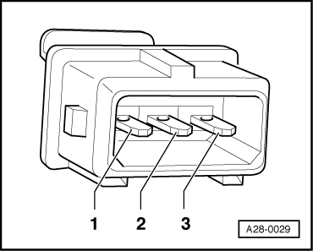
→ Rectangular plug for engine speed sender
- ‒ Checking engine speed sender =>Page 28-18

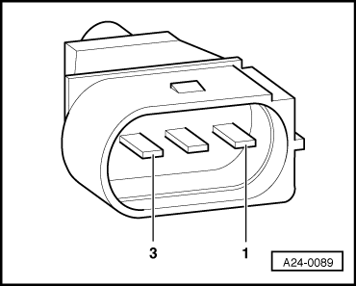
- ‒ → Oval plug for engine speed sender
- ‒ Checking engine speed sender =>Page 28-21
Checking engine speed sender with rectangular plug
Fitting location for sender and connector =>Page 24-7
- ‒ Before carrying out the test, make sure that the sender is correctly installed and firmly seated.
- ‒ Disconnect connector for engine speed sensor (identification: grey connector).

- ‒ → Connect multimeter between contacts 1 and 2 to measure resistance.
  - ‒ Specified value: 730 ...1000 ω
If the specification is not obtained:
- ‒ Fit a new engine speed sender.
If the specification is obtained:
- ‒ Connect multimeter between contacts 1 and 3 (earth) and 2 and 3 (earth) to measure resistance.
  - ‒ Specified value: infinity in each case ω (no continuity).
If the specification is not obtained:
- ‒ Fit a new engine speed sender.
If the specification is obtained:
- ‒ Connect test box V.A.G 1598/22 to wiring harness for engine control unit =>Page 24-24.

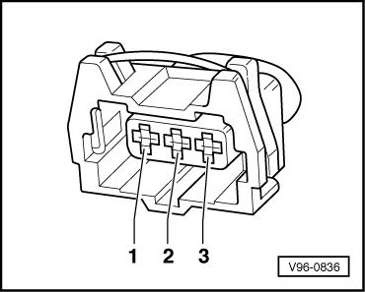
- ‒ → Check for open circuit and short to positive or earth in the following wiring connections:
Connector  contact | Test box V.A.G 1598/22  socket
1 (signal) | 56
2 (earth) | 63
3 (screening) | 67
- ‒ Rectify short circuit or open circuit if necessary.
- ‒ If no fault has yet been found, check tightness of sender wheel at crankshaft.
Checking of sender wheel involves removing sender.
- ‒ Slowly crank engine and check sender wheel for concentricity/tight fit.
Note:
It is normal for there to be a larger gap at a certain point in the sender wheel, as this is the reference mark.
- ‒ If no faults have been found in any of the above tests, fit a new engine control unit =>Page 24-26.
Checking engine speed sender with oval plug
Fitting location for sender and connector =>Page 24-7
- ‒ Before carrying out the test, make sure that the sender is correctly installed and firmly seated.
- ‒ Disconnect connector for engine speed sensor (identification: grey connector).

- ‒ → Connect multimeter between contacts 2 and 3 to measure resistance.
  - ‒ Specified value: 730 ...1000 ω
If the specification is not obtained:
- ‒ Fit a new engine speed sender.
If the specification is obtained:
- ‒ Connect multimeter between contacts 2 and 1 (earth) and 3 and 1 (earth) to measure resistance.
  - ‒ Specified value: infinity in each case ω (no continuity).
If the specification is not obtained:
- ‒ Fit a new engine speed sender.
If the specification is obtained:
- ‒ Connect test box V.A.G 1598/22 to wiring harness for engine control unit =>Page 24-24.

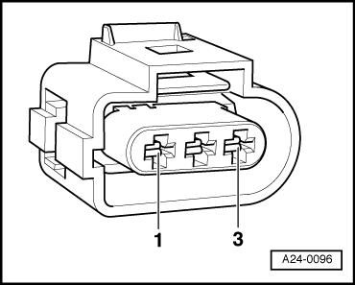
- ‒ → Check for open circuit and short to positive or earth in the following wiring connections:
Connector  contact | Test box V.A.G 1598/22  socket
1 (signal) | 56
2 (earth) | 63
3 (screening) | 67
- ‒ Rectify short circuit or open circuit if necessary.
- ‒ If no fault has yet been found, check tightness of sender wheel at crankshaft.
Checking of sender wheel involves removing sender.
- ‒ Slowly crank engine and check sender wheel for concentricity/tight fit.
Note:
It is normal for there to be a larger gap at a certain point in the sender wheel, as this is the reference mark.
- ‒ If no faults have been found in any of the above tests, fit a new engine control unit =>Page 24-26.

Checking ignition system
Checking coolant temperature sender -G62

Special tools,
testers and auxiliary items required
- ◆ V.A.G 1526 A
- ◆ V.A.G 1594 A
- ◆ V.A.G 1598/22
Notes:

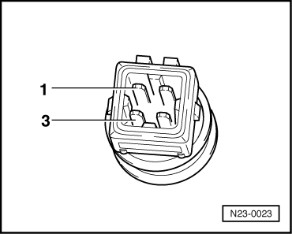
- ◆ For testing the operation of the coolant temperature sender, see also "Reading measured value block", Display Group 003, display zone 3.
- ◆ Fitting location of coolant temperature sender => Page 24-5.
Test sequence
- ‒ Disconnect connector on coolant temperature sender.
- ‒ → Check resistance between contacts 1 and 3 on the sender.
Scale A shows resistance values for temperature range 0...50 °C and scale B the values for temperature range 50...100 °C.

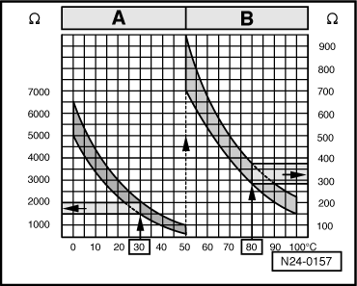
→ Sample readings:
- ◆ 30 °C corresponds to a resistance of 1500...2000 ω
- ◆ 80 °C corresponds to a resistance of 275..375 ω
If the specification is not obtained:
- ‒ Renew coolant temperature sender.
If the specification is obtained:
- ‒ Connect test box V.A.G 1598/22 to wiring harness for engine control unit =>Page 24-24.

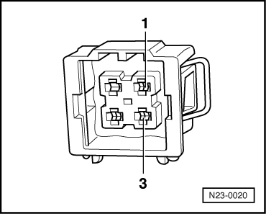
- ‒ → Check the following wires for open circuit and short to positive or earth (or short circuit to each other):
Connector  contact | Test box V.A.G 1598/22  socket
1 (signal) | 53
3 (earth) | 67
- ‒ Rectify short circuit or open circuit if necessary.
- ‒ If the wiring is OK, fit a new engine control unit => Page 24-26.

Checking ignition system
Checking control unit power supply

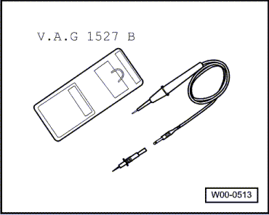
Special tools, testers and auxiliary items required
- ◆ V.A.G 1527 B

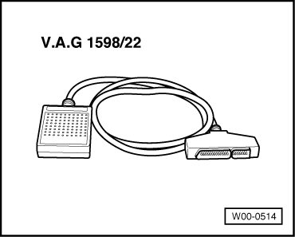
- ◆ V.A.G 1598/22
Notes:
- ◆ For testing the power supply to the engine control unit, see also "Reading measured value block", Display Group 003, display zone 2.
- ◆ Fitting location of engine control unit: In electronics box, plenum chamber, right-hand side.
Test requirements:

- ● → Fuse S115 OK (in relay and fuse carrier, electronics box, plenum chamber, position 9:
- ● Battery voltage at least 11 V
- ● Alternator OK
Test sequence
- ‒ Connect test box V.A.G 1598/22 to wiring harness for engine control unit =>Page 24-24.
- ‒ Connect voltage tester V.A.G 1527 B as follows:
Test box V.A.G 1598/22  socket | Measure to
1 (positive via ignition) | Engine earth
1 (positive via ignition) | V.A.G 1598/22  Socket 2 (earth)
3 (permanent positive) | Engine earth
- ‒ Switch the ignition on.
  - ‒ The LED should light up each time.
If the LED does not light up:
- ‒ Use current flow diagram to eliminate open circuit in wiring/short circuit.
=> "Current flow diagrams, Electrical fault-finding and Fitting locations" binder

Checking ignition system
Checking knock sensors

Special tools,
testers and auxiliary items required
- ◆ V.A.G 1526 A
- ◆ V.A.G 1594 A
- ◆ V.A.G 1598/22
Notes:
- ◆ For testing the operation of the knock sensors, see "Reading measured value block", Display Groups 012, 013, 014 and 015.
- ◆ Fitting locations of plug connectors and knock sensors => Page 24-5.
- ◆ It is not possible to carry out an electrical test of the knock sensors themselves (interrogating fault memory =>Page 01-8).
- ◆ Detach intake manifold when removing and installing knock sensors.
- ◆ To ensure that the knock sensors function properly it is important to keep exactly to the specified tightening torque of 20 Nm.
- ◆ Check connectors for corrosion.
- ◆ Use only gold plated contacts when repairing the contacts in the plug connectors for the knock sensors.

Checking knock sensor wiring
- ‒ Unplug the connector for the relevant knock sensor in the engine compartment.
- ‒ → Test for short circuits between all three contacts in the knock sensor connector. The must be no connection between any of the wires.
- ‒ If there is a connection between the contacts, fit a new knock sensor.
Checking wiring from knock sensors to engine control unit
- ‒ Connect test box V.A.G 1598/22 to wiring harness for engine control unit =>Page 24-24.
- ‒ Check for open circuit and short to earth/positive or earth in the following wiring connections:

- ● → Knock sensor 1
-G61 connector  contact | Test box V.A.G 1598/22  socket
1 (signal) | 68
2 (earth) | 67
3 (screening) | 67
- ● Knock sensor 2
-G66 connector  contact | Test box V.A.G 1598/22  socket
1 (signal) | 60
2 (earth) | 67
3 (screening) | 67
- ‒ Rectify short circuit or open circuit if necessary.

Checking ignition system
Checking Hall sensor

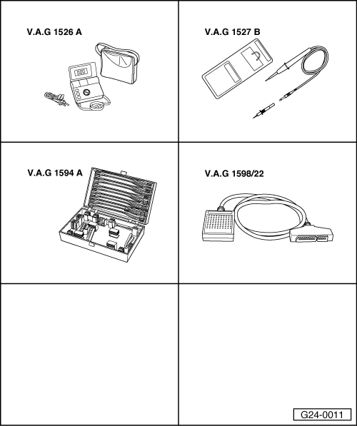
Special tools,
testers and auxiliary items required
- ◆ V.A.G 1526 A
- ◆ V.A.G 1527 B
- ◆ V.A.G 1594 A
- ◆ V.A.G 1598/22
Notes:
- ◆ Hall sender -G40 is located at rear of left-hand cylinder head (bank 2).
- ◆ Hall sender -G163 is located at front of right-hand cylinder head (bank 1).
- ◆ Fitting location =>Page 24-7.
Checking power supply
- ‒ Disconnect 3-pin connector from relevant Hall sender.

- ‒ → Connect multimeter between contacts 1 (positive) and 3 (earth) to measure voltage.
- ‒ Switch the ignition on.
  - ‒ Specified value: at least 9 V
If the specification is not obtained:
- ‒ Connect test box V.A.G 1598/22 to wiring harness for engine control unit =>Page 24-24.

- ‒ → Check the following wires for open circuit and short to positive or earth (or short circuit to each other):
-G40 connector  contact | Test box V.A.G 1598/22  socket
1 (positive) | 11
3 (earth) | 67

-G163 connector  contact | Test box V.A.G 1598/22  socket
1 (positive) | 11
3 (earth) | 14
- ‒ If the wiring is OK, fit a new engine control unit => Page 24-26.
Checking function
Note:
To check function of Hall sender, pull 5-pin plug off output stage with ignition coils and then interrogate fault memory.
Test requirements:
- ● Power supply of Hall sender OK, checking =>Page 28-34.
Test sequence
- ‒ Slide back rubber grommets on connectors for Hall senders but leave connectors plugged in.
- ‒ Connect up voltage tester V.A.G 1527 B between receptacle 2 (Hall sender signal) and receptacle 1 (positive).
Note:
Receptacles are numbered accordingly on the back of the connector.
- ‒ Operate the starter for a few seconds.
  - ‒ The LED should flash briefly every second engine revolution.
If LED does not flash:
- ‒ Switch off ignition.
- ‒ Disconnect 3-pin connector from relevant Hall sender.
- ‒ Connect test box V.A.G 1598/22 to wiring harness for engine control unit =>Page 24-24.

- ‒ → Check for open circuit and short to positive or earth in the following wiring connections:
-G40 connector  contact | Test box V.A.G 1598/22  socket
2 (signal) | 76

-G163 connector  contact | Test box V.A.G 1598/22  socket
2 (signal) | 44
- ‒ Rectify short circuit or open circuit if necessary.
- ‒ If there are no open circuits or short circuits, reconnect engine control unit to engine wiring harness.

- ‒ → Connect multimeter between contacts 2 and 3 of connector to measure voltage.
- ‒ Switch the ignition on.
  - ‒ Specified value: at least 9 V
If the specification is not obtained:
- ‒ Fit a new engine control unit => Page 24-26.
If the specification is obtained:
- ‒ Fit a new Hall sender.

Checking camshaft timing control
Checking camshaft timing control function
Special tools, testers and auxiliary items required

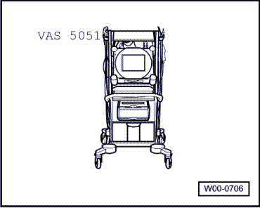
- ◆ VAS 5051
- or
- ◆ V.A.G 1551 with V.A.G 1551/3 A
Test requirements:
- ● Coolant temperature at least 80 °C.
Test sequence
- ‒ Connect fault reader V.A.G 1551 => Page 01-2.
- ‒ Read measured value block, Display Group 027, Engine idling =>Page 01-154.

→ Display readout:
  Read measured value block 27 ⇒
  1 2 3 4
- ‒ Observe display in display zones 1, 3
and 4.
Notes:
- ◆ Display zone 1 shows status of camshaft timing control:
  - ‒ Value "0": Actuation of camshaft timing not active
  - ‒ Value "1": Actuation of camshaft timing active (Value "1" can only obtained by way of a test drive)
- ◆ Positions marked "X" in display zone 1 can be ignored as regards checking of camshaft timing control.
- ◆ Display zones 3 and 4 show whether camshafts have actually been adjusted (feedback):
  - ‒ Normal position: -3.0°crankshaft...6.0°crankshaft
  - ‒ Switched position: 16.0°crankshaft...25.0°crankshaft
Specified values (engine idling):
Display zone 1 | Display zone 3 | Display zone 4
X.....X0 | -3.0...6.0°crankshaft | -3.0...6.0°crankshaft
- ‒ Take the vehicle for a test drive.
Warning:
Attach fault reader to rear seat and operate it from there. When doing this, always observe the relevant safety precautions.
Page 24-1.
- ‒ Accelerate vehicle rapidly from standstill in first gear.
Specified values (test drive):
Display zone 1 | Display zone 3 | Display zone 4
X.....X1 | 16.0...25.0°crankshaft | 16.0...25.0°crankshaft
Note:
If a value between 6.0 °crankshaft and 16.0 °crankshaft is displayed in fields 3 and/or 4during test drive, the camshaft adjustment solenoid valves are switching the oil pressure properly to the respective mechanical camshaft adjuster, but this is not able to reach its end position (e.g. on account of stiffness).
- ‒ If specified values are not attained, check camshaft adjustment solenoid valves=>Page 28-43.

Checking camshaft timing control
Checking camshaft adjustment solenoid valves

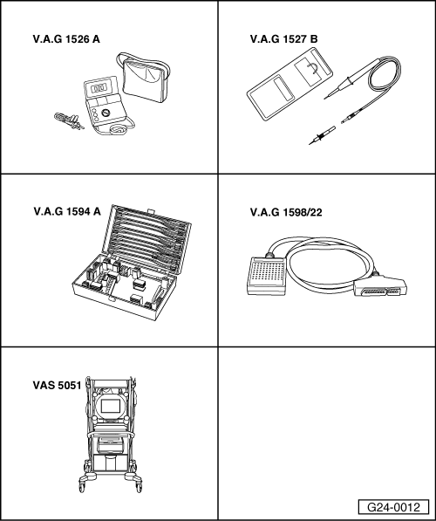
Special tools,
testers and auxiliary items required
- ◆ V.A.G 1526 A
- ◆ V.A.G 1527 B
- ◆ V.A.G 1594 A
- ◆ V.A.G 1598/22
- ◆ VAS 5051
- or
- ◆ V.A.G 1551 with V.A.G 1551/3 A
Note:
Fitting location of solenoid valves =>Page 24-8.
Test sequence
- ‒ Connect fault reader V.A.G 1551 => Page 01-2.
- ‒ Start final control diagnosis and actuate camshaft timing control => Page 01-82.

→ Display readout:
  Final control diagnosis ⇒
  Camshaft timing control 1
- Camshaft adjustment valve 1 -N205 and camshaft adjustment valve 2 -N208 must be clearly heard to click.
If valves do not click:
- ‒ Switch off ignition.

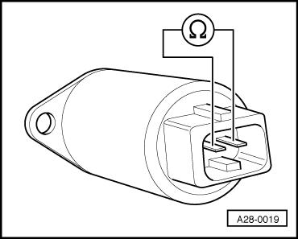
- ‒ Pull respective plug off solenoid valve.
- ‒ → Connect multimeter to valve to measure resistance.
  - ‒ Specified value: 10 ... 18 ω
If the specification is not obtained:
- ‒ Replace valve.

Checking power supply of camshaft adjustment valves -N205 and -N208
- ‒ Disconnect connector from relevant solenoid valve.
- ‒ → Connect up voltage tester V.A.G 1527 B between contact 1 and engine earth.
- ‒ Operate the starter for a few seconds. Engine may start.
  - ‒ The LED should light up.

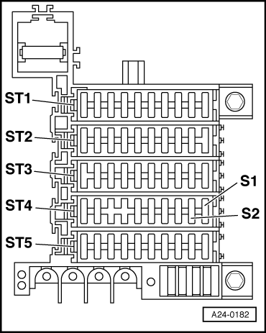
If the LED does not light up:
- ‒ Carry out the following tests (marked with dots):
- ● → Check fuse S2 (in fuse holder, fuse carrier ST4 - blue).

- ● → Check for open circuit between contact 1 on connector and fuse in fuse holder .
=> "Current flow diagrams, Electrical fault-finding and Fitting locations" binder
- ● Check fuel pump relay => Page 24-50.
Checking actuation of camshaft timing control

- ‒ → Connect up voltage tester V.A.G 1527 B between contacts 1 and 2.
- ‒ Start final control diagnosis and actuate camshaft timing control => Page 01-82.

→ Display readout:
  Final control diagnosis ⇒
  Camshaft timing control 1
  - ‒ The LED should flash.
If the LED lamp does not flash or if it lights up continuously:
- ‒ Connect test box V.A.G 1598/22 to wiring harness for engine control unit =>Page 24-24.

- ‒ → Check for open circuit and short to positive or earth in the following wiring connection:
-N205 connector  contact | Test box V.A.G 1598/22  socket
2 | 55

-N208 connector  contact | Test box V.A.G 1598/22  socket
2 | 55
- ‒ If necessary, rectify short circuit to earth or open circuit.
- ‒ If no open circuits or short circuits are found, fit a new engine control unit =>Page 24-26.
- ‒ If wiring is OK, replace mechanical camshaft adjuster.
=> 6-cylinder engine (5-valve), Mechanical Components; Repair Group 15; Servicing Valve Gear; Removing and installing camshafts

