Technical data
Engine data
Code letters |  |  | AQF | AQG | ARU | AQH
Production |  |  | 02.99 ä | 02.99 ä | 02.99 ä | 08.99 ä
Capacity |  | l | 4.172 | 3.697 | 4.172 | 4.172
Output |  | kW at rpm | 228/6000 | 191/6000 | 175/5000 | 264/7000
Torque |  | Nm at rpm | 410/3300 | 350/3200 | 410/3300 | 430/3500
Bore |  | øin mm | 84.5 | 84.5 | 84.5 | 84.5
Stroke |  | mm | 93.0 | 82.4 | 93.0 | 93.0
Compression |  |  | 11.0 | 11.0 | 11.0 | 11.0
ROZ/MOZ 98/88 recommended min. RON |  |  | 95 | 95 | 95 | 95
Injection system |  |  | Motronic | Motronic | Motronic | Motronic
Ignition |  |  | Motronic | Motronic | Motronic | Motronic
Knock control |  |  | yes | yes | yes | yes
Self-diagnosis |  |  | yes | yes | yes | yes
Lambda control |  |  | yes | yes | yes | yes
Catalytic converter |  |  | yes | yes | yes | yes
Turbocharging |  |  | no | no | no | no
Secondary air inlet |  |  | yes | yes | yes | yes
Emission standard |  |  | EU 2 + D3 | EU 2 + D3 | EU 2 + D3 | EU 2 + D3

Code letters |  |  | AQF | AQG | ARU | AQH
Valve timing
with 1 mm valve lift and 0 mm valve play
Inlet opens after TDC |  |  | 25° | 20° | 25° | 24°
Inlet closes after BDC |  |  | 45° | 30° | 45° | 64°
Exhaust opens before BDC |  |  | 38° | 38° | 38° | 27°
Exhaust closes before TDC |  |  | 8° | 8° | 8° | 3°

Code letters |  |  | AUW | AKC | AVN | AVP
Production |  |  | 04.00 ä | 04.00 ä | 05.00 ä | 09.00 ä
Capacity |  | l | 4.172 | 3.697 | 4.172 | 4.172
Output |  | kW at rpm | 228/6000 | 191/6000 | 175/5000 | 265/7000
Torque |  | Nm at rpm | 410/3300 | 350/3200 | 410/3300 | 420/3500
Bore |  | øin mm | 84.5 | 84.5 | 84.5 | 84.5
Stroke |  | mm | 93.0 | 82.4 | 93.0 | 93.0
Compression |  |  | 11.0 | 10.8 | 11.0 | 11.0
ROZ/MOZ 98/88 recommended min. RON |  |  | 95 | 95 | 95 | 95
Injection system |  |  | Motronic | Motronic | Motronic | Motronic
Ignition |  |  | Motronic | Motronic | Motronic | Motronic
Knock control |  |  | yes | yes | yes | yes
Self-diagnosis |  |  | yes | yes | yes | yes
Lambda control |  |  | yes | yes | yes | yes
Catalytic converter |  |  | yes | yes | yes | yes
Turbocharging |  |  | no | no | no | no
Secondary air inlet |  |  | yes | yes | yes | yes
Emission standard |  |  | EU 4 | EU 4 | EU 4 | EU 3

Code letters |  |  | AUW | AKC | AVN | AVP
Valve timing
with 1 mm valve lift and 0 mm valve play
Inlet opens after TDC |  |  | 25° | 20° | 25° | 24°
Inlet closes after BDC |  |  | 45° | 30° | 45° | 64°
Exhaust opens before BDC |  |  | 38° | 38° | 38° | 27°
Exhaust closes before TDC |  |  | 8° | 8° | 8° | 3°

Removing and installing engine
Removing
Notes:
- ◆ Take out engine forwards together with gearbox.
- ◆ Ask customer for radio anti-theft code.
- ◆ Renew all cut and defective cable ties. Refit cable ties in the same position when installing the engine.
- ◆ Battery is located on right of luggage compartment beneath trim.

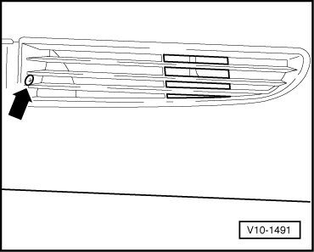
- ‒ With the ignition switched off disconnect the battery earth strap.
- ‒ → Unscrew vent grille on left; unclip vent grille on right.

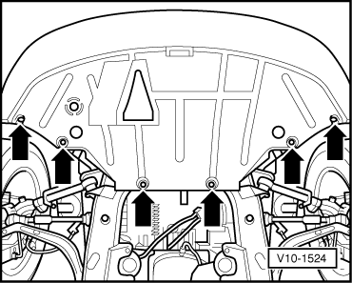
- ‒ → Remove noise insulation.

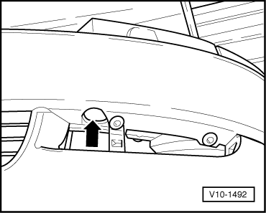
- ‒ → Unscrew bumper on left and right.
Vehicles with headlamp washer system:
- ‒ Pull off hose to jets at bumper (in vent grille on right).

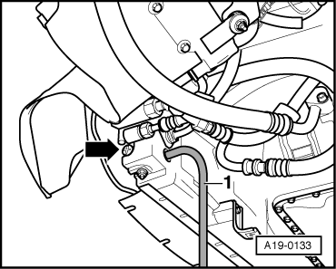
- ‒ Attach auxiliary hose -1- to connection.
- ‒ Place container V.A.G 1306 under the engine.
- ‒ → Drain coolant at bottom left of radiator -arrow-.

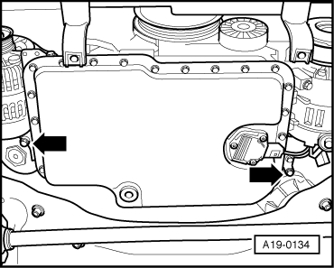
- ‒ → Drain coolant at drain plug -arrows-.

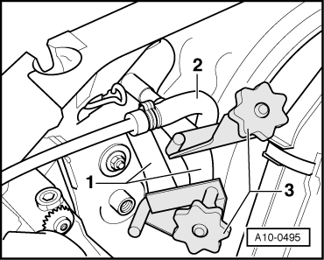
- ‒ → Disconnect oil pipes for hydraulic fluid of power steering with special tool 3094.
- ‒ Detach the oil pipes -1- for the hydraulic fluid of the power steering.
- ‒ Disconnect coolant hose -2-.

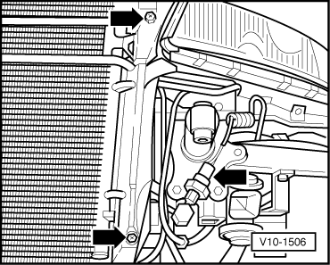
- ‒ → Unscrew air duct for radiator on left and right.
- ‒ Pull off connector for high-pressure switch.
- ‒ Remove suction hose to air cleaner.

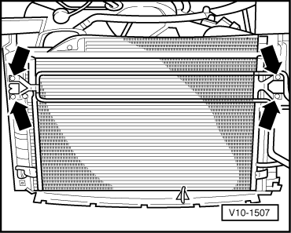
- ‒ → Unscrew hydraulic fluid cooling coil -arrows- and put aside.
- ‒ Disengage air conditioner condenser and hang up on the side.
- ‒ Detach connector for headlight on left and right.
- ‒ Detach connector for indicator on left and right.
- ‒ Remove bolts and detach oil lines for automatic gearbox
- ‒ Disconnect the bottom left and top right coolant hoses from the radiator.
- ‒ Detach connector for electric radiator fan.

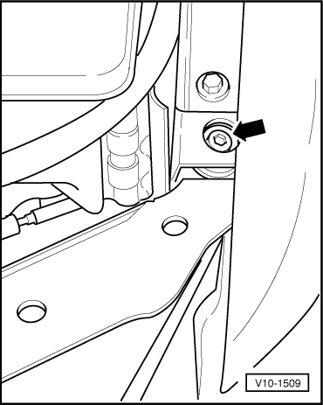
- ‒ Detach bonnet lock release cable.
- ‒ Pull off bonnet rest at both front wings.
- ‒ → Unscrew bolts for lock carrier beneath bonnet rest.

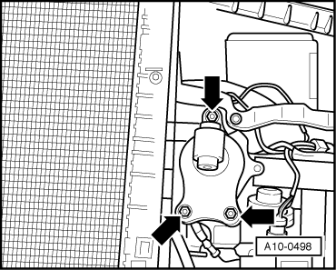
- ‒ → Unscrew impact damper for bumper on left and right -arrows-.
- ‒ Remove front end with radiator.

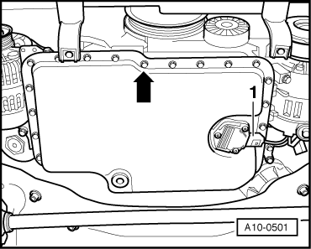
- ‒ → Remove connector -1- from oil gauge and expose wiring.

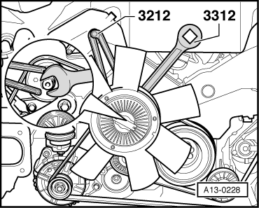
- ‒ → Counterhold pulley for viscous fan with 2- hole pin wrench 3212 and unscrew viscous fan with claw wrench 3312 (left-hand thread).
Notes:
- ◆ Mark the running direction with chalk or felt pen before removing the ribbed belt. If the belt runs in the opposite direction when it is refitted, this can cause breakage.

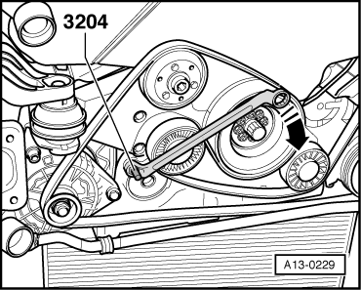
- ◆ When installing the ribbed belt ensure correct running direction and correct seating of the belt in the pulley.
- ‒ → To slacken the ribbed belt turn tensioner towards right with 17 mm ring wrench until both bore holes are above each other and secure with mandrel 3204.
- ‒ Remove ribbed V-belt.
- ‒ Unbolt ribbed belt pulley on hydraulic pump, using pin wrench 3212 to counterhold.

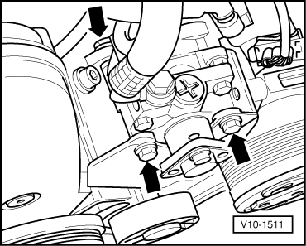
Note:
Take care of shims behind ribbed belt sprocket. Re-use on assembly.
- ‒ → Unscrew hydraulic pump from retainer and set down at longitudinal member.

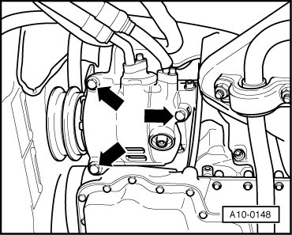
- ‒ → Unscrew AC compressor and hang up on side.
Notes:
- ◆ Do not open hydraulic connections.
- ◆ Take care not to bend pipes.
- ◆ Take care with dowel sleeves for guiding AC compressor at retainer.

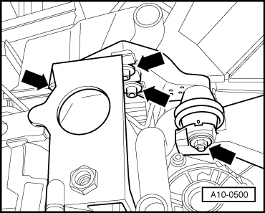
- ‒ → Remove torque reaction support -arrows-.

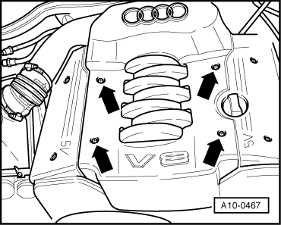
- ‒ → Remove engine cover -arrows-.

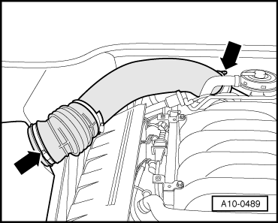
- ‒ → Remove air intake pipe -arrows- between air cleaner and throttle valve unit.

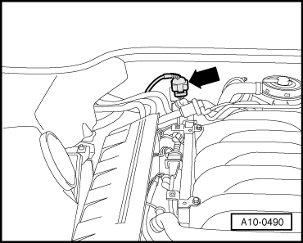
- ‒ → Unplug the connector of the lambda probe on the left -arrow- and expose wiring.

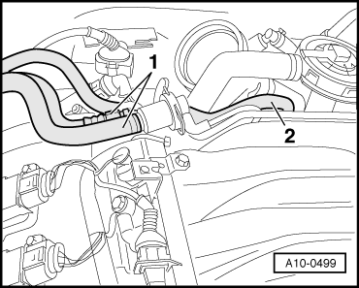
- ‒ → Separate fuel feed and return lines -1-.
- ‒ Detach hose -2-.

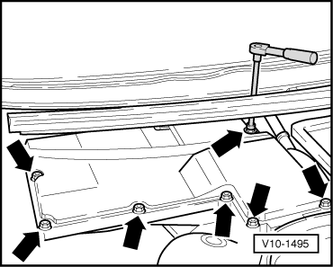
- ‒ → Open E-box; to do so, unscrew 7 screws -arrow-. Unclip hole cover for top left screw.

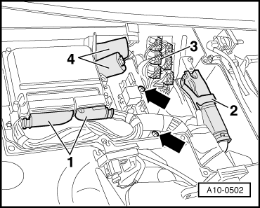
- ‒ → Detach the connectors from engine control unit -1-, the gearbox control unit -2- and on the bulkhead -3-.
- ‒ Unplug the connectors -4-.
- ‒ Unscrew the bracket for the relay and fuses -arrows-.
- ‒ Pull off weather strip between engine compartment and plenum chamber.
- ‒ Unscrew wiring harness from bulkhead, remove spacer sleeves, expose wiring and set down on engine.

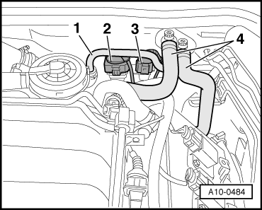
- ‒ → Detach pipe of brake servo -1-.
- ‒ Unplug connector -2- and expose wiring
- ‒ Unclip connector -3- from bracket.
- ‒ Detach coolant pipes -4- to heating system heat exchanger (supply and return) at bleed valves.

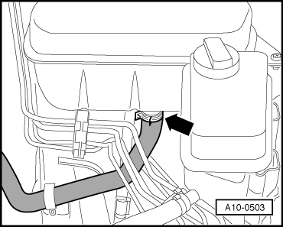
- ‒ → Detach water hose -arrow-.
- ‒ Unscrew top part of air filter.
- ‒ Detach connector from air mass meter.
- ‒ Pull connector off ACF valve.
- ‒ Expose wiring to engine.
- ‒ Detach vacuum pipe for intake manifold switching in front of left headlight.

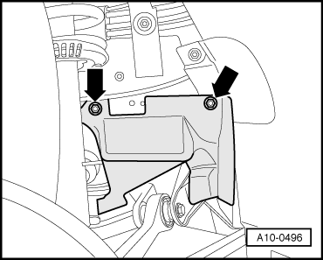
- ‒ → Remove cover -arrows- on longitudinal member.

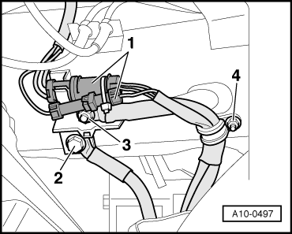
- ‒ Unclip cover of distribution box.
- ‒ → Unclip connector -1- for starter cable at junction box on right longitudinal member and detach.
- ‒ Unscrew starter cable -3- in junction box.
- ‒ Unscrew earth wire -2-.
- ‒ Unscrew wiring loom from longitudinal member -4-.
- ‒ Remove air duct for alternator.
Note:
The isolating element in front exhaust pipe must not be deflected more than 10° to avoid damage..

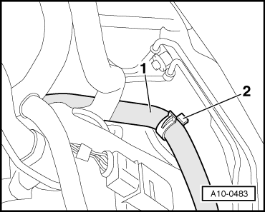
- ‒ → Unclip hose -1- from bracket and set aside.
- ‒ Unscrew bracket -2-.
- ‒ Release upper bolt of connection exhaust manifold/exhaust pipe.

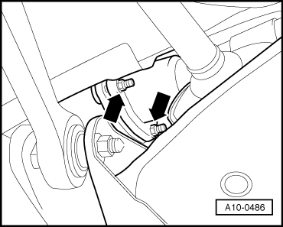
- ‒ → Detach connecting bolts -arrows- exhaust manifold/front exhaust pipe from below.

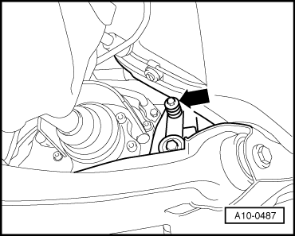
- ‒ → Unscrew exhaust pipe from retainer
-arrow-.

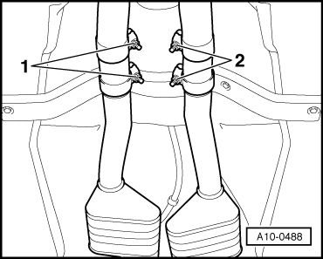
- ‒ → Release double clamp -1- and push it forward.
- ‒ Carefully remove exhaust pipe.
Note:
The isolating element in front exhaust pipe must not be deflected more than 10°to avoid damage..

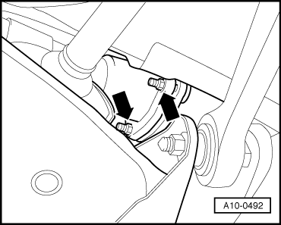
- ‒ Remove the right wheel.
- ‒ Release upper bolt of connection exhaust manifold/exhaust pipe (accessible through opening of track rod).
- ‒ → Detach connecting bolts -arrows- exhaust manifold/front exhaust pipe from below.

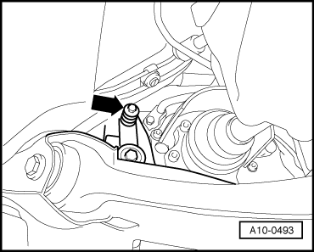
- ‒ → Unscrew exhaust pipe from retainer
-arrow-.

- ‒ → Release double clamp -2- and push it forward.
- ‒ Carefully remove exhaust pipe.
Note:
The isolating element in front exhaust pipe must not be deflected more than 10°to avoid damage..

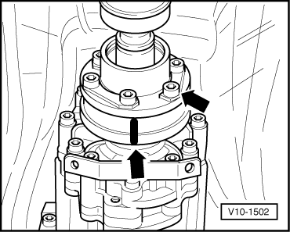
- ‒ → Mark propshaft with gearbox output.
- ‒ Unscrew propshaft.
- ‒ Install support for propshaft.

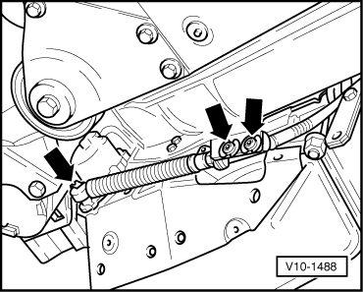
- ‒ → Unscrew selector lever cable at bracket.
- ‒ Unclip fastener at bracket and set aside.
- ‒ Unscrew drive shaft on left and right.
- ‒ Unscrew shield for drive shaft on left.
- ‒ Use gearbox lifter V.A.G 1383 to raise gearbox.
- ‒ Unscrew gearbox mounting on right and left.
- ‒ Lower and remove gearbox lifter.

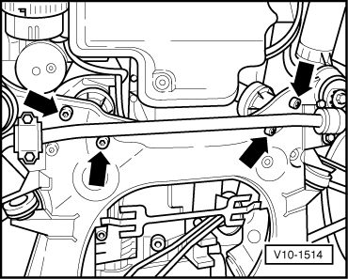
- ‒ → Unscrew engine mounting on left and right.

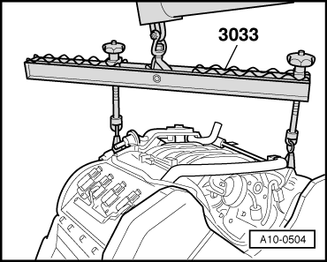
- ‒ → Engage lifting tackle V.A.G 3033 on both engine mounts as illustrated
- ‒ Place assembly crane V.A.G 1202 A (500 kg) in position and engage lifting tackle 3033.
- ‒ Carefully raise engine and pull it out forwards.

Removing and installing engine
Separating engine from gearbox.

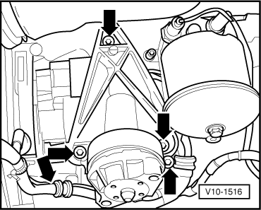
- ‒ → Unscrew engine support on right.
- ‒ Set down engine with gearbox; for example on workbench; leave suspended from crane; if appropriate, set down on two old tyres in order to be able to separate engine from gearbox.

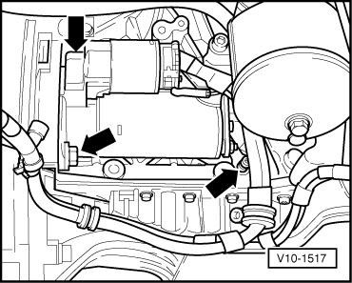
- ‒ Unscrew electric wiring from starter.
- ‒ → Remove starter -arrow-.
- ‒ Disconnect electric wires from gearbox and set aside.
If engine or gearbox is replaced:

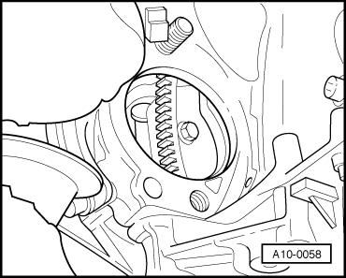
- ‒ With the two assemblies separated, crank engine to TDC and align mark on gearbox bell housing with mark on converter.
Note:
Before unscrewing converter from drive plate, mark respective position of both components.
- ‒ → Unscrew converter from drive plate, 3 bolts.
Tightening torque 85 Nm.

Removing and installing engine
Attaching engine to repair stand

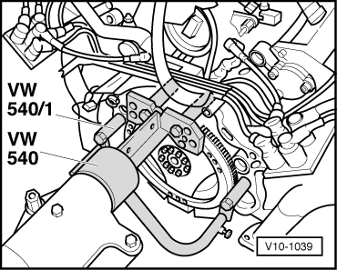
- ‒ → When performing assembly work, attach engine with engine mount VW 540/1 to repair stand.

Removing and installing engine
Installing
Installation is carried out in the reverse order to removal, noting the following:
Important
To avoid contact corrosion use is only to be made of approved bolts, nuts and washers etc. These feature a special surface coating and can be recognised by their greenish colour.
- ‒ Check clutch release bearing for wear, renew if necessary.
- ‒ Vehicles with automatic gearbox have no needle bearing in the crankshaft.
- ‒ In the case of exchange engines with manual gearbox, check whether needle bearing has been fitted in crankshaft and install if necessary.
- ‒ Check whether the dowel sleeves for centralising engine/gearbox are in the cylinder block, install if necessary.
- ‒ Renew all self-locking nuts.
- ‒ Stress-free alignment of exhaust system:
- ‒ Check hydraulic fluid level and top up, if necessary.

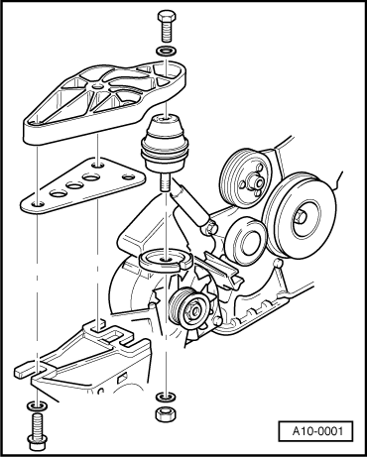
- ‒ Top up coolant => Page 19-9.
- ‒ → Carry out stress-free installation of torque reaction support; fit shims, if necessary.
- ‒ Rock engine mount to carry out stress-free alignment.
- ‒ Check oil level before starting engine.
- ‒ Check fluid level in automatic gearbox.
- ‒ After connecting battery, enter anti theft code for radio.
=> Radio -operating instructions
- ‒ Close windows fully using electric window switches.
- ‒ Then actuate all electric window switches again for at least one second in the "close" direction to activate the automatic open/close function.
- ‒ Set clock to correct time.

Removing and installing engine
Tightening torques - engine codes

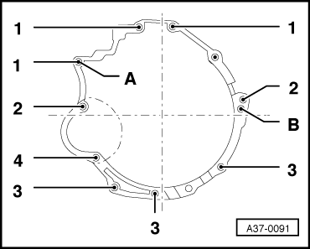
- ‒ → Engine/gearbox attachment (gearbox flange layout).
Item | Bolt | Quant. | Nm
1 | M 12x75 | 3 | 65
2 | M 12x90 | 2 | 65
3 | M 10x45 | 3 | 45
4 | M 10x80 | 1 | 65
Dowel sleeves for centring (A and B).
Bolted joint |  | Tightening torques
Torque converter to drive plate:
Engine code letters |  | 85 Nm
Front right engine support to engine |  | 45 Nm
Alternator to engine | M10  M 8 | 40 Nm  25 Nm
Exhaust manifold to cylinder head |  | 25 Nm
A/C compressor to bracket |  | 25 Nm
Bracket for central hydraulic pump and AC compressor to engine |  | 25 Nm
Drive shafts to flanged shafts | M 10 | 77 Nm
Exhaust pipe to manifold |  | 40 Nm
Gearbox mounting to subframe |  | 40 Nm
Engine carrier to bodywork |  | 50 Nm
Wheel bolts to wheel hub |  | 120 Nm

Dismantling and assembling engine
Removing and installing ribbed belt

Special tools, testers and auxiliary items required
- ◆ Special tool 3212
- ◆ Special tool 3312
- ◆ Setting pin 3204
Removing
- ‒ → Remove noise insulation.

- ‒ Remove suction hose to air cleaner.
- ‒ → Remove engine cover.

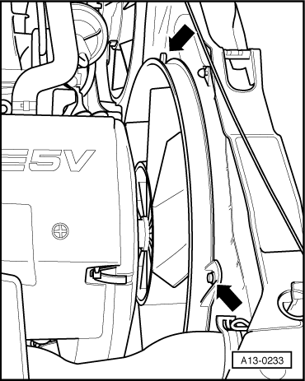
- ‒ → Unscrew vent ring for the viscous fan-arrows-.

- ‒ → Counterhold pulley for viscous fan with 2- hole pin wrench 3212 and unscrew viscous fan with claw wrench 3312 (left-hand thread).
- ‒ Remove viscous fan with vent ring.
Notes:

- ◆ Mark the running direction with chalk or felt pen before removing the ribbed belt. If the belt runs in the opposite direction when it is refitted, this can cause breakage.
- ◆ When installing the ribbed belt ensure correct running direction and correct seating of the belt in the pulley.
- ‒ → To slacken the ribbed belt turn tensioner towards right with 17 mm ring wrench until both bore holes are above each other and secure with mandrel 3204.
- ‒ Remove ribbed V-belt.

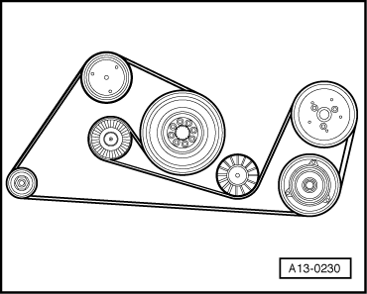
Installing
Installation is carried out in the reverse order; note the following:
Note:
When installing the ribbed belt ensure correct running direction and correct seating of the belt in the pulley.
- ‒ → Fit ribbed belt on crankshaft pulley and idler wheels first; fit onto tensioning roller last.

- ‒ → For tensioning the ribbed belt turn tensioner towards the right in direction of arrow using a 17 mm ring wrench and remove mandrel 3204.
- ‒ Start engine and check belt running.

- ‒ Install viscous fan with vent ring (left-hand thread).
- ‒ → Counterhold pulley for viscous fan with 2-hole pin wrench 3212 and unscrew viscous fan with clamp wrench 3312 (left thread).
- ‒ Install the noise insulation.
- ‒ Install engine cover.
Tightening torques
Component |  | Nm
Viscous fan with torque wrench 1331 and open-end wrench 3312 |  | 37
Viscous fan with torque wrench without open-end wrench 3312 |  | 70
Vent ring to radiator |  | 10

Dismantling and assembling engine
Removing and installing toothed belt
Special tools, testers and auxiliary items required
- ◆ Spring pin from 2024 A
- ◆ Special tool 3212
- ◆ Special tool 3312
- ◆ Socket attachment 3078 (22 mm A/F)
- ◆ Clamping bolt 3242
- ◆ Camshaft retainers T40005
- ◆ Special tool T40007
- ◆ V.A.G 1410 Torque wrench
- ◆ Plug-in tool V.A.S 5122
- ◆ Tensioning roller wrench T40009

Removing
- ‒ → Remove engine cover first.
- ‒ Detach toothed belt cover.

- ‒ → Remove noise insulation -arrows-.
- ‒ Removing and installing ribbed belt => Page 13-1.
- ‒ Remove ribbed belt pulley for viscous fan.

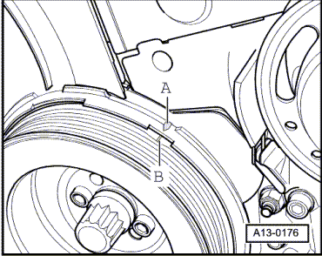
- ‒ → Crank engine by hand into TDC position. The markings -A- and -B- must face each other.

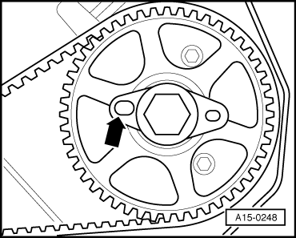
- ‒ → Check position of camshaft: The large holes of the fixing plates at the camshaft gears must be facing in toward each other; if this is not the case rotate crankshaft one further revolution.

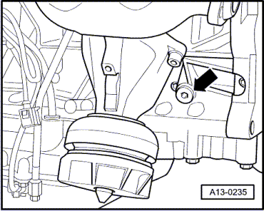
- ‒ → Unscrew plug -arrow- from left of cylinder block.
- ‒ The TDC hole in the crankshaft must be located behind the hole of the removed plug (can be felt).

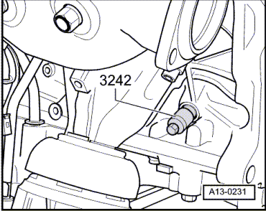
- ‒ → Screw crankshaft fixture 3242 into the hole of the removed plug and tighten.

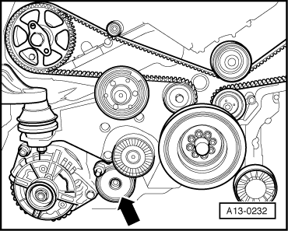
- ‒ → Remove tensioner for the ribbed belt.
- ‒ Remove vibration damper.

- ‒ → Remove bracket for viscous fan
-arrows-.
Notes:

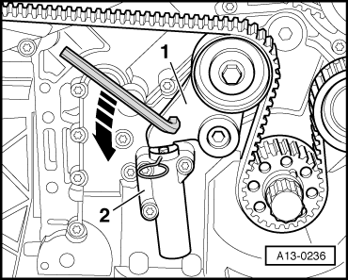
- ◆ Mark the running direction with chalk or felt pen before removing the toothed belt. If the belt runs in the opposite direction when it is refitted, this can cause breakage.
- ◆ The toothed belt tensioner is oil damped. and can only be compressed slowly by applying continuous pressure.
- ◆ Use spring pin from 2024 A.
- ‒ → Turn toothed belt tensioning lever -1- to the left in direction of arrow with 8 mm Allen key until the tensioning element -2- has been compressed sufficiently to enable a 2 mm ø spring cotter to fit into the hole and into the tappet.

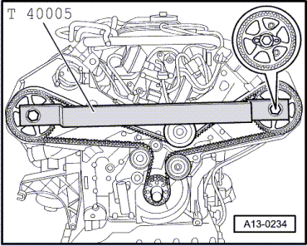
- ‒ Insert spring cotter and release toothed belt tensioning lever.
- ‒ → Insert camshaft retainers T40005 into fixing plates of the two camshafts.
- ‒ Loosen both camshaft bolts and screw out with approx. 5 turns.
- ‒ Remove camshaft retainers T40005.

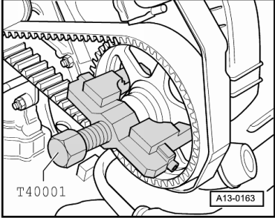
- ‒ → Unplug both camshaft sprockets with special tool T40001.

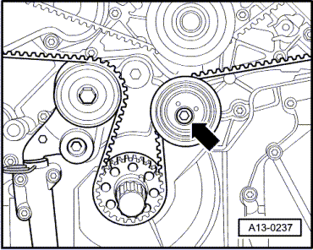
- ‒ → Loosen toothed belt tensioning roller (arrow).
- ‒ Remove toothed belt sprocket cyl. bank 1-4 with the toothed belt.
Installing

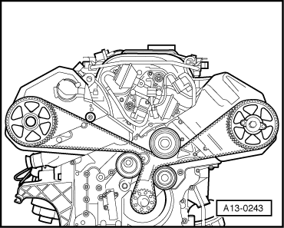
- ‒ → Put toothed belt onto toothed belt sprocket of crankshaft first, onto idler wheel of the toothed belt tensioner, the tensioning roller, onto the toothed belt sprocket of the camshaft cyl. bank 5-8 as well as the water pump and the calming roller.
- ‒ Lastly remove the toothed belt sprocket of the camshaft cyl. bank 1-4, attach toothed belt and screw onto camshaft.
- ‒ Tighten both camshaft sprockets by hand with fixing plates.

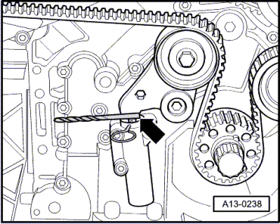
Note:
The camshaft sprockets must be fitted sufficiently loosely onto the taper face so that they can still be moved on the camshafts but do not tilt.
- ‒ Insert camshaft retainers T40005.
- ‒ → Position a 5 mm gauge (e.g. drill) between the tensioner and the hydraulic element piston -arrow-.

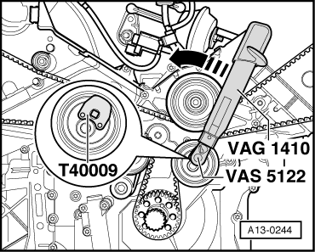
- ‒ → Tension the toothed belt with tensioning roller wrench T40009 and torque wrench V.A.G 1410 with plug-in tool V.A.S 5122 by turning anti-clockwise -in direction of arrow- to 4 Nm and tighten eccenter roller, tightening torque 22 Nm.
- ‒ Take out the 5 mm gauge.

- ‒ → Turn toothed belt tensioning lever -1- towards left as far as it will go using an 8 mm Allen key until the spring cotter can be taken out.

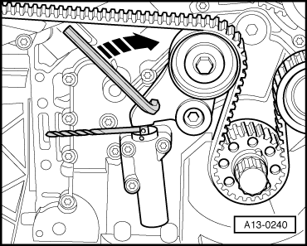
  - ‒ → Turn toothed belt tensioning lever to the right in direction of arrow as far as it will go using an 8 mm Allen key until a 7 mm gauge (e.g. drill) can be inserted between toothed belt tensioning lever and hydraulic element.
  - ‒ Tighten bolts on camshaft sprocket.
Note:
The camshaft retainers T40005 are used for counterhold.
- ‒ Remove the camshaft retainers T40005.
- ‒ Take out the 7 mm gauge.

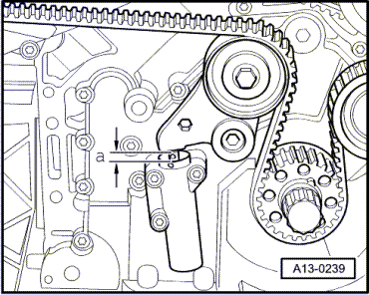
- ‒ Screw out crankshaft retainer 3242 and close bore with plug.
- ‒ Crank engine with 2 turns of the crankshaft.
- ‒ → Check adjusting measure -a- between toothed belt tensioning lever and hydraulic element.
Adjusting measurement a = 5mm.
- ‒ With deviations re-adjust the adjusting measure of 5 mm at tensioning roller.
Tightening torques
Toothed belt sprocket to camshaft |  | 55 Nm
Idler roller |  | 45 Nm
Toothed belt tensioning pulley |  | 20 Nm
Belt pulley to crankshaft |  | 20 Nm
Toothed belt tensioning element |  | 10 Nm
Eccentric roller |  | 22 Nm
Central bolt 1) of crankshaft |  | 200 Nm + 180°2)
1) The central bolt must always be replaced.
2) 2 x 90°further turns are permitted.

Dismantling and assembling engine
Removing and installing impact absorber
- ‒ Removing and installing ribbed belt => Page 13-1.

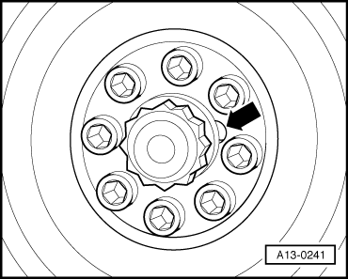
Note:
The central bolt does not have to be loosened to remove the vibration damper.
- ‒ Remove vibration damper.
- ‒ → When installing ensure that notch
-arrow- in vibration damper is aligned with the arresting notch on the toothed belt wheel.
- ‒ Installing vibration damper
  - ‒ Tightening torque: 20 Nm
- ‒ Install ribbed belt =>Page 13-1.

Dismantling and assembling engine
Removing toothed belt from camshaft sprockets
Special tools, testers and auxiliary items required
- ◆ Special tool 3212
- ◆ Special tool 3312
- ◆ Socket attachment 3078 (22 mm A/F)
- ◆ Clamping bolt 3242

- ◆ Camshaft retainers T40005
- ◆ Special tool T40007
Removing
- ‒ Remove suction hose to air cleaner.
- ‒ → Remove engine cover.

- ‒ → Unscrew vent ring for the viscous fan -arrows-.

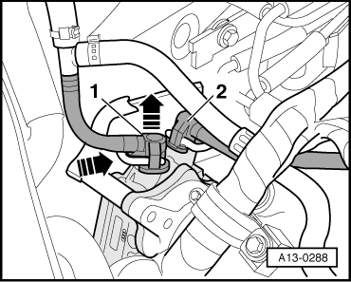
- ‒ → Counterhold pulley for viscous fan with 2- hole pin wrench 3212 and unscrew viscous fan with claw wrench 3312 (left-hand thread).
- ‒ Remove viscous fan with vent ring.
- ‒ Remove ribbed belt pulley for viscous fan.
Notes:

- ◆ Mark the running direction with chalk or felt pen before removing the ribbed belt. If the belt runs in the opposite direction when it is refitted, this can cause breakage.
- ◆ When installing the ribbed belt ensure correct running direction and correct seating of the belt in the pulley.
- ‒ → To slacken the ribbed belt turn tensioner towards right with 17 mm ring wrench until both bore holes are above each other and secure with mandrel 3204.
- ‒ Remove ribbed V-belt.

- ‒ → Crank engine by hand into TDC position. The markings -A- and -B- must face each other.

- ‒ → Check position of camshaft: The large holes of the fixing plates at the camshaft gears must be facing in toward each other; if this is not the case rotate crankshaft one further revolution.

- ‒ → Unscrew plug -arrow- from left of cylinder block.
- ‒ The TDC hole in the crankshaft must be located behind the hole of the removed plug (can be felt).

- ‒ → Screw crankshaft fixture 3242 into the hole of the removed plug and tighten.

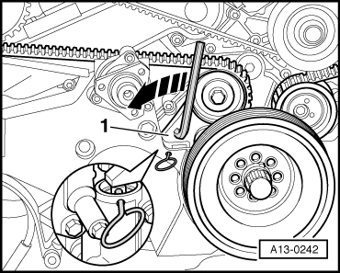
Note:
The toothed belt tensioner is oil damped, and can only be compressed slowly by applying continuous pressure.
- ‒ → Turn toothed belt tensioning lever -1- to the left in direction of arrow with 8 mm Allen key until the tensioning element -2- has been compressed sufficiently to enable a 2 mm ø spring cotter to fit into the hole and into the tappet.
- ‒ Insert spring cotter and release toothed belt tensioning lever.

- ‒ → Insert camshaft retainers T40005 into fixing plates of the two camshafts.
- ‒ Loosen both camshaft bolts and screw out with approx. 5 turns.
- ‒ Remove camshaft retainers T40005.

- ‒ → Unplug both camshaft sprockets with special tool T40001.
- ‒ Remove toothed belt sprocket cyl. bank 1-4 with the toothed belt.
Attach
- ‒ Remove the toothed belt sprocket of the camshaft cyl. bank 1-4, attach toothed belt and screw onto camshaft.
- ‒ Tighten both camshaft sprockets by hand with fixing plates.

Note:
The camshaft sprockets must be fitted sufficiently loosely onto the taper face so that they can still be moved on the camshafts but do not tilt.
- ‒ Insert camshaft retainers T40005.
- ‒ → Turn toothed belt tensioning lever -1- towards left as far as it will go using an 8 mm Allen key until the spring cotter can be taken out.
  - ‒ Tighten bolts on camshaft sprocket.
Note:
The camshaft retainers T40005 are used for counterhold.
- ‒ Remove the camshaft retainers T40005.
- ‒ Screw out crankshaft retainer 3242 and close bore with plug.
- ‒ Crank engine by 2 turns of the crankshaft.
Tightening torques
Toothed belt sprocket to camshaft |  | 55 Nm
Idler roller |  | 45 Nm

Dismantling and assembling engine
Servicing flywheel

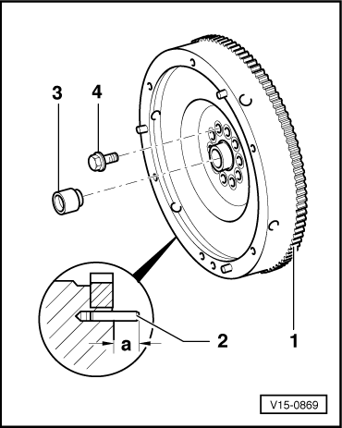
1- Starter ring gear
- ◆ Heat to 200 °C before installing.
2- Straight pin for TDC sender
- ◆ Installation dimension 21 mm
3- Needle bearing bush
- ◆ Removing and installing => Page13-28
4- Bolt for flywheel
- ◆ Always replace
- ◆ Without dual-mass flywheel 60 Nm + 90° further turn
- ◆ With dual-mass flywheel
- ‒ Screw length 22.5 mm
60 Nm + 90° further turn
- ‒ Screw length 43 mm
60 Nm + 180° further turn

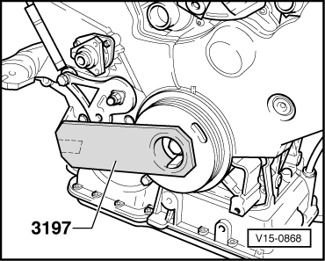
- ‒ → Loosen flywheel bolts using counterhold tool 3197.
- ‒ Install in reverse order.

Dismantling and assembling engine
Removing and installing needle bearing bush

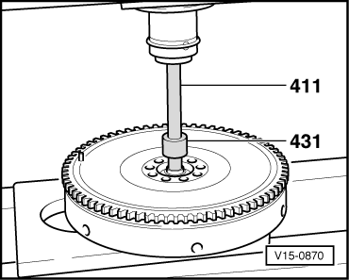
- ‒ → Press out needle bearing bush using VW 411 and VW 431.

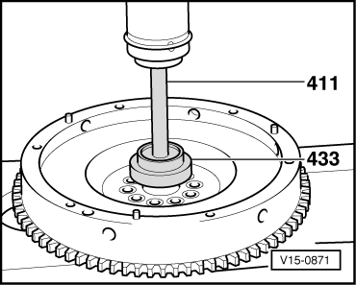
- ‒ → Use VW 411 and VW 433 to press in needle bearing bush so that it is flush.

Dismantling and assembling engine
Drive plate

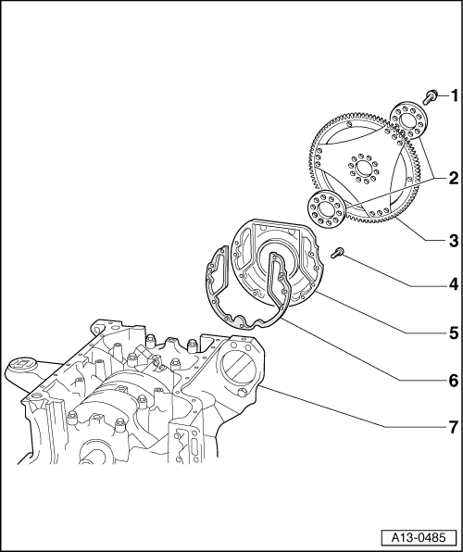
- 60 Nm + 90° further turn
  - ◆ install using locking fluid
=> Parts List
  - ◆ Always replace
- Washer
- Drive plate
  - ◆ On assembly, make sure drive plate has been fitted with pin for ignition point
  - ◆ Pin length 20 to 22 mm from drive plate
- 10 Nm
- Rear sealing flange with oil seal
- Gasket
- Engine block

Removing and installing cylinder head
Removing and installing left cylinder head cover

Removing
- ‒ → Remove engine cover -arrows-.

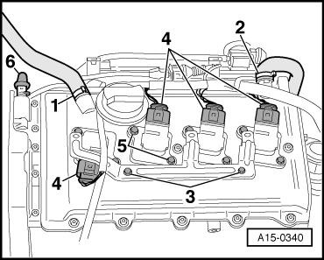
- ‒ → Detach hose -1-.
- ‒ Pull off hose -2-.
- ‒ Unbolt bracket -3-.
- ‒ Pull connectors -4- from ignition coils.
- ‒ Remove ignition coils -5-.
- ‒ Remove the valve cover.
Installing
Installation is carried out in the reverse order; note the following:
- ◆ Replace cylinder head cover gaskets if damaged.

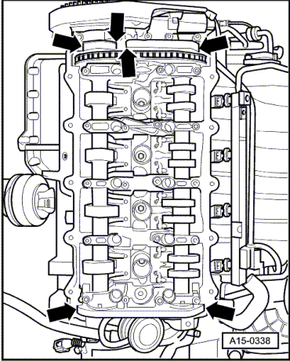
- ‒ → Apply a small quantity of sealant "D 545.300 A2" to sides of joints -arrows- on upper sealing surface of cylinder head.
- ‒ Tighten nuts for cylinder head cover crosswise and in stages.
Tightening torques
Component |  | Nm
Cylinder head cover to cylinder head |  | 10

Removing and installing cylinder head
Removing and installing right cylinder head cover

Removing
- ‒ → Remove engine cover -arrows-.

- ‒ → Remove air intake pipe -arrows- between air cleaner and throttle valve unit.

- ‒ → Separate fuel feed and return lines -1-.
- ‒ Detach hose -2-.

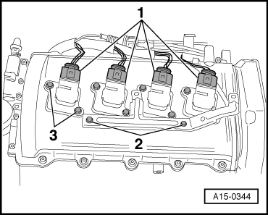
- ‒ → Detach connectors -1- from ignition coils.
- ‒ Unbolt bracket -2-.
- ‒ Remove ignition coils -3-.
- ‒ Detach crankcase breather hose.
- ‒ Remove the valve cover.
Installing
Installation is carried out in the reverse order; note the following:
- ◆ Replace cylinder head cover gaskets if damaged.

- ‒ → Apply a small quantity of sealant "D 545.300 A2 to sides of joints -arrows- on upper sealing surface of cylinder head.
- ‒ Tighten nuts for cylinder head cover in diagonal sequence.
Tightening torques
Component |  | Nm
Cylinder head cover to cylinder head |  | 10

Removing and installing cylinder head
Removing left cylinder head
Notes:
- ◆ Secure all hose connections with the correct hose clips (same as original equipment):
=> Parts List
- ◆ All cable ties which are released or cut open when removing must be fitted in the same position when installing.
- ◆ Replace the cylinder head bolts.
- ◆ When performing repairs, replace seals, gaskets, self-locking nuts and bolts which have a specified tightening angle.

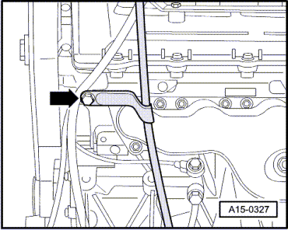
- ◆ When fitting a new cylinder head or cylinder head gasket, drain off all the old coolant and re-fill with new coolant.
- ‒ Drain off the coolant => Page 19-8.
- ‒ → Unbolt guide tube for oil dipstick from cylinder head.
- ‒ Remove the toothed belt guard.

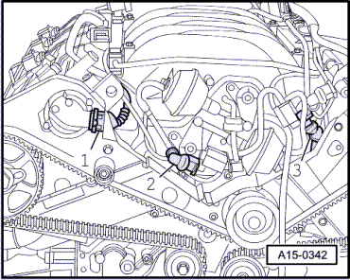
- ‒ → Pull off connector -2-.
- ‒ Pull off connector -3-.
- ‒ Remove the toothed belt from the camshafts => Page 13-18.
- ‒ Remove camshaft sprocket from cylinder bank 5-8.

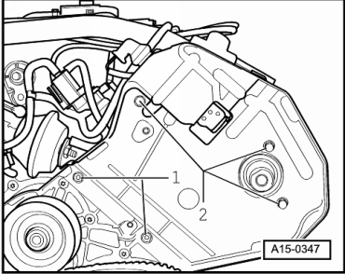
- ‒ → Slacken bolts -1-.
- ‒ Twist out bolts -2- and remove toothed belt guard.

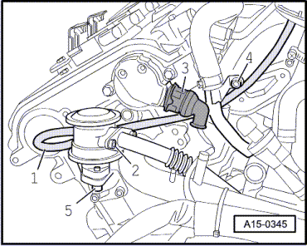
- ‒ → Detach hose -1-.
- ‒ Remove bolts -2-.
- ‒ Pull off connector -3-.
- ‒ Unscrew bolts -4- and remove oil pipe.
- ‒ Screw out bolts -5- and detach combination valve.

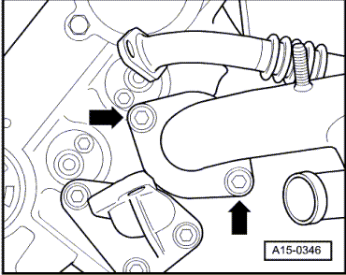
- ‒ → Unscrew water pipe -arrows-.

- ‒ → Detach hose -1-.
- ‒ Pull off hose -2-.
- ‒ Unbolt bracket -3-.
- ‒ Pull connectors -4- from ignition coils.
- ‒ Remove ignition coils -5-.
- ‒ Pull off connector -6-.
- ‒ Remove the valve cover.

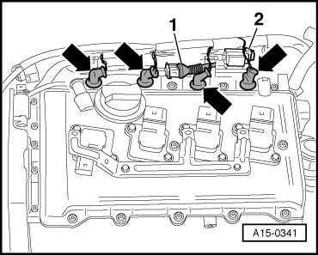
- ‒ → Detach connector -1- for knock sensor cyl. bank 4-8.
- ‒ Pull off connectors -arrows- from injectors cyl. bank 4-8 and set wiring harness aside.
- ‒ Pull off connector for knock sensor cyl. bank 1-4.
- ‒ Unplug connectors from injectors cyl. bank 1-4.

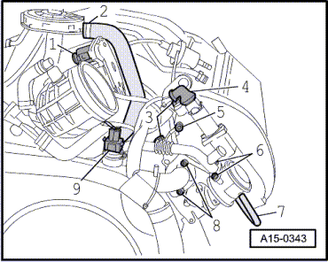
- ‒ → Pull off connector -1-.
- ‒ Pull off hose -2-.
- ‒ Remove bolts -8-.
- ‒ Pull off connector -9-.
- ‒ Remove water pipe.
- ‒ Remove intake pipe.

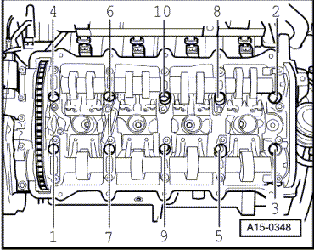
- ‒ → Maintain sequence when loosening cylinder head bolts.
- ‒ Remove cylinder head and place on a soft surface.

Removing and installing cylinder head
Removing right cylinder head
Notes:
- ◆ Secure all hose connections with the correct hose clips (same as original equipment):
=> Parts List
- ◆ All cable ties which are released or cut open when removing must be fitted in the same position when installing.
- ◆ Replace the cylinder head bolts.
- ◆ When performing repairs, replace seals, gaskets, self-locking nuts and bolts which have a specified tightening angle.
- ◆ When fitting a new cylinder head or cylinder head gasket, drain off all the old coolant and re-fill with new coolant.
- ‒ Drain off the coolant => Page 19-8.
- ‒ Remove the toothed belt guard.

- ‒ → Disconnect plug -1- from Hall sender.
- ‒ Pull off connector -2-.
- ‒ Pull off connector -3-.
- ‒ Remove the toothed belt from the camshafts => Page 13-18.

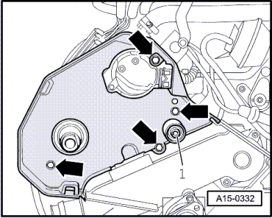
- ‒ Remove calming roller -1-.
- ‒ → Remove toothed belt guard -arrows-.

- ‒ → Detach connectors -1- from ignition coils.
- ‒ Unbolt retainer -2-.
- ‒ Remove ignition coils -3-.
- ‒ Detach crankcase breather hose.
- ‒ Remove the valve cover.

- ‒ → Unscrew water pipe -arrows-.

- ‒ → Pull off connector -1-.
- ‒ Pull off hose -2-.
- ‒ Unscrew bracket -3-.
- ‒ Pull off connector -4-.
- ‒ Unscrew earth cable -5- from cylinder head.
- ‒ Remove bolts -6-.
- ‒ Pull hose -7- off combination valve.
- ‒ Remove bolts -8-.
- ‒ Pull off connector -9-.
- ‒ Remove water pipe.

- ‒ Remove intake pipe.
- ‒ → Maintain sequence when loosening the cylinder head bolts.
- ‒ Remove cylinder head and place on a soft surface.

Removing and installing cylinder head
Installing cylinder head
Notes:
- ◆ Replace the cylinder head bolts.
- ◆ When performing repairs, replace seals, gaskets, self-locking nuts and bolts which have a specified tightening angle.
- ◆ If repairing, carefully remove any remains of gasket material from the cylinder head and cylinder block. Make sure that no long scores or scratches are made on the surfaces.
- ◆ Carefully remove any remaining emery and abrasive material.
- ◆ No oil or coolant must be allowed to remain in the blind holes for the cylinder head bolts in the cylinder head.
- ◆ Remove new cylinder head gasket from packaging, just before installation.
- ◆ Handle gasket extremely carefully. Damaging the silicone layer or the indented area will lead to leaks.
- ◆ Position cylinder head gasket on dowel pins. Marking -top- or part number must face cylinder head
- ◆ After working on the valve gear, turn the engine carefully at least 2 rotations to ensure that none of the valves make contact when the starter is operated.
Installation is carried out in the reverse order; note the following:
- ‒ Note identification markings on cylinder head gasket.
- ‒ Place cylinder head on.
- ‒ Insert cylinder head bolts and tighten by hand.

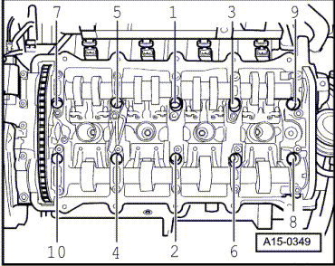
- ‒ → Tighten cylinder head bolts in four stages in sequence shown as follows:
- ‒ Tighten using torque wrench:
  - ‒ 1st Stage: 35 Nm
  - ‒ 2nd Stage: 60 Nm
- ‒ Tighten with rigid wrench:
  - ‒ 3rd Stage: 90°(1/4 turn) further)
  - ‒ 4th Stage: 90°(1/4 turn) further)
Note:
It is not necessary to retighten cylinder head bolts after repairs have been performed.

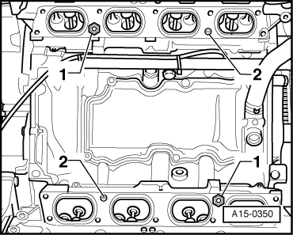
- ‒ → Replace seals of intake pipe. For this remove fixing bolts -1-, tightening torque 0.6 Nm.
- ‒ Positioning pin for intake pipe -2-, tightening torque 7 Nm.
Note:
Replace cylinder head cover gaskets if damaged.

- ‒ → Apply a small quantity of sealant "D 545.300 A2 to sides of joints -arrows- on upper sealing surface of cylinder head.
- ‒ Tighten nuts for cylinder head diagonally.
- ‒ Attach toothed belt onto camshaft sprockets => Page 13-18.
Tightening torques
Component |  | Nm
Dipstick guide tube to cylinder head |  | 10
Toothed belt guard to cylinder head |  | 10
Front section of coolant pipe to cylinder head |  | 10
Cylinder head cover to cylinder head |  | 10
Intake manifold to cylinder head |  | 10
Combination valve to cylinder head |  | 8
Positioning pin for intake pipe |  | 7
Fixing bolt for intake pipe seal |  | 0.6

Servicing valve gear
Checking camshaft axial clearance

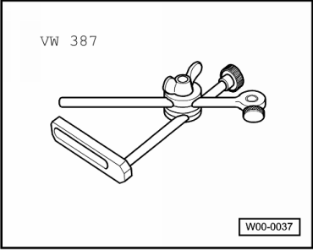
Special tools and workshop equipment required
- ◆ Universal dial gauge bracket VW 387
- ◆ Dial gauge
Test sequence
- ‒ Removing camshaft => page 15-30.
- ‒ Remove rocker finger.
- ‒ Insert camshafts without chain into cylinder head and bolt tight with bearing caps 2 and 4.

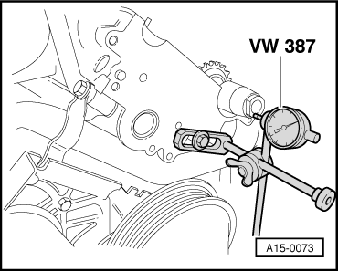
- ‒ → Attach dial gauge with universal dial gauge holder VW 387 to cylinder head.
- ‒ Press camshaft by hand against the dial gauge.
- ‒ Set dial gauge to -0-
- ‒ Press crankshaft away from dial gauge.
- ‒ Note dial gauge reading:
New | Wear limit
0.05 ... 0.15 mm | 0.20 mm

Servicing valve gear
Removing and installing camshafts and camshaft adjuster
Removing
- ‒ Remove toothed belt from camshaft sprockets => Page 13-18.
- ‒ Remove camshaft sprocket from cylinder bank 5-8.

- ‒ → Slacken bolts -1-.
- ‒ Twist out bolts -2- and remove toothed belt guard.
- ‒ Remove cylinder head cover => Page 15-3.
- ‒ Remove the Hall sender -Pos. 15-25.

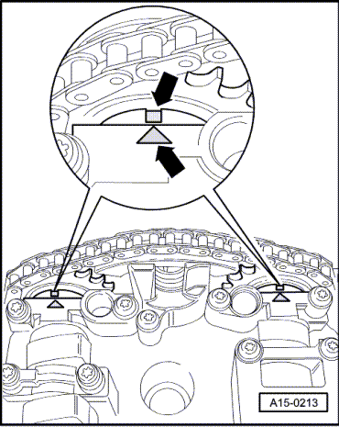
- ‒ → Re-check TDC position of camshafts:
  - ‒ The marks on the two camshafts must align with the arrows on the bearing caps.
When reusing the old drive chain:

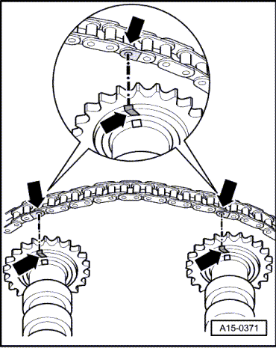
- ‒ → Clean drive chain and chain sprockets of the camshafts and mark installation position with colour marking.
Important
Do not mark chain with a centre punch or by making a notch or similar!
Continued:

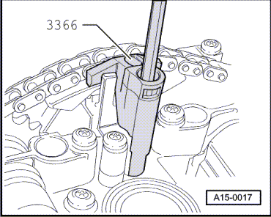
- ‒ → Hold camshaft adjuster in position with retainer for chain tensioner 3366.
Note:
If the retainer for chain tensioner is tightened excessively, this can damage the camshaft adjuster.

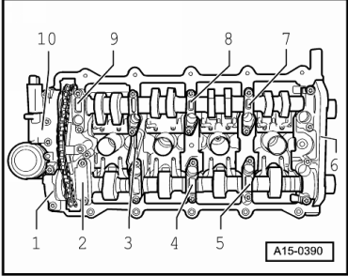
- ‒ → Mark sequence and installation position of all bearing caps as illustrated independent from the available markings on the bearing caps.

- ‒ → Unscrew securing bolts of camshaft adjuster -10-.
- ‒ Unscrew bearing cap 1
- ‒ Unscrew bearing cap 2, 4, 6, 8 and 9 and put down on clean surface according to sequence.
- ‒ Slacken off bearing caps 3, 5 and 7 of inlet and exhaust camshafts alternately and diagonally, and remove.
- ‒ Lift out both camshafts together with the camshaft adjuster.
Installing

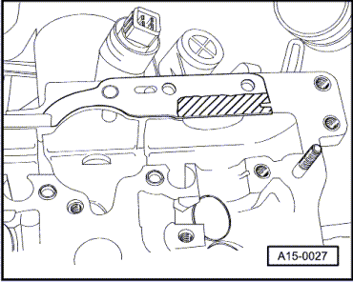
Installation is carried out in the reverse order; note the following:
- ‒ Replace the half-round sealing plug.
- ‒ Remove all traces of sealant from cylinder head and bearing caps.
- ‒ → Renew rubber/metal gasket for camshaft adjuster and apply a thin coat of sealant AMV 188 02" to the shaded area.

- ‒ Fit drive chain on camshaft sprockets as follows:
When reusing the old drive chain:
  - ‒ → Move coloured markings -arrows- to cap.
When using a new drive chain:

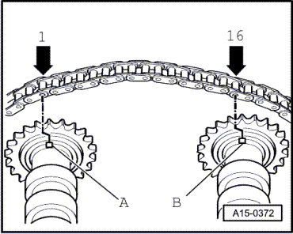
  - ‒ → The distance between the notches -A- and -B- on the camshafts must be 16 rollers at the drive chain. The illustration shows the exact positions of the 1st and 16th rollers on the sprockets.
  - ‒ The chain rollers -1- and -16- are opposite the notches -A- and -B- and are misaligned by1/2 tooth width towards left.
Continued:
- ‒ Push camshaft adjuster between drive chain (2nd mechanic required).
- ‒ Position camshafts together with drive chain and camshaft adjuster on cylinder head.
- ‒ Oil running surfaces of both camshafts.
Note:
Dowel sleeves for bearing caps and camshaft adjuster must be located in cylinder head.

- ‒ → Install bearing cap 3, 5 and 7 according to marking.
- ‒ Tighten bearing caps 3, 5 and 7 of inlet and exhaust camshafts in stages and diagonally (watch position of dowel sleeves).
- ‒ Install the rest of the bearing caps of the inlet and exhaust camshafts and tighten from the inside towards the outside in stages and diagonally.
- ‒ Tighten mechanical camshaft adjuster -10- (watch position of dowel sleeves).
- ‒ Remove holder for chain tensioner 3366.

- ‒ Check correct setting of camshafts:
  - ‒ → The two markings on the camshafts must align with the two arrows on the bearing caps - arrows -.
Note:
In order for both markings to be okay turn camshaft towards rotation direction, if necessary.

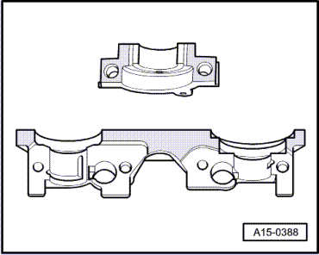
- ‒ → Coat the shaded area of the double bearing cap -6- as well as the outer bearing cap -1- adjacent to the camshaft adjuster thinly with sealant AMV 188 02 and install bearing cap with the camshaft sealing rings (note position of dowel sleeves).
- ‒ Fit the remaining bearing caps (note position of dowel sleeves).
- ‒ Tighten the other bearing caps.
- ‒ Install toothed belt (adjust valve timing)
=>Page 13-13.
Note:
Note all instructions on removing and installing the toothed belt =>Page 13-6.
- ‒ Install cylinder head cover => Page 15-5.
Notes:
- ◆ Wait about 30 minutes after installing the camshafts before starting the engine. Hydraulic valve compensation elements have to settle (otherwise valves will strike pistons).
- ◆ When working on the valve gear, turn the engine carefully at least 2 rotations to ensure that none of the valves make contact when the starter is operated.
Tightening torques
Component |  | Nm
Bearing cap to cylinder head |  | 5 + 90°
Camshaft adjuster to cylinder head |  | 5 + 90°
Hall sender rotor to camshaft |  | 23
Hall sender housing to cylinder head |  | 10

Servicing valve gear
Renewing valve stem seals

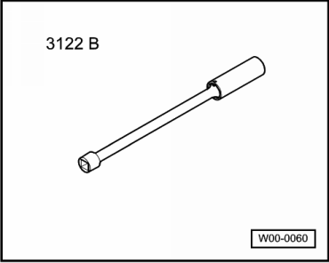
Special tools and workshop equipment required
- ◆ Spark plug socket 3122 B

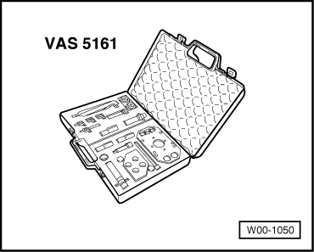
- ◆ Disassembly and assembly tool for valve wedges VAS 5161

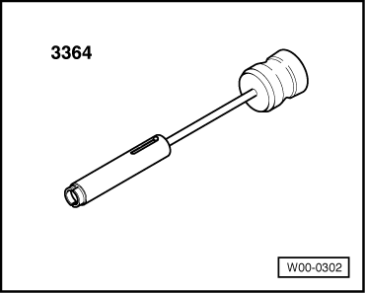
- ◆ Puller 3364

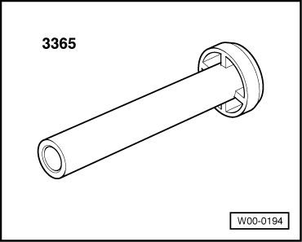
- ◆ Fitting tool 3365
Removing

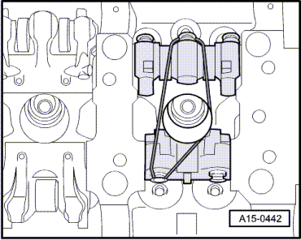
- ● Cylinder head in situ
- ‒ Removing camshafts => Page 15-30.
- ‒ Remove spark plugs with spark plug spanner 3122B.
- ‒ → Turn roller rocker finger upwards and secure with elastic.

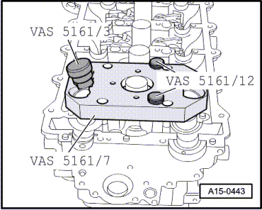
- ‒ → Attach guide plate VAS 5161/7 from V.A.S 1561 onto cylinder head.
- ‒ Attach guide plate VAS 5161/7 with the knurled screws VAS 5161/12.
- ‒ Insert the outlet mandrel VAS 5161/3 into guide plate and release stuck valve wedges with a plastic hammer.

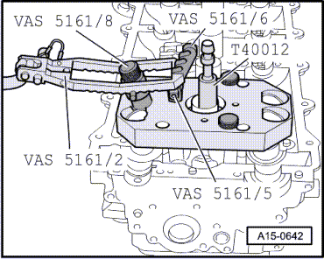
- ‒ → Screw engage part VAS 5161/6 into guide plate VAS 5161/7 with VAS 5161/5.
- ‒ Insert the assembly cartridge VAS 5161/8 into the guide plate VAS 5161/7.
- ‒ Screw adapter T40012 with sealing ring into respective spark plug thread hand-tight, applying constant pressure.
  - ‒ Minimum pressure: 6 bar
- ‒ Attach pressure fork VAS 5161/2 to engage part VAS 5161/6 and press assembly cartridge downwards. At the same turn knurled screw of the pressure cartridge towards the right until the tips engage into the valve wedges.
- ‒ By slightly moving the knurled screw back and forth the valve wedges are pushed apart and taken up into the cartridge.
- ‒ Release the pressure fork.
- ‒ Remove valve spring and valve disk.

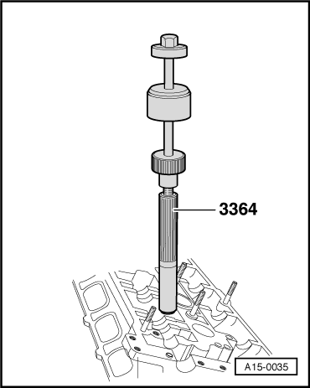
- ‒ → Pull off valve stem seals with extractor 3364.
Installing

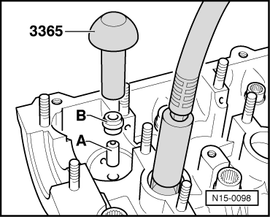
- ‒ → To prevent damage to the new valve stem seals, place plastic sleeve -A- on valve stem.
- ‒ Moisten sealing lip with oil.
- ‒ Place valve stem seal -B- in the tool 3365 and push carefully onto the valve guide.
- ‒ When replacing the valves moisten valve stem with oil before installing.

Servicing valve gear
Checking valve guides
Special tools and workshop equipment required

- ◆ Universal dial gauge bracket VW 387
- ◆ Dial gauge

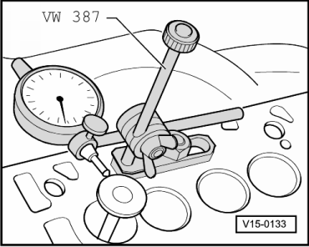
- ‒ → Set valve in guide. The end of the valve stem is flush with guide. Due to the slight difference in stem diameters. Ensure that only an inlet valve is used in the inlet guide and an exhaust valve in the exhaust guide.
- ‒ Determine rock.
Wear limit
Inlet valve guide | Exhaust valve guide
0.80 mm | 0.80 mm
Notes:
- ◆ If the wear limit is exceeded, repeat the measurement with new valves. If the wear limit is again exceeded, renew the cylinder head. The valve guides cannot be replaced.
- ◆ If the valve must be renewed as part of a repair, use a new valve for the calculation.

Servicing valve gear
Checking valves
- ‒ Visually inspect stem and seat for running-in marks. Replace valves in the case of severe running-in marks.

Servicing valve gear
Reworking valve seats
Note:
If a good seating pattern cannot be obtained by grinding the valve seats (lapping), they must be refaced (reworked):
Special tools and workshop equipment required
- ◆ Depth gauge
- ◆ Valve seat machining tool
Notes:
- ◆ When repairing engines with leaking valves, it is not sufficient to reface the valve seats and renew the valves. Valve guides must be checked for wear, particularly in the case of high-mileage engines
=>Page 15-45.
- ◆ Only rework the valve seats as far as is necessary to ensure a good seating pattern.
- ◆ Before starting to rework the valve seats, calculate the maximum permissible reworking dimension.
- ◆ If the maximum reworking dimension is exceeded, the hydraulic tappets will not work properly and the cylinder head will have to be renewed.
Calculating maximum permissible reworking dimension
- ‒ Insert valve and press firmly against valve seat.
Note:
If the valve must be renewed as part of a repair, use a new valve for the calculation.
- ‒ Measure distance between end of valve stem and central axis of camshaft. (Central axis of camshaft is level with top of cylinder head.)
- ‒ Calculate max. permissible reworking dimension from measured distance and minimum dimension.
Minimum dimensions
Outer inlet valves | Central inlet valve | Exhaust valves
34.0 mm | 33.7 mm | 34.4 mm
Measured distance minus minimum dimension
= max. permissible reworking dimension.
Example (for outer inlet valve):
 | Measured distance | 34.4 mm
- | Minimum dimension | -34.0 mm
= | max. permissible reworking dim. | = 0.4 mm
Note:
If the maximum permissible reworking dimension is 0 mm or less than 0 mm, repeat the measurement with a new valve. If the measured result is again 0 mm or less than 0 mm, renew the cylinder head.

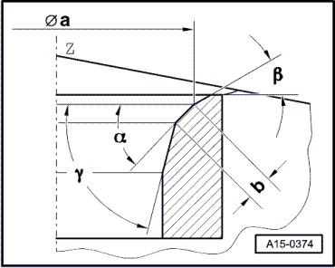
→ Rework valve seats
Inlet valve seat
a | = | ø26.2 mm
b | = | 1.5 ... 1.8 mm
Z | = | Lower surface of cylinder head
α | = | 45°valve seat angle
β | = | 30°upper correction angle
γ | = | 60°lower correction angle

Exhaust valve seat
a | = | ø29.0 mm
b | = | approx. 1.8 mm
Z | = | Lower surface of cylinder head
α | = | 45°valve seat angle
β | = | 30°upper correction angle
γ | = | 60°lower correction angle

Replace sealing rings of cylinder heads
Renewing camshaft oil seals

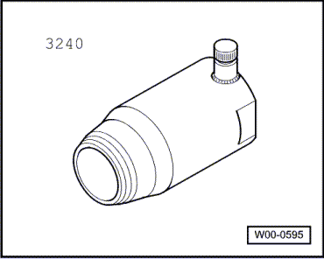
Special tools and workshop equipment required
- ◆ Special tool 3240

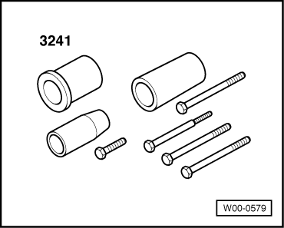
- ◆ Fitting tool 3241
Removing
Note:
If the sealing ring leaks on one side it is recommended to replace both sides.

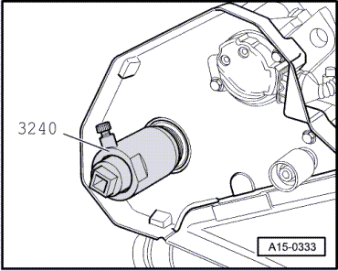
- ‒ Remove toothed belt from camshaft sprockets => Page 13-18.
- ‒ Adjust inner part of oil seal extractor 3240 until it is flush with the outer part and lock in position with knurled screw.
- ‒ → Lubricate threaded head of oil seal extractor 3240, place it in position and, exerting firm pressure, screw it into oil seal as far as possible.
- ‒ Loosen knurled screw and turn inner part of extractor against camshaft until oil seal has been extracted.
- ‒ Clamp flats of oil seal extractor in vice. Remove oil seal with pliers.
- ‒ Clean contact surface and sealing surface.
Installing

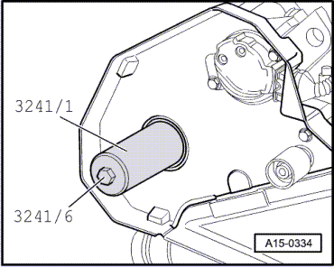
- ‒ Do not lubricate sealing lip and outer edge.
- ‒ Fit sleeve from insertion tool 3241/2 from puller sleeve 3241/1onto the camshaft.
- ‒ → Use insertion tool 3241/1 and bolt 3241/6 to press in seal until it is flush with the cylinder head.
- ‒ Install toothed belt => Page 13-23.

Replace sealing rings of cylinder heads
Replace sealing ring for Hall sender - right cylinder head
Special tools and workshop equipment required

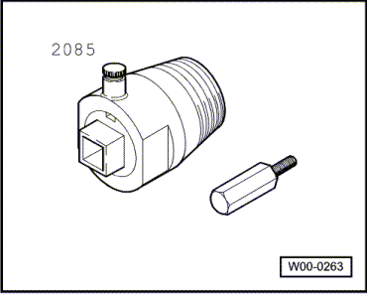
- ◆ Oil seal extractor 2085

- ◆ Puller sleeves 3241

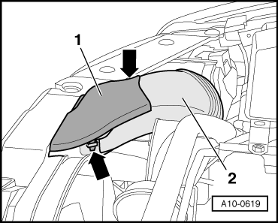
Removing
- ‒ → Unclip cover for belt guide -1-
- ‒ Remove suction hose -2- to air cleaner.

- ‒ → Counterhold pulley for viscous fan with 2- hole pin wrench 3212 and unscrew viscous fan with claw wrench 3312 (left-hand thread).

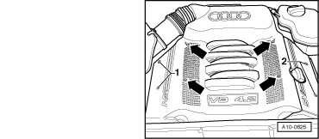
- ‒ → Remove engine cover -arrows-.

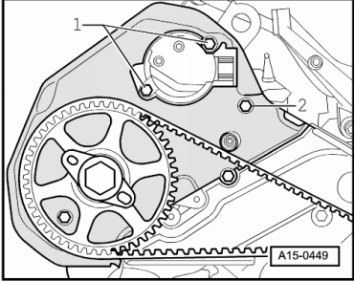
- ‒ Remove the toothed belt guard.
- ‒ Unplug connector from Hall sender.
- ‒ → Unscrew bolts -1-.
- ‒ Release bolt -2-
- ‒ Pull toothed belt guard towards front and remove Hall sender housing.

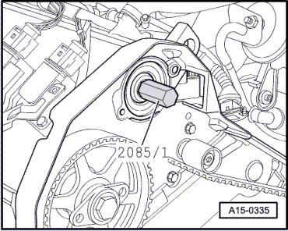
- ‒ → Screw in bolt from seal extractor 2085/Page

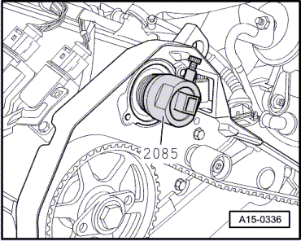
- ‒ → Use seal extractor 2085 and bolt 2085/1 to pull out seal.
Installing
- ‒ Clean contact surface and sealing surface.
- ‒ Do not lubricate sealing lip or outer circumference of seal before pressing in.
- ‒ Attach puller sleeve from insertion tool 3241 onto the camshaft.

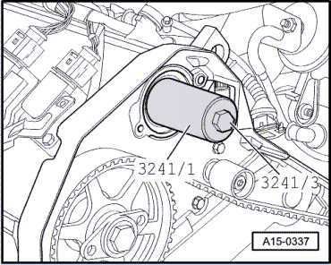
- ‒ → Use insertion tool 3241/1 and bolt 3241/3 to press in seal until it is flush.
- ‒ Screw in Hall sender plate.
- ‒ Install the Hall sender housing.
- ‒ Attach cable plug onto Hall sender.
Tightening torques
Component |  | Nm
Hall sender housing |  | 10
Hall sender plate |  | 23

Replace sealing rings of cylinder heads
Replace sealing ring for Hall sender - left cylinder head
Special tools and workshop equipment required

- ◆ Oil seal extractor 2085

- ◆ Puller sleeves 3241

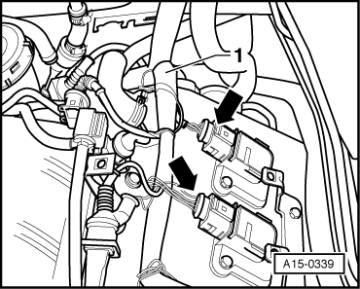
Removing
- ‒ → Detach connector of ignition coils -arrows- and put wiring harness to the side.
- ‒ Unplug connector from Hall sender.
- ‒ Unbolt Hall sender housing (10 Nm).
- ‒ Unbolt Hall sender plate (23 Nm) and lever off carefully with a screwdriver.

- ‒ → Screw in bolt from seal extractor 2085/1.

- ‒ → Use seal extractor 2085 and bolt 2085/1 to pull out seal.
Installing
- ‒ Clean contact surface and sealing surface.
- ‒ Do not lubricate sealing lip or outer circumference of seal before pressing in.
- ‒ Attach puller sleeve from insertion tool 3241 onto the camshaft.

- ‒ → Use insertion tool 3241/1 and bolt 3241/3 to press in seal until it is flush.
- ‒ Screw in Hall sender plate.
- ‒ Install the Hall sender housing.
- ‒ Attach cable plug onto Hall sender.
Component |  | Nm
Hall sender housing |  | 10
Hall sender plate |  | 23

Removing and installing parts of the lubrication system
Removing and installing parts of the lubrication system

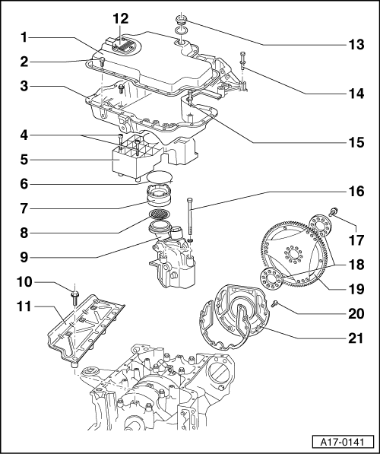

Removing and installing parts of the lubrication system
Sump/oil pump
Note:
Always replace seals and gaskets.
- Bottom part of oil sump
- 10 Nm
- Top part of oil sump
- 10 Nm
- Honeycomb insert
- Circlip

- Rubber intake piece
- Strainer
- Oil pump
  - ◆ Removing => Page 17-11
  - ◆ Replace only as complete unit
- 25 Nm
- Oil splash guard
- Oil level gauge
- 35 Nm
- 25 Nm
- 10 Nm
- 25 Nm

- 60 Nm + 90° further turn
  - ◆ install using locking fluid
=> Parts List
  - ◆ Always replace
- Washer
- Drive plate
  - ◆ On assembly, make sure drive plate has been fitted with pin for ignition point
  - ◆ Pin length 20 to 22 mm from drive plate
- 10 Nm
- Rear sealing flange with oil seal

Removing and installing parts of the lubrication system
Oil filter/Oil cooler

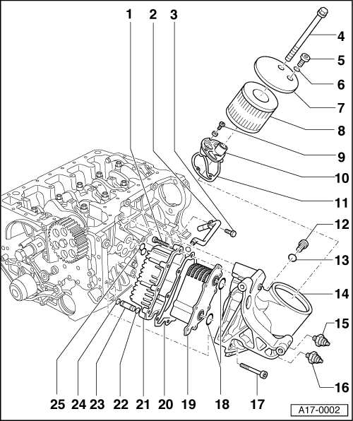
Note:
Always replace seals and gaskets.
- 20 Nm
- Coolant pipe, outlet
- 10 Nm
- 25 Nm
- 50 Nm
- Sealing ring
- Oil filter cover
- Oil filter element

- 10 Nm
- Valve plate with
  - ◆ Relief valve for oil filter and oil cooler
- Gasket
- 50 Nm
- Gasket
- Housing for oil filter and oil cooler
- Oil pressure switch
  - ◆ White 1.8 bar
- Oil pressure switch
  - ◆ Brown 0.3 bar
- 25 Nm

- Sealing ring
- Oil cooler
  - ◆ With coolant circulation
- Gasket
- Housing for oil cooler
  - ◆ With coolant drain screw
- Sealing ring
- Pipe connection
  - ◆ Coolant inlet
- Sealing ring
- Gasket

Removing and installing parts of the lubrication system
Removing and installing lower section of sump
Special tools, testers and auxiliary items required

  - ‒ Electric drill with plastic brush attachment
  - ‒ Silicone sealant
=> Parts List
  - ‒ Torque wrench 10 Nm/45Nm
Removing
- ‒ → Remove noise insulation.

- ‒ Drain engine oil.
- ‒ → Pull connector -1- off oil level gauge.
- ‒ Remove lower part of sump -arrow-.
Installing:

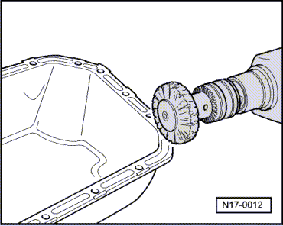
The assembly is carried out in the reverse order to removal, noting the following:
- ‒ Clean sealing surfaces: they must be free of oil and grease.
Important
Wear protective glasses.
- ‒ → Remove sealant residues from sump or engine block, e.g. with rotating plastic brush.
Note:

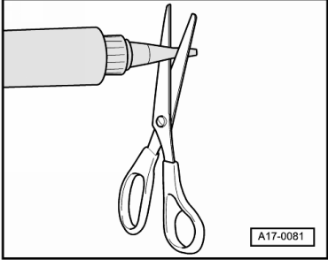
The sump must be installed within 5 minutes after applying the silicone sealant.
- ‒ → Cut off nozzle of tube at front marking (ø of nozzle approx. 3 mm).
  - ‒ Thickness of sealant bead: 2 ... 3 mm
Note:
The bead of sealant must not be thicker than 3 mm, as otherwise excess sealant will enter the sump and obstruct the strainer in the oil intake manifold.
- ‒ Fit sump immediately. Tighten all bolts initially to 5 Nm.
- ‒ Tighten bolts in diagonal sequence to 15 Nm.
- ‒ Attach new sealing ring to oil drain plug and tighten to 30 Nm.
Note:
After fitting sump assembly, the sealant must dry for approx. 30 minutes. Only then may the engine oil be filled.
- ‒ Top up engine oil.
Tightening torques
Component | Nm
Sump (lower section) | 9
Oil drain plug | 50

Removing and installing parts of the lubrication system
Removing oil pump

Removing
- ‒ → Remove noise insulation.

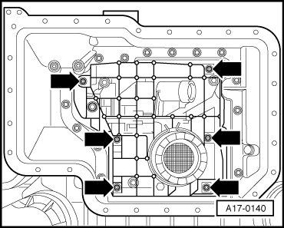
- ‒ Pull out dipstick.
- ‒ Drain engine oil.
- ‒ Remove lower section of oil sump => Page 17-7.
- ‒ → Remove mesh insert -arrows-.

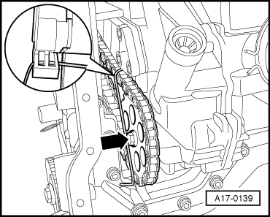
- ‒ → Unscrew bolt -arrow- on chain sprocket of oil pump.
- ‒ Remove chain tensioner with auxiliary tool -arrow-.
- ‒ Unscrew chain sprocket of oil pump.

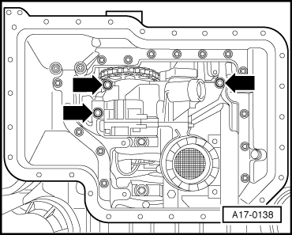
- ‒ Unscrew oil pump -arrows- and pull out downwards.
Installing
Install in reverse order.
Tightening torques
Component |  | Nm
Chain wheel of oil pump |  | 34
Honeycomb insert |  | 9
Oil pump |  | 30
- ‒ Install lower section of sump =>Page 17-8.

Removing and installing parts of the lubrication system
Checking oil pressure switch and oil pressure
Checking oil pressure switch
Visual and acoustic oil pressure indicator
Read measured value block, Audi A8 Workshop Manual, Electrical System
=> Electrical System; Repair group 01; Initiating self-diagnosis of dash panel insert with V.A.G 1551; 08 - Reading measured value block
Test requirements
- ● Measured value block OK
- ● Oil level OK.
- ● Oil pressure warning lamp (K3) must light with ignition switched on.
- ● OK symbol must light (call up symbol) on vehicles with autocheck system.
- ● Engine oil temperature approx. 80 °C (radiator fan must have been in operation once).

Checking oil pressure switch.
- ‒ → Unscrew engine cover.
- ‒ Unscrew and set aside top part of air filter.
- ‒ Remove bottom part of air filter.

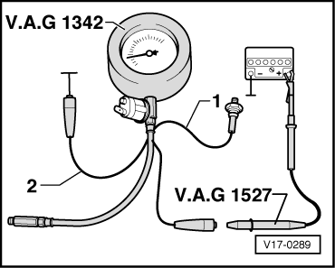
- ‒ → Unscrew oil pressure switch and screw in Adapter V.A.G 1342/3.
- ‒ Screw V.A.G 1342 to adaptor V.A.G 1342/3.
- ‒ Connect wire -2- (brown) to earth (-).
- ‒ Connect wire -1- (blue) to oil pressure switch.
- ‒ Attach diode test lamp V.A.G 1527 to line -1- and battery positive (+).
- ‒ Fit bottom part of air filter.
- ‒ Fit top part of air filter.
- ‒ Start engine and check switching points with the necessary engine speed.
Oil pressure at idling speed | 1 to 2.5 bar
Oil pressure at 3000 rpm | 3 to 5 bar
Notes:
- ◆ 0.3 bar oil pressure switch (brown insulation), switch opens as of 0.15 to 0.45 bar
- ◆ 1.8 bar oil pressure switch (white insulation), switch closes as of 1.6 to 2.0 bar
Checking oil pressure

- ‒ → Unscrew engine cover.
- ‒ Unscrew and set aside top part of air filter.
- ‒ Remove bottom part of air filter.

- ‒ → Unscrew oil pressure switch and screw in oil pressure tester V.A.G 1342.
- ‒ Screw V.A.G 1342 to adaptor V.A.G 1342/3.
- ‒ Screw oil pressure switch into V.A.G 1342.
- ‒ Fit bottom part of air filter.
- ‒ Fit top part of air filter.
- ‒ Start engine.
- ‒ Engine oil temperature at least 80 °C
Oil pressure at idling speed | 1 to 2.5 bar
Oil pressure at 3000 rpm | 3 to 5 bar
Note:
If the oil pressure is far too high (relief valve sticking or incorrectly installed) too much pressure will be exerted on the hydraulic tappets. The engine cuts out shortly after being started and the next time starting is attempted, it is revved at a noticeably high level by the starter due to lack of compression.

Removing and installing parts of the lubrication system
Engine oil
The engine is filled with a high quality multigrade oil at the factory which can be used all year round, except in extremely cold climates.
Viscosity grades and oil specifications
Viscosity grades and oil specifications:
=> Maintenance Manual
Oil system capacity:
=> Exhaust Emissions Test binder
Removing and installing parts of the lubrication system
Check oil level
Notes:
- ◆ Engine must be warm (oil temperature greater than 60 °C) when checking oil level.
- ◆ The vehicle must be standing on level ground when checking the oil level.
- ◆ After switching off the engine wait a few minutes to allow the oil to flow back into the sump.
- ‒ Pull out dipstick, wipe with a clean cloth and insert it again as far as it will go.

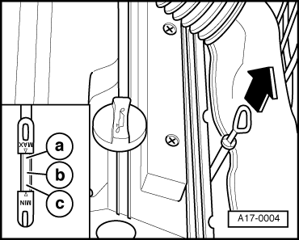
- ‒ Pull out the dipstick again and read off the oil level.
→ Markings on oil dipstick:
- a- - Oilmust not be topped up.
- b- - Oilmay be topped up.
  - After doing so, it may be that the oil level is then in range a.
- c- - Oil must be topped up.
  - After topping up it is sufficient for the oil level to be somewhere in the range b (knurled area).
Oil capacity with filter replacement => Exhaust Emission Test binder
Note:
The oil level must not exceed the max. marking on the dipstick.

Removing and installing parts of the cooling system
Removing and installing parts of the cooling system

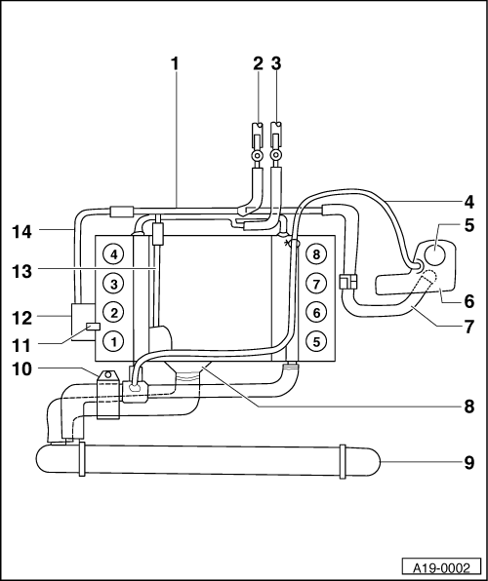
Notes:
- ◆ Renew all gaskets and seals.
- ◆ Drain off and top up coolant =>Page 19-8.
- ◆ Checking cooling system for leaks => Page 19-14.
- Coolant pipe, rear
- From heating-system heat exchanger
  - ◆ With bleeder valve
- To heating-system heat exchanger
  - ◆ With bleeder valve

- Return hose
- Cap for expansion tank
  - ◆ Checking => Page 19-14
- Expansion tank
- Filler hose
- Thermostat
  - ◆ Replacing =>Page 19-6
  - ◆ Start of opening approx. 87°
  - ◆ End of opening approx. 102°
  - ◆ Opening stroke approx. 8 mm
- Radiator
- Bracket for coolant hoses

- Coolant pipe
  - ◆ Connection between oil cooler and engine block
- Oil cooler
- Coolant pipe
- Coolant pipe to oil cooler

Removing and installing parts of the cooling system
Removing and installing coolant pump

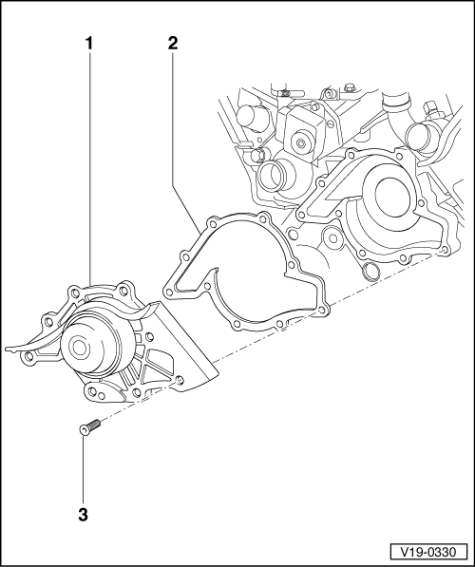
Notes:
- ◆ Always replace seals and gaskets.
- ◆ Drain off and top up coolant =>Page 19-8.
- Coolant pump
  - ◆ Removing => Page 19-5
- Gasket
- 10 Nm
Removing

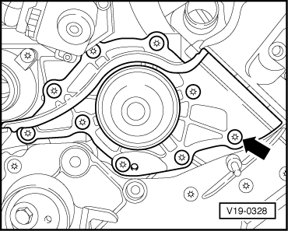
- ‒ Remove toothed belt => Page 13-6.
Note:
The vibration damper does not have to be unbolted or removed.
- ‒ Unscrew toothed belt tensioning pulley.
- ‒ → Remove coolant pump (9 x Torx screws).
Installing
- ‒ Remove coolant pump (9 x Torx screws).
- ‒ Install toothed belt tensioning pulley.
- ‒ Install toothed belt =>Page 13-6.
Tightening torques
Component | Nm
Coolant pump | 14
Toothed belt tensioning pulley | 45

Removing and installing parts of the cooling system
Removing and installing thermostat
Removing

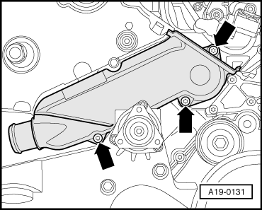
The thermostat is located at the front right of the engine beneath the intake manifold.
- ‒ Drain off the coolant => Page 19-8.
- ‒ Remove the toothed belt from the camshafts => Page 13-18.
- ‒ → Remove thermostat housing -arrows-.
Installing:

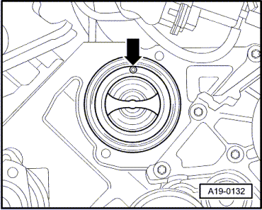
- ‒ → Installation position of thermostat
Starts to open | 87°
Fully open | 102°
Opening travel | 8 mm
Note:
Install with bleeder valve facing upwards.
- ‒ Install thermostat housing.
- ‒ Attach toothed belt onto camshaft sprockets => Page 13-18.
- ‒ Top up the coolant => Page 19-8.
Tightening torques
Component | Nm
Coolant thermostat housing | 10

Removing and installing parts of the cooling system
Draining and filling cooling system
Notes:
- ◆ To prevent frost damage and corrosion and to raise the boiling point of the coolant, the specified coolant additive must be used in the cooling system at all times of the year.
- ◆ Recommended mixture ratio: 50:50
- ◆ Capacity approx. 9.0 l
- ◆ Only use coolant G12.
Important
The coolant additives -G11- and -G12- are not to be mixed. Otherwise, this can result in serious damage to the engine.
Identifying coolant additive
-G11- | Colour | green
-G12- | Colour | red
mixed | Colour | brown1)
1) Replace coolant immediately

Draining coolant
- ‒ Carefully unscrew filler cap on expansion tank to relieve pressure.
- ‒ → Remove noise insulation.
- ‒ Remove vent grille in bumper on left.

- ‒ → Attach auxiliary hose -1- to connection.
- ‒ Place container V.A.G 1306 under the engine.
- ‒ Drain coolant at bottom left of radiator -arrow-

- ‒ → Drain coolant at drain plug -arrows-.
Filling
Notes:
- ◆ The cooling system is filled all year round with a mixture of water and antifreeze/corrosion protection agent.
- ◆ Only use coolant additive G 012 A8 D - meeting specification TL VW 774 D.
Identification: red colour
Important
The two different coolant additives G 011 A8 C and G 012 A8 D must not be mixed together. Otherwise, this can result in serious damage to the engine.
- ◆ If the fluid in the expansion tank is brown, this means G 012 A8 D has been mixed with another type of coolant. In this case, flush out the cooling system and fill with fresh coolant. To flush the system, fill it with clean water and run the engine for about 2 minutes. This should remove as much of the old coolant as possible.
- ◆ G 012 A8 D and coolant additives marked "meeting specification TL VW 774 D" prevent frost and corrosion damage, stop scaling and at the same time raise the boiling point of coolant. For these reasons the cooling system must be filled all year round with the correct anti freeze and anti corrosion additive.
- ◆ Because of its high boiling point, the coolant improves engine reliability under heavy loads, particularly in countries with tropical climates.
- ◆ Protection against frost must be assured to about -25 °C (in countries with an arctic climate to about -35 °C).
- ◆ The coolant concentration must not be reduced by adding water even in warmer seasons and in warmer countries. The anti freeze ratio must be at least 40 %.

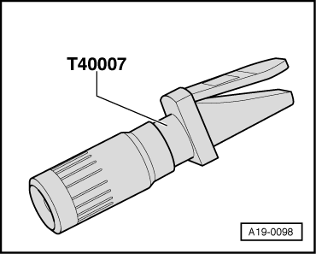
- ◆ If greater frost protection is required in very cold climates, the amount of G 012 A8 D can be increased, but only up to 60 % (this gives frost protection to about -40 °C), as otherwise frost protection is reduced again and cooling effectiveness is also reduced.
- ◆ If radiator, heat exchanger, cylinder head or cylinder head gasket is replaced, do not reuse old coolant.
- ◆ → Use special tool T40007 to check frost protection of coolant additive G012 A8 D in cooling system.
- ‒ Close drain cock at radiator and pull hose off connection piece.
- ‒ Screw in (20 Nm) the two coolant drain screws on the left and right of the engine block. Replace gaskets.
- ‒ Switch ignition on.
- ‒ Set air conditioner to HI.
- ‒ Switch off ignition.
- ‒ Open bleeder screw at heating-system heat exchanger approx. 2 turns.
- ‒ Put in coolant. Squeezing the top hose several times will help to force out the air.
- ‒ Allow engine to warm up. Leave AC set to HI until a coolant temperature of slightly less than 100 °C is indicated. The engine is to be warmed up at a speed of between 2000 and 3000 rpm with several brief increases to 4000 and 5000 rpm.
- ‒ Stop engine. Wait for about 5 - 10 minutes and then carefully open filler cap on expansion tank (system will be under pressure).
- ‒ Top up coolant to max. mark.
- ‒ Close filler cap on expansion tank.
- ‒ Run engine and repeat topping up procedure as necessary.

Removing and installing parts of the cooling system
Checking cooling system for leaks

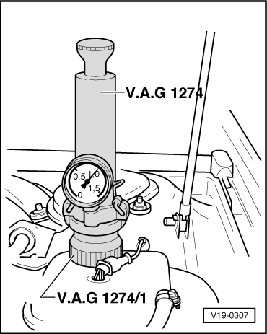
Note:
Engine must be at operating temperature.
- ‒ → Fit tester VW 1274 with adapter VW 1274/1 on expansion tank.
- ‒ Using hand pump on tester, build up a pressure of approx. 1.0 bar. If this pressure is not maintained, locate and rectify leaks.

Removing and installing parts of the cooling system
Checking relief valve in cap

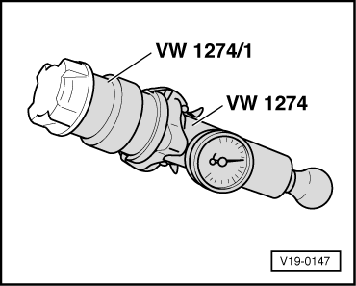
- ‒ → Fit filler cap on tester.
- ‒ Build up pressure with hand pump.
Pressure relief valve should open at an overpressure of 1.2 - 1.5 bar.

Removing and installing parts of the cooling system
Removing and installing viscous fan

Special tools, testers and auxiliary items required
- ◆ Special tool 3212
- ◆ Special tool 3312
Removing
- ‒ Remove suction hose to air cleaner.
- ‒ → Unscrew vent ring for the viscous fan -arrows-.

- ‒ → Counterhold pulley for viscous fan with 2- hole pin wrench 3212 and unscrew viscous fan with claw wrench 3312 (left-hand thread).
- ‒ Remove viscous fan with vent ring.
Installing
Installation is carried out in the reverse order; note the following:

- ‒ Install viscous fan with vent ring (left-hand thread).
- ‒ → Counterhold pulley for viscous fan with 2-hole pin wrench 3212 and unscrew viscous fan with clamp wrench 3312 (left thread).
Tightening torques
Component |  | Nm
Viscous fan with torque wrench 1331 and open-end wrench 3312 |  | 37
Viscous fan with torque wrench without open-end wrench 3312 |  | 70
Vent ring to radiator |  | 10

Removing and installing exhaust system, engine code AQG
Removing and installing exhaust system, engine code AQG

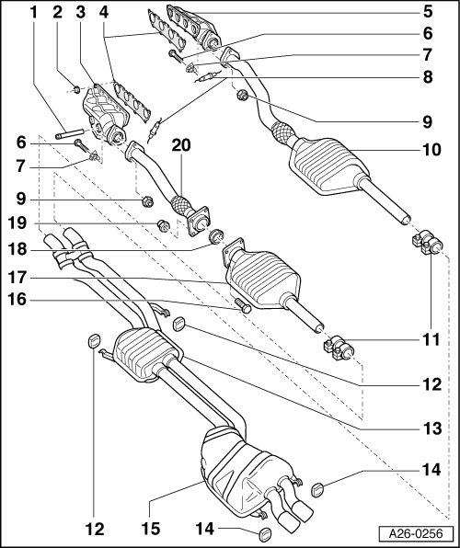
Notes:
- ◆ Stress-free alignment of exhaust system,=> Page 26-15
- ◆ Checking exhaust system for leaks=> Page 26-20
- ◆ Joint between centre and rear silencer => Fig.1
- ◆ Renew all gaskets and hexagon nuts.
- ◆ Retainers of centre and end silencer are identical but have different elasticity (refer to parts film).
- ◆ Removing and installing exhaust manifold => Page 26-6.
- Hexagon nut 25 Nm

- Hexagon nut 25 Nm
- Exhaust manifold, left
- Exhaust manifold gaskets
  - ◆ Metal side of gaskets must be facing cylinder head
- Exhaust manifold, right
- Hexagon bolt
- Locking device
- Lambda probes, 50 Nm
  - ◆ Testing
=> Motronic Injection and Ignition System (8-cylinder); Repair group 24: Testing lambda control
  - ◆ Grease thread with G5. Keep grease away from slits in probe body.

- Hexagon nut 25 Nm
  - ◆ Always replace
- Exhaust pipe, front with catalytic converter, right
- Twin clamp
  - ◆ Tighten evenly, 40 Nm
  - ◆ Installation position => Page 26-17
  - ◆ Always replace after unfastening union.
- Retainer
  - ◆ Same appearance as retainer (item 11) but different elasticity
  - ◆ Hexagon bolts for attaching bracket to floor group, 25 Nm
- Centre silencer

- Retainer
  - ◆ Same appearance as retainer (item 9) but different elasticity
  - ◆ Hexagon bolts for attaching bracket to floor group, 25 Nm
- Rear silencer
  - ◆ Checking pretension of exhaust system => Page 26-18 rear silencer alignment
  - ◆ Tailpipe alignments => Page 26-18
- Hexagon bolt
- Catalytic converter, left.
- Sealing ring
- Hexagon nut 25 Nm
  - ◆ Always replace
- Exhaust pipe, front left

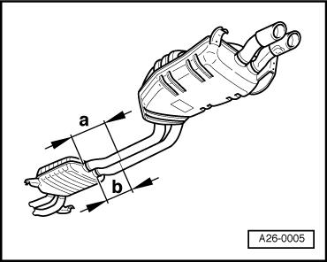
→ Fig.1 Separating point between centre and rear silencers
- ‒ A joint is provided for replacing the centre/rear silencer.
- ‒ Detach connecting pipe between centre and rear silencer at locations marked by a groove:
- ‒ Dimension -a- approx. 240 mm
- ‒ Dimension -b- approx. 200 mm
- ‒ Two short twin clamps are provided for connection of centre and rear silencer.
- ‒ Installation position of twin clamps at rear => Page 26-19.
- ‒ Ends of bolts must not be lower than bottom edge of clamping sleeve.
- ‒ Tailpipe alignment => Page 26-18
- ‒ Rear silencer alignment, => Page 26-18

Removing and installing exhaust system, engine code AQG
Removing and installing exhaust manifold
Removing

- ‒ Remove engine => Page10-1.
For left exhaust manifold only
- ‒ → Remove oil dipstick guide tube -arrow-.

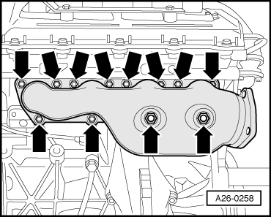
Both exhaust manifolds
- ‒ → Unscrew exhaust manifold -arrows-.
Installing
Notes:
- ◆ Fit new self-locking nuts.
- ◆ Renew seals and gaskets.
- ◆ Replace sealing ring for oil dipstick guide tube.
- ‒ Install in reverse order.
Tightening torques
Bolted joint |  | Tightening torques
Exhaust manifold to cylinder head |  | 25 Nm
Dipstick guide tube to cylinder head |  | 22 Nm

Removing and installing exhaust system, engine code AQG
Removing and installing front exhaust pipe with catalytic converter

Notes:
- ◆ Always replace seals, gaskets and self-locking nuts.
- ◆ The isolating element in front exhaust pipe must not be deflected more than 10°to avoid damage..
Removing
- ‒ → Remove engine cover -arrows-.
- ‒ Remove cover above left cylinder head.

- ‒ → Unclip hose -1- from bracket and set aside.
- ‒ Unscrew bracket -2-.
- ‒ Release upper bolt of connection exhaust manifold/exhaust pipe.

- ‒ → Disconnect the cable for the lambda probe on the bulkhead.

- ‒ → Detach connecting bolts -arrows- exhaust manifold/front exhaust pipe from below.

- ‒ → Unscrew exhaust pipe from retainer
-arrow-.

- ‒ → Release double clamp -1- and push it forward.
- ‒ Carefully remove exhaust pipe.
Note:
The isolating element in front exhaust pipe must not be deflected more than 10° to avoid damage.
Installing
Installation is carried out in the reverse order; note the following:
- ‒ Stress-free alignment of exhaust system => Page 26-15
Tightening torques
Component |  | Nm
Front exhaust pipe with catalytic converter to mounting lug |  | 25
Front exhaust pipe with catalytic converter to exhaust manifold |  | 25
Clamping sleeve for exhaust pipe |  | 40

Removing and installing exhaust system, engine code AQG
Removing and installing front exhaust pipe with catalytic converter

Notes:
- ◆ Always replace seals, gaskets and self-locking nuts.
- ◆ The isolating element in front exhaust pipe must not be deflected more than 10°to avoid damage.
Removing
- ‒ → Remove engine cover -arrows-.

- ‒ → Remove air intake pipe -arrows- between air cleaner and throttle valve unit.

- ‒ → Disconnect the cable for the lambda probe on the bulkhead and set aside.

- ‒ Remove the right wheel.
- ‒ Release upper bolt of connection exhaust manifold/exhaust pipe (accessible through opening of track rod).
- ‒ → Detach connecting bolts -arrows- exhaust manifold/front exhaust pipe from below.

- ‒ → Unscrew exhaust pipe from bracket -arrow-

- ‒ → Release double clamp -2- and push it forward.
- ‒ Carefully remove exhaust pipe.
Note:
The isolating element in front exhaust pipe must not be deflected more than 10°to avoid damage.
Installing
Installation is carried out in the reverse order; note the following:
- ‒ Stress-free alignment of exhaust system => Page 26-15
Tightening torques
Component |  | Nm
Front exhaust pipe with catalytic converter to mounting lug |  | 25
Front exhaust pipe with catalytic converter to exhaust manifold |  | 25
Wheel front left |  | 110

Removing and installing exhaust system, engine code AQG
Stress-free exhaust system alignment, engine code AQG
Perform stress-free alignment of exhaust system as follows to avoid noise and corrosion.
Notes:
- ◆ When performing stress-free exhaust system alignment, make sure that silencer system mounts are fitted free of stress.
- ◆ Unfasten all screw connections of exhaust system (except exhaust manifold) including catalytic converter mounting.
- ◆ The exhaust system is aligned when cold.
- ◆ The following work must be performed in the specified sequence.
- ◆ The dimensions illustrated are approximate.

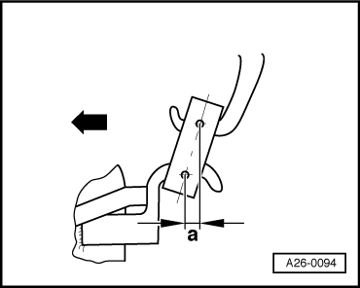
- ‒ → Check pretension at left retainer on centre silencer.
- ‒ Dimension -a- 10 -12mm
- ‒ Arrow faces in direction of travel.

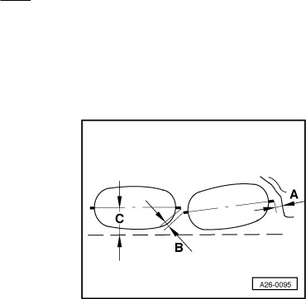
Catalytic converter alignment
- ‒ → Dimension -A- = 13 - 17 mm
- ‒ Dimension -B- 9 mm
- ‒ -C- parallel with bottom edge of vehicle
- ‒ Catalytic converters are shown from rear in direction of travel.
Note:
Distance between pipes and cross member must be at least 34 mm.
Installation position of twin clamps between catalytic converters and centre silencer.

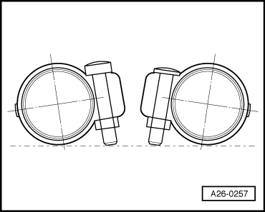
Notes:
- ◆ Twin clamps are to be replaced after unfastening screw connection.
- ◆ Twin clamps are shown from rear in direction of travel.
- ‒ → Align screw connection of double clamp as illustrated. End of bolts must not be lower than bottom edge of clamping sleeve.
- ‒ Tightening torque of hexagon nut: 40 Nm.
Aligning tailpipes

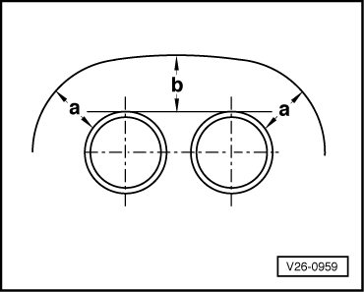
- ‒ → Distance -a- right = Distance -a- left
- ‒ Distance -b- between bumper recess at top and tailpipe must be at least 20 mm.
Rear silencer alignment

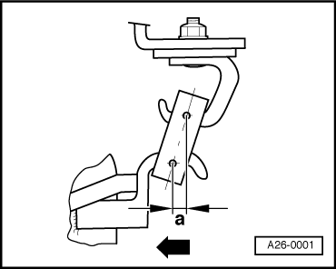
- ‒ → The illustration shows the rear left mounting on the rear silencer.
- ‒ Pretension -a- = 10-12 mm is to be corrected by adjustment in twin clamps between centre and rear silencer.
- ‒ Arrow faces in direction of travel.

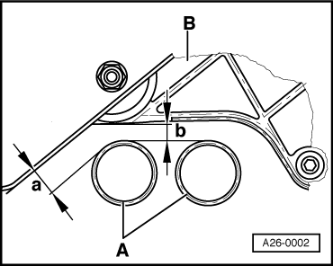
- ‒ → Distance of exhaust pipes -A- from rear axle -B- (between centre and rear silencer):
Dimension -a- approx. 27 mm
Dimension -b- approx. 24.5 mm
Note:
Exhaust pipes -A- are shown from rear in direction of travel.
Installation position of twin clamps at rear

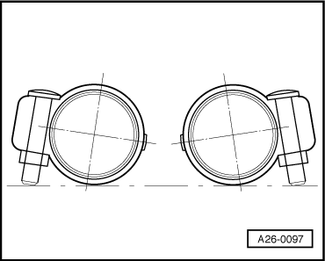
Notes:
- ◆ Squeeze together pipes of centre/end silencer as far as they will go.
- ◆ Twin clamps are to be replaced after unfastening screw connection.
- ◆ Twin clamps are shown from rear in direction of travel.
- ‒ → Align screw connection of double clamp as illustrated. End of bolts must not be lower than bottom edge of clamping sleeve.
- ‒ Tightening torque of hexagon nut: 40 Nm.

Removing and installing exhaust system, engine code AQG
Testing exhaust system for leaks, engine code AQG
The exhaust system is to be checked for leaks as follows:
- ‒ Run engine.
- ‒ Plug tailpipes (with rags or stoppers, etc.) until check is completed.
- ‒ Connection points:
Check cylinder head/manifold, manifold/front exhaust pipe etc. for leaks by listening.
- ‒ Eliminate any leaks found.

