Checking auxiliary signals
Checking engine mounting
(Not installed in all vehicles)
The hydraulically damped engine mountings with electric actuation prevent that oscillations of the engine are transferred to the body throughout the entire speed range.
In idling operation the engine mountings are soft.
In driving operation the engine mountings are hard.
- ‒ Switch the ignition on.
- ‒ Perform final control diagnosis and actuate engine mounting => Page 01-72.

→ Indicated on display:
  Final control diagnosis ⇒
  Valve left for engine mounting -N144
- ‒ Press ⇒key.

→ Indicated on display:
  Final control diagnosis ⇒
  Valve right for engine mounting -N145
Upon actuation of engine mounting, both solenoid valves should give a clearly audible click.
If specified value is not attained, perform the following tests:
Checking voltage supply of engine mountings

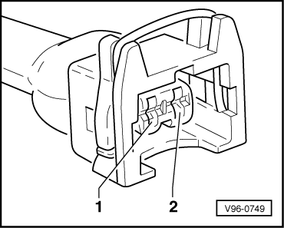
- ‒ Disconnect connector from relevant solenoid valve.
- ‒ → Connect diode test lamp V.A.G 1527 between engine earth and socket 1 (positive) on connector using cables from adapter set V.A.G 1594.
- ‒ Operate the starter for a few seconds. Engine may start.
The diode test lamp should illuminate.
If the diode test lamp does not illuminate, carry out the following tests:

- ‒ Checking fuse for engine mounting.
=> Current Flow Diagrams, Electrical Fault-finding and Fitting Locations binder
If the fuse is OK:
- ‒ → Check the wiring from socket 1 via the fuse to the fuel pump relay for continuity.
=> Current Flow Diagrams, Electrical Fault-finding and Fitting Locations binder
Checking actuation of engine mounting

- ‒ Disconnect connector from relevant engine mounting.
- ‒ → Connect diode test lamp V.A.G 1527 between sockets 1 (positive) and 2 on connector for intake air changeover solenoid valve using cables from adapter set V.A.G 1594.
- ‒ Actuate final control diagnosis and actuate relevant engine mounting => Page 01-72.
The diode test lamp should flash upon actuation of engine mounting.

If the diode test lamp is continuously lit:
- ‒ → Check wiring connections from socket 2 of the relevant connector for the engine mounting for earth short.
If the diode test lamp does not flash:
Checking wiring
- ‒ Connect test box V.A.G 1598/31 to wiring harness for engine control unit; do not connect the engine control unit => Page 24-12.

- ‒ → Check wiring connection of the relevant connector for engine mounting for open circuits as well as shorts to positive.
2-pin connector on wiring harness, contact | Test box V.A.G 1598/31, socket
Engine mounting 1 -N144  2 | 105
Engine mounting 2 -N145  2 | 116
Wire resistance: max. 1.5 Ohm
- ‒ Rectify any open/short circuit as necessary.
=> Current Flow Diagrams, Electrical Fault-finding and Fitting Locations binder
If no short or open circuit is found.
- ‒ Replace the relevant engine mounting.

