Audi A8 | Fitting Locations | No. 201 / 1
 |  | Edition 02.2006

Position of relays and fuses

Fuses in fuse holder, left dash panel

Fuse colours

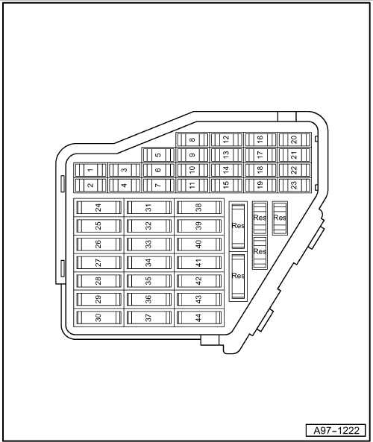
40 A - | orange

30 A - | green

25 A - | white

20 A - | yellow

15 A - | blue

10 A - | red

7,5 A - | brown

5 A - | beige

3 A - | purple

1 A - | black

Audi A8 | Fitting Locations | No. 201 / 2

Fuses in fuse holder, left dash panel

No. |  | Current Flow Diagram designation | Nominal value |  | Function/component |  | Terminal
1 | - | SB1 - Fuse 1 on fuse holder | 5A | - | J530 - | Garage door operation control unit | 15
2 | - | SB2 - Fuse 2 on fuse holder | 10A  5A* | - | J446 - | Parking aid control unit | 30
3 | - | SB3 - Fuse 3 on fuse holder | 5A | - | J446 - | Parking aid control unit | 15
4 | - | SB4 - Fuse 4 on fuse holder | 10A | - | J431 -  V48 -  V49 - | Headlight range control, control unit  left headlight range control motor  right headlight range control motor | 15
5 | - | SB5 - Fuse 5 on fuse holder | 10A  5A* | - | J285 -  J533 - | Control unit in dash panel insert  Data bus diagnostic interface | 30
6 | - | SB6 - Fuse 6 on fuse holder | 10A | - | J527 - | Steering column electronics control unit | 30
7 | - | SB7 - Fuse 7 on fuse holder | 5A | - | T16 - | Diagnosic connetion | 30
8 | - | SB8 - Fuse 8 on fuse holder | 5A | - | T16 -  G266 - | Diagnostic connector  Oil level and oil temperature sender* | 15
9 | - | SB9 - Fuse 9 on fuse holder | 10A  5A* | - | J104 -  J527 - | ABS control unit with ESP  Steering column electronics control unit | 15
10 | - | SB10 - Fuse 10 on fuse holder | 5A | - | J533 -  G266 - | Data bus diagnostic interfaces  Oil level and oil temperature sender** | 15
11 | - | Vacant |  | -
12 | - | SB12 - Fuse 12 on fuse holder | 5A | - | F - | Brake light switch | 30
13 | - | SB13 - Fuse 13 on fuse holder | 10A | - | R36 -  J526 -  J412 -  R115 - | Telephone transmitter and receiver unit  Telephone and telematics control unit  Mobile telephone operating electronics control unit  Chip card reader for telephone | 30

* - from model year 2004

** - up to model year 2003

Audi A8 | Fitting Locations | No. 201 / 3

No. |  | Current Flow Diagram designation | Nominal value |  | Function/component |  | Terminal
14 | - | SB14 -Fuse 14 on fuse holder | 5A | - | J608 - | Special vehicle control unit# | 30
15 | - | SB15 -Fuse 15 on fuse holder | 5A | - | E408 - | Entry and start authorisation button | 30
16 | - | SB16 -Fuse 16 on fuse holder | 10A | - |  | Rear-Seat-Entertainment | 15
17 | - | SB17 - Fuse 17 on fuse holder | 10A  5A* | - | J428 -  Z47 - | Adaptive cruise control unit  Sensor heater for adaptive cruise control system** | 15
18 | - | SB18 -Fuse 18 on fuse holder | 5A | - | Z20 -  Z21 - | Left washer jet heater element  Right washer jet heater element | 75
19 | - | SB19 - Fuse 19 on fuse holder | 15A  10A# | - | J711 -  J608 - | Washer fluid heater relay**  Special vehicle control unit# | 75  30
20 | - | SB20 -Fuse 20 on fuse holder | 5A | - | J502 - | Tyre pressure monitor control unit | 30
21 | - | SB21 -Fuse 21 on fuse holder | 5A | - | J608 - | Special vehicle control unit# | 15
22 | - | SB22 -Fuse 22 on fuse holder | 5A | - | F47 - | Brake pedal switch | 87
23 | - | SB23 -Fuse 23 on fuse holder | 5A | - |  | Card system Italy (Telepass) | 30
24 | - | SB24 - Fuse 24 on fuse holder | 15A | - | J4 -  H2 -  H7 - | Dual tone horn relay  Treble tone horn  Bass tone horn | 30
25 | - | SB25 -Fuse 25 on fuse holder | 40A | - | J400 - | Wiper motor control unit | 30
26 | - | SB26-Fuse 26 on fuse holder | 30A  15A# | - | U18 -  U19 -  J608 - | 12 V socket 2**  12 V socket 3**  Special vehicle control unit# | 30
27 | - | SB27 -Fuse 27 on fuse holder | 25A | - | J104 - | ABS control unit | 30
28 | - | Vacant
29 | - | SB29 -Fuse 29 on fuse holder | 1A | - |  | Switch illumination | 58s

* - from model year 2004

** - up to model year 2004

# - from model year 2006

Audi A8 | Fitting Locations | No. 201 / 4

No. |  | Current Flow Diagram designation | Nominal value |  | Function/component |  | Terminal
30 | - | Vacant |  | -
31 | - | SB31 - Fuse 31 on fuse holder | 30A | - | J519 - | Onboard supply control unit | 30
32 | - | Vacant |  | -
33 | - | SB33 - Fuse 33 on fuse holder | 25A | - | Z42 - | Rear left footwell heater element | 75
34 | - | Vacant |  | -
35 | - | Vacant |  | -
36 | - | Vacant |  | -
37 | - | SB37 - Fuse 37 on fuse holder | 15A | - | J698 - | Refrigerator box** | 15
38 | - | SB38 - Fuse 38 on fuse holder | 30A | - | J519 - | Onboard supply control unit | 30
39 | - | SB39 - Fuse 39 on fuse holder | 15A  7.5A* | - | J386 - | Driver door control unit | 30
40 | - | SB40 - Fuse 40 on fuse holder | 25A | - | J519 -  V123 -  V124 - | Onboard supply control unit  Steering column vertical adjustment motor  Steering column axial adjustment motor | 30
41 | - | SB41 - Fuse 41 on fuse holder | 15A  7.5A* | - | J388 - | Rear left door control unit | 30
42 | - | SB42 - Fuse 42 on fuse holder | 25A | - | J518 - | Entry and start authorisation control unit | 30
43 | - | SB43 - Fuse 43 on fuse holder | 10A | - |  | Left headlight with cornering lights** | 15
44 | - | SB44 - Fuse 44 on fuse holder | 10A | - |  | Right headlight with cornering lights** | 15

* - from model year 2004

** - from model year 2006

Audi A8 | Fitting Locations | No. 201 / 5

Position of relays and fuses

Fuses in fuse holder, right dash panel

Fuse colours

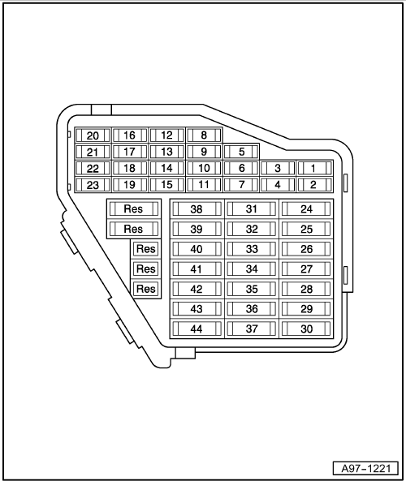
40 A - | orange

30 A - | green

25 A - | white

20 A - | yellow

15 A - | blue

10 A - | red

7,5 A - | brown

5 A - | beige

3 A - | purple

1 A - | black

Audi A8 | Fitting Locations | No. 201 / 6

Fuses in fuse holder, right dash panel

No. |  | Current Flow Diagram designation | Nominal value |  | Function/component |  | Terminal
1 | - | SC1-Fuse 1 on fuse holder | 5A | - | J540 - | Electric park and handbrake control unit | 15
2 | - | SC2 - Fuse 2 on fuse holder | 10A | - | J255 - | Climatronic control unit | 30
3 | - | SC3 - Fuse 3 on fuse holder | 5A | - | F189 -  F305 -  N110 -  J624 - | Tiptronic switch  Gear selector position P switch  Selector lever lock solenoid  Engine control unit 2 (6.0 l petrol engine) | 15
4 | - | SC4 - Fuse 4 on fuse holder | 15A | - | J217 - | Automatic gearbox control unit (multitronic®) 01J, 01T | 87
5 | - | SC5 - Fuse 5 on fuse holder | 15A | - | J299 -  N112 -  G70 -  N18 -  N145 -  N382 -  J338 -  J724 -  V157 - | Secondary air pump relay  Secondary air inlet valve  Air mass meter  Exhaust gas recirculation valve  Right electrohydraulic engine mounting solenoid valve  Torque rod valve  Throttle valve module  Turbocharger 1 control unit  Intake manifold flap motor | 87
6 | - | SC6 - Fuse 6 on fuse holder | 15A | - | G39 -  G108 - | Lambda probe  lambda probe 2 | 87
7 | - | SC7 - Fuse 7 on fuse holder | 15A  10A | - | G130 -  G131 -  N276 -  N290 - | Lambda probe after catalytic converter  Lambda probe 2 after catalytic converter  Fuel pressure regulating valve (TDI)  Fuel metering valve | 87

Audi A8 | Fitting Locations | No. 201 / 7

No. |  | Current Flow Diagram designation | Nominal value |  | Function/component |  | Terminal
8 | - | SC8 - Fuse 8 on fuse holder | 10A | - | N205 -  N208 -  N382 -  N321 -  N213 -  N144 -  J544 -  J725 -  V51 -  V275 - | Inlet camshaft control valve 1  Inlet camshaft control valve 2  Torque rod valve  Exhaust flap 1 valve  Exhaust gas recirculation valve 2  Left electrohydraulic engine mounting solenoid valve  Throttle valve module 2  Turbocharger 2 control unit  continued coolant circulation pump  Intake manifold flap 2 motor | 87
9 | - | SC9 - Fuse 9 on fuse holder | 5A | - | G238 -  E265 -  E128 - E129 -  G65 -  J255 -  E256 - | Air quality sensor  Rear Climatronic operating and display unit  Heated left driver seat switch  Heated right driver seat switch  High pressure sender  Climatronic control unit  TCS and ESP button | 15
10 | - | SC10 -Fuse 10 on fuse holder | 10A | - | J197 - | Adaptive suspension control unit | 15
11 | - | SC11 -Fuse 11 on fuse holder | 5A | - | G397 - | Rain and light detector sensor | 30
12 | - | SC12 -Fuse 12 on fuse holder | 5A | - | J523 - | Front information display and operating unit control unit | 30
13 | - | SC13 -Fuse 13 on fuse holder | 10A | - | J528 - | Roof electronics control unit | 30
14 | - | SC14 - Fuse 14 on fuse holder | 5A | - | R41 -  R92 -  R129 - | CD changer  CD ROM drive  Video recorder / DVD player | 30
15 | - | SC15 -Fuse 15 on fuse holder | 5A | - | J644 - | Energy management control unit | 30
16 | - | SC16 -Fuse 16 on fuse holder | 5A  7.5A | - | N79 -  N79 - | Heater element for crankcase breather (V8 TDI) (up to model year 05)  Heater element for crankcase breather (V8 TDI) (from model year 06) | 87

Audi A8 | Fitting Locations | No. 201 / 8

No. |  | Current Flow Diagram designation | Nominal value |  | Function/component |  | Terminal
17 | - | SC17 - Fuse 17 on fuse holder | 5A* | - | V7 -  V177 - | Vacant  Radiator fan  Radiator fan 2 | 87
18 | - | SC18 - Fuse 18 on fuse holder | 5A | - | L34 -  J234 -  J706 - | Map reading light bulb (up to 12/02)  Vacant (from → 201/3 )  Airbag control unit**  Seat occupied recognition control unit (only USA)** | 15
19 | - | SC19 - Fuse 19 on fuse holder | 5A | - | G70 - | Air mass meter (TDI) | 15
20 | - | SC20 - Fuse 20 on fuse holder | 5A | - | J672 -  J673 -  J526 - | Driver seat ventilation control unit  Front passenger seat ventilation control unit  Telephone / telematics control unit (USA) | 75
21 | - | SC21 - Fuse 21 on fuse holder | 5A  15A | - | J271 -  J623 -  J248 - | Motronic current supply relay  Engine control unit (petrol engine)  Diesel direct injection system control unit | 30
22 | - | SC22 - Fuse 22 on fuse holder | 10A | - | V166 -  J445 - | Fuel cooling pump (TDI)  Fuel cooling pump relay | 30
23 | - | SC23 - Fuse 23 on fuse holder | 5A | - | F321 - | Parking brake contact switch | 30
24 | - | SC24 - Fuse 24 on fuse holder | 20A  10A* | - | J520 - | Onboard supply control unit 2 | 30
25 | - | SC25 - Fuse 25 on fuse holder | 15A | - | J217 - | Automatic gearbox control unit 09E | 30
26 | - | SC26 - Fuse 26 on fuse holder | 15A  10A* | - | J255 -  E265 - | SClimatronic control unit  Rear Climatronic operating and display unit | 30

* - from model year 2004

** - from model year 2005

Audi A8 | Fitting Locations | No. 201 / 9

No. |  | Current Flow Diagram designation | Nominal value |  | Function/component |  | Terminal
27 | - | SC27 - Fuse 27 on fuse holder | 20A | - | J245 - | Sliding sunroof adjustment control unit | 30
28 | - | SC28 - Fuse 28 on fuse holder | 15A  5A* | - | J623 -  J248 -  J17 -  J49 -  J569 - | Engine control unit  Diesel direct injection system control unit  Fuel pump relay  Electric fuel pump 2 relay  Brake servo relay | 15
29 | - | SC29 - Fuse 29 on fuse holder | 20A  15A* | - | N30.. - | Injectors | 87
30 | - | SC30 - Fuse 30 on fuse holder | 30A | - | N... -  J623 - | Ignition coils with output stage  Engine control unit | 87
31 | - | SC31 - Fuse 31 on fuse holder | 20A | - | G23 -  N115 -  V144 - | Right fuel pump  Active charcoal filter system solenoid valve 2 (USA)  Fuel system diagnostic pump (USA) | 87
32 | - | SC32 - Fuse 32 on fuse holder | 15A  10A*  5A | - | J217 -  J217 - | Automatic gearbox control unit (multitronic®) 01J, 01T  Automatic gearbox control unit 09E, 09L | 15
33 | - | SC33 -Fuse 33 on fuse holder | 25A | - | Z43 - | Rear right footwell heater element | 75
34 | - | SC34 - Fuse 34 on fuse holder | 20A | - | E265 - | Seat heating/rear seat ventilation  Rear Climatronic operating and display unit | 30
35 | - | SC35 - Fuse 35 on fuse holder | 20A | - | J255 -  J672 -  J673 - | Climatronic control unit  Seat heating/front seat ventilation  Driver seat ventilation control unit  Front passenger seat ventilation control unit | 30

* - from model year 2004

Audi A8 | Fitting Locations | No. 201 / 10

No. |  | Current Flow Diagram designation | Nominal value |  | Function/component |  | Terminal
36 | - | SC36 -Fuse 36 on fuse holder | 20A | - | U1 - | Front cigarette lighter | 30
37 | - | SC37 -Fuse 37 on fuse holder | 20A  30A  25A# | - | U9 -  U18 -  U19 - | Rear cigarette lighter  12 V socket 2**  12 V socket 3** | 30
38 | - | SC38 - Fuse 38 on fuse holder | 20A* | - | V284 - | Vacant  Radiator fan 3* | 30
39 | - | SC39 - Fuse 39 on fuse holder | 15A  7.5A* | - | J387 - | Front passenger side door control unit | 30
40 | - | SC40 - Fuse 40 on fuse holder | 15A | - | J569 -  V192 - | Brake servo relay  Vacuum pump for brakes | 30
41 | - | SC41 - Fuse 41 on fuse holder | 15A  7.5A* | - | J389 - | Rear right door control unit | 30
42 | - | SC42 - Fuse 42 on fuse holder | 20A | - | J364 - | Auxiliary heater control unit | 30
43 | - | SC43 - Fuse 43 on fuse holder | 20A  30A* | - | J39 - | Headlight washer system relay | 30
44 | - | SC44 - Fuse 44 on fuse holder | 15A  30A* | - | U10 -  V2 - | Trailer socket  Fresh air blower (air conditioning system)* | 15

* - from model year 2004

** - from model year 2005

# - from model year 2006

Audi A8 | Fitting Locations | No. 201 / 11

Position relay and fuse holder in electronics box plenum chamber
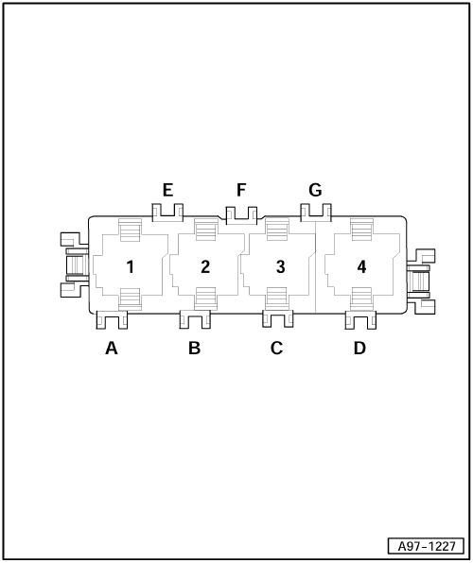
1 - | Glow plug relay (V8 TDI, ASE) - J52

- | Secondary air pump relay - J299

2 - | Glow plug relay 2 (V8 TDI, ASE) - J495

- | Secondary air pump relay 2 (only VR 12) - J545

- | from model year 04

- | Motronic current supply relay - J271

- | Terminal 30 voltage supply relay - J317

3 - | Terminal 30 voltage supply relay - J317

- | Motronic current supply relay - J271

- | from model year 04

- | Glow plug relay 2 (V8 TDI, ASE) - J495

- | Secondary air pump relay 2 (only VR 12, BHT) - J545

- | Automatic glow period control unit - J179 (V8 TDI, BVN)

4 - | Automatic glow period control unit - J179 (V6 TDI, ASB, BNG)

- | Glow period control unit 2 - J703 (V8 TDI, BVN)

Audi A8 | Fitting Locations | No. 201 / 12

A - | Vacant

B - | Engine glow plug strip fuse(V8 TDI, ASE) - S39, 60A (from model year 2004 80A)

- | Glow plugs fuse (V6 TDI, ASB, BNG/V8 TDI, ASE, BVN) - S125, 80A (from model year 2004)

- | Secondary air pump fuse -

- | S130, 50A

C - | Glow plugs fuse (V8 TDI, ASE) - S125, 60A (from model year 2004 80A)

- | Glow plugs fuse 2 (V8 TDI, ASE, BVN) - S189, 80A (from model year 2004)

- | Secondary air pump fuse 2 (only VR12, BHT) - S284, 50A

- | Automatic gearbox fuse, run-on - S286

D - | Vacant

E - | Vacant

F - | Vacant

G - | Vacant

Audi A8 | Fitting Locations | No. 201 / 13

Position relay and fuse holder behind left dash panel
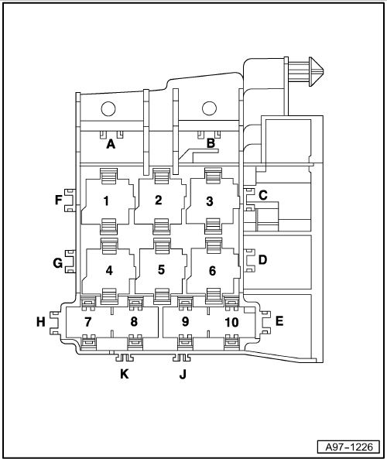
1 - | Adaptive suspension compressor relay - J403

2 - | Dual tone horn relay - J4

3 - | Terminal 15 voltage supply relay - J329

4 - | Washer fluid heater relay - J711 (up to model year 04)

5 - | Taxi alarm remote control, control unit - J601 (from model year 06)

6 - | Terminal 75 voltage supply relay 1 - J680

7 - | Coupling steering column switch - T17f, black (up to model year 03)

- | Vacant (rom model year 04)

8 - | Coupling dash panel vent illumination - T17g, grey

9 - | Coupling loudspeaker in dash panel - T6a, black

- | Coupling loudspeaker in dash panel - T10t, black (loudspeaker with servomotor)

10 - | Coupling electronic steering column lock - T8a, black

Audi A8 | Fitting Locations | No. 201 / 14

A - | ABS control unit fuse 1 - S123, 60A

B - | Levelling system fuse - S110 40A

C - | Window regulator thermal fuse - S43, 40A (from model year 04 30A)

D - | Seat adjustment thermal fuse 1 - S44, 30A

E - | Seat adjustment thermal fuse 2 - S45, 30A

F - | Vacant

J - | Coupling driver airbag - T5a, yellow (up to model year 03)

- | Vacant (rom model year 04)

K - | Vacant

Audi A8 | Fitting Locations | No. 201 / 15

Position relay and fuse holder in front right footwell
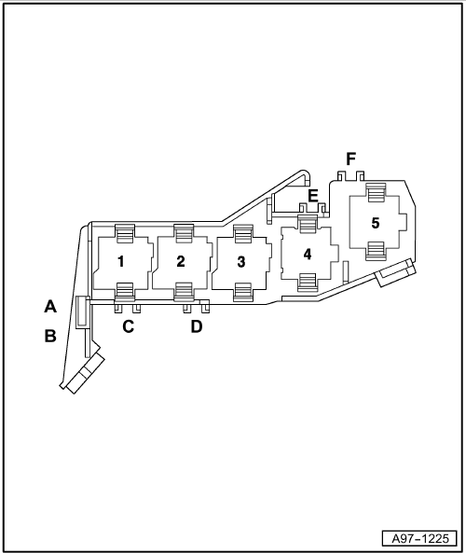
1.1 - | Radiator fan 3 relay 3 (6.0 l petrol engine) - J752

1.1 - | Fuel cooling pump relay (TDI) - J445

1.1 - | Brake servo relay (petrol engine) - J569

1.2 - | Additional coolant pump relay - J496

1.2 - | Charge air cooling pump relay (V8 TDI, BVN) - J536

- | Continued coolant circulation relay - J151

2 - | Starter motor relay - J53

3 - | Starter motor relay 2 - J695

4 - | Fuel pump relay - J17

- | Engine component current supply relay (V10, BSM) - J757

5 - | Headlight washer system relay - J39

A - | Front passenger side window regulator fuse - S170, 30A

B - | Front passenger seat adjustment thermal fuse 1 - S46, 30A

Audi A8 | Fitting Locations | No. 201 / 16

C - | Hot air blower single fuse - S25, 30A (up to model year 03)

- | Vacant (rom model year 04)

D - | Front passenger seat adjustment thermal fuse 2 - S80, 30A

E - | Vacant

F - | Vacant

Audi A8 | Fitting Locations | No. 201 / 17

Assignment main fuse carrier right A-pillar
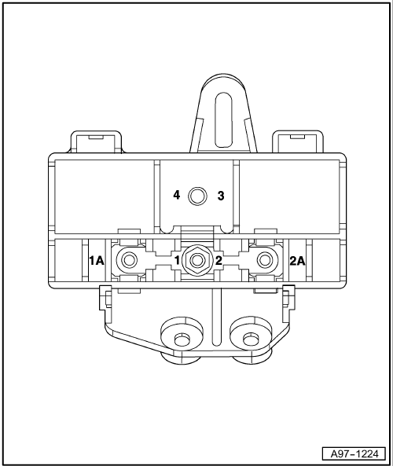
1 - | Radiator fan single fuse - S42, 60A

1A - | Screw point radiator fan

2 - | Radiator fan fuse for 2nd speed - S104, 60A

2A - | Screw point radiator fan fuse for 2nd speed

3 - | Terminal 30 screw point (battery)

4 - | Terminal 30 screw point (starter)

Audi A8 | Fitting Locations | No. 201 / 18

Position relay and fuse holder right in luggage compartment
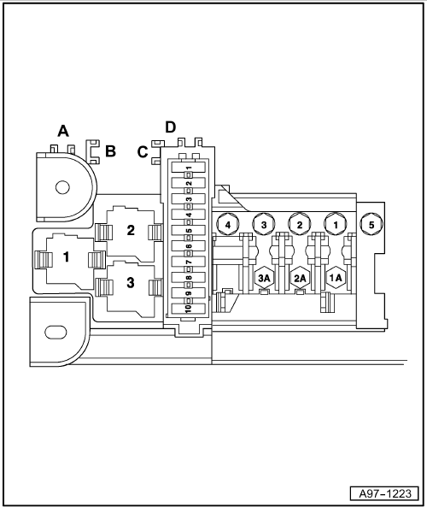
1 - | Heated rear window relay - J9

2 - | Vacant

- | Current supply relay - J16 (from model year 05)

3 - | Fuel pump relay (Common Rail-Diesel) - J17

- | Electric fuel pump 2 relay (petrol engine) - J49

- | Cold start relay for fuel pump - J748 (from model year 06)

A - | Heated rear window single fuse - S41, 40A

B - | Rear seat adjustment thermal fuse 1 - S335, 30A (up to model year 05)

- | Fuel pump fuse - S81, 40A (from model year 06)

C - | Rear seat adjustment thermal fuse 2 - S336, 30A

D - | Vacant

- | Communications fuse - S254, 15A (from model year 05)

Audi A8 | Fitting Locations | No. 201 / 19

Position relay and fuse holder right in luggage compartment
1 - | Terminal 30, fuse 1 - S131, 110A for heated windscreen - Z2

1A - | Terminal 30a screw point heated windscreen - Z2

2 - | Terminal 30, fuse 2 - S132, 60A for radio, navigation, TV tuner

2A - | Terminal 30a screw point

3 - | Terminal 30, fuse 3 - S133, 150A for onboard supply

3A - | Terminal 30a screw point (onboard supply)

4 - | Terminal 30 screw point

5 - | Terminal 30 screw point

Audi A8 | Fitting Locations | No. 201 / 20

Position relay and fuse holder right in luggage compartment

Fuse holder (up to model year 03)

Fuse designation: SF

1 - | Convenience system central control unit (left light) - J393, 20A

2 - | Convenience system central control unit (right light) - J393, 10A

3 - | Convenience system central control unit (power latching system) - J393, 20A

4 - | Electric park and handbrake control unit - J540, left parking brake motor - V282, 30A

5 - | Electric park and handbrake control unit - J540, right parking brake motor - V283, 30A

6 - | Trailer detector control unit (left light) - J345, 15A

7 - | Trailer detector control unit (right light) - J345, 15A

8 - | Trailer detector control unit - J345, 10A

9 - | Fuel pump - G23, 20A

10 - | Fuel system pressurisation pump - G6, 20A

Audi A8 | Fitting Locations | No. 201 / 21

Position relay and fuse holder right in luggage compartment

Fuse holder (from model year 04)

Fuse designation: SF

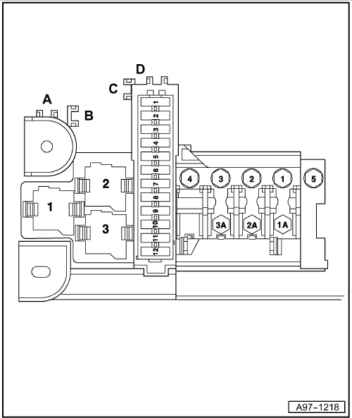
1 - | Fuel pump - G23, 20A

2 - | Fuel system pressurisation pump - G6, 20A

3 - | Trailer socket - U10, Kl. 15, 15A (up to model year 05)

- | Vacant (rom model year 06)

4 - | Vacant

5 - | Convenience system central control unit (rear left light) - J393, 20A

6 - | Convenience system central control unit (rear right light) - J393, 10A

7 - | Convenience system central control unit (power latching system) - J393, 20A

8 - | Electric park and handbrake control unit - J540, left parking brake motor - V282, 30A

9 - | Electric park and handbrake control unit - J540, right parking brake motor - V283, 30A

Audi A8 | Fitting Locations | No. 201 / 22

10 - | Trailer detector control unit (left light) - J345, 15A

11 - | Trailer detector control unit (right light) - J345, 15A

12 - | Trailer detector control unit - J345, 15A

Audi A8 | Fitting Locations | No. 201 / 23

Position fuse holder on left in luggage compartment (up to model year 03)

Fuse designation: SD

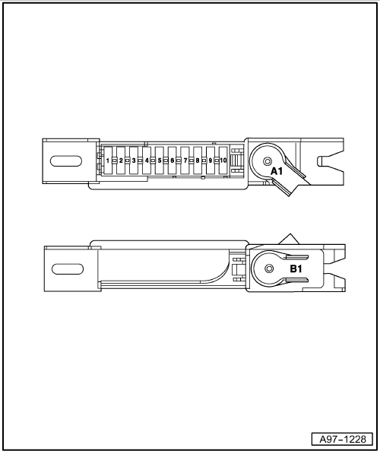
1 - | Digital sound package control unit - J525, 30A

2 - | Navigation system with CD drive control unit - J401, 5A

3 - | TV tuner - R78, 10A

4 - | Vacant

5 - | Radio - R, 5A

6 - | Middle loudspeaker in rear shelf - R148, 30A

7 - | 12 V socket - U5, 20A

8 - | Remote control receiver for auxiliary heating - R64, 5A

9 - | Vacant

10 - | Vacant

A1 - | Terminal 30 screw point (battery)

B1 - | Terminal 30 screw point

Audi A8 | Fitting Locations | No. 201 / 24

Position fuse holder on left in luggage compartment (from model year 04)

Fuse designation: SD

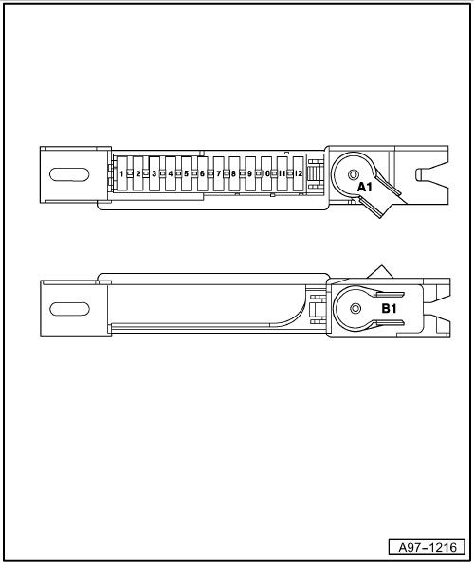
1 - | Vacant

2 - | Vacant

3 - | Vacant

4 - | Vacant

5 - | Digital sound package control unit - J525, 30A

6 - | Navigation system with CD drive control unit - J401, 5A

7 - | TV tuner - R78, 10A

8 - | Vacant

9 - | Radio - R, 5A

- | Digital radio - R147, 5A

- | Satellite radio - R146, 5A (USA)

10 - | Middle loudspeaker in rear shelf - R148, 15A

11 - | 12 V socket - U5, 20A

12 - | Remote control receiver for auxiliary heating - R64, 5A

A1 - | Terminal 30 screw point (battery)

B1 - | Terminal 30 screw point

