Fuses

Overview of fuses

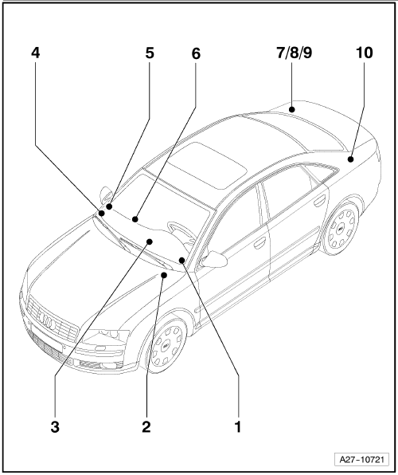
1 - | Fuses (SB) on fuse holder, left dash panel

q | Location → page 802/3

q | Position of fuses, left-hand drive → page 802/4

q | Position of fuses, right-hand drive → page 802/8

2 - | Relay and fuse holder (S), in electronics box, in plenum chamber

q | Position of fuses, left-hand drive → page 802/24

q | Position of fuses, right-hand drive → page 802/25

3 - | Relay and fuse holder (S), behind left dash panel

q | Position of fuses, left-hand drive → page 802/26

q | Position of fuses, right-hand drive → page 802/27

4 - | Fuses (SC) on fuse holder, right dash panel

q | Location → page 802/13

q | Position of fuses, left-hand drive → page 802/14

q | Position of fuses, right-hand drive → page 802/20

Audi A8 | Fitting Locations | No. 802 / 2

5 - | Fuses (S) on main fuse carrier, right A-pillar

q | Position of fuses → page 802/30

6 - | Relay and fuse holder (S) in front right footwell

q | Position of fuses, left-hand drive → page 802/28

q | Position of fuses, right-hand drive → page 802/29

7 - | Relay and fuse holder right in luggage compartment

q | Position of fuses → page 802/31

8 - | Relay and fuse holder right in luggage compartment, fuses

q | Position of fuses → page 802/32

9 - | Relay and fuse holder (SF) right in luggage compartment, fuses

q | Position of fuses up to model year 2003 → page 802/33

q | Position of fuses from model year 2004 → page 802/34

q | Position of fuses, right-hand drive → page 802/36

10 - | Fuses (SD) on fuse holder, left in luggage compartment

q | Position of fuses, up to model year 2003 → page 802/38

q | Position of fuses, from model year 2004 → page 802/39

q | Position of fuses, right-hand drive → page 802/41

Audi A8 | Fitting Locations | No. 802 / 3

Location of fuses (SB)
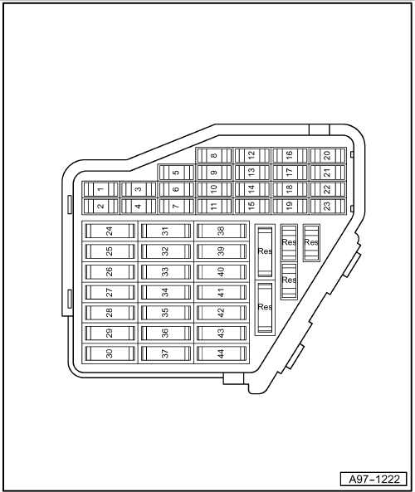

Fuse colours

40A orange

30A green

25A white

20A yellow

15A blue

10A red

7,5A brown

5A beige

3A purple

1A black

Audi A8 | Fitting Locations | No. 802 / 4

Fuses in fuse holder, left dash panel

No. |  | Current Flow Diagram designation | Nominal value |  | Function/component | Terminal
1 | - | SB1 - Fuse 1 on fuse holder B | 5 A | - | J530 - Garage door operation control unit | 15
2 | - | SB2 - Fuse 2 on fuse holder B | 10 A  5 A¹) | - | J446 - Parking aid control unit | 30
3 | - | SB3 - Fuse 3 on fuse holder B | 5 A | - | J446 - Parking aid control unit | 15
4 | - | SB4 - Fuse 4 on fuse holder B | 10 A | - | J431 - Headlight range control, control unit  V48 - Left headlight range control motor  V49 - Right headlight range control motor | 15
5 | - | SB5 - Fuse 5 on fuse holder B | 10 A  5 A¹) | - | J285 - Control unit in dash panel insert  J533 - Data bus diagnostic interface²) | 30
6 | - | SB6 - Fuse 6 on fuse holder B | 10 A | - | J527 - Steering column electronics control unit | 30
7 | - | SB7 - Fuse 7 on fuse holder B | 5 A | - | T16 - 16-pin connector, diagnostic connector | 30
8 | - | SB8 - Fuse 8 on fuse holder B | 5 A | - | G266 - Oil level and oil temperature sender¹)  T16 - 16-pin connector, diagnostic connector | 15
9 | - | SB9 - Fuse 9 on fuse holder B | 10 A  5 A¹) | - | J104 - ABS control unit  J527 - Steering column electronics control unit | 15
10 | - | SB10 - Fuse 10 on fuse holder B | 5 A | - | G266 - Oil level and oil temperature sender²)  J533 - Data bus diagnostic interface¹) | 15
11 | - | SB11 - Fuse 11 on fuse holder B | 10 A |  | J759 - Lane departure warning control unit³) | 15
12 | - | SB12 - Fuse 12 on fuse holder B | 5 A | - | F - Brake light switch | 30

¹) from model year 2004

²) up to model year 2003

³) from September 2007

Audi A8 | Fitting Locations | No. 802 / 5

No. |  | Current Flow Diagram designation | Nominal value |  | Function/component | Terminal
13 | - | SB13 - Fuse 13 on fuse holder B | 10 A | - | J412 -Mobile telephone operating electronics control unit  J526 - Telephone and telematics control unit, telematics  R36 - Telephone transmitter and receiver unit  R115 - Chip card reader for telephone | 30
14 | - | SB14 - Fuse 14 on fuse holder B | 5 A | - | J608 - Special vehicle control unit³) | 30
15 | - | SB15 - Fuse 15 on fuse holder B | 5 A | - | E408 - Entry and start authorisation button | 30
16 | - | SB16 - Fuse 16 on fuse holder B | 10 A | - | - Rear-Seat-Entertainment | 15
17 | - | SB17 - Fuse 17 on fuse holder B | 10 A  5 A¹) | - | J428 - Adaptive cruise control unit  Z47 - Sensor heater for adaptive cruise control system²) | 15
18 | - | SB18 - Fuse 18 on fuse holder B | 5 A | - | Z20 - Left washer jet heater element  Z21 - Right washer jet heater element | 75
19 | - | SB19 - Fuse 19 on fuse holder B | 15 A  10 A³) | - | J608 - Special vehicle control unit³)  J711 - Washer fluid heater relay²) | 30  75
20 | - | SB20 - Fuse 20 on fuse holder B | 5 A | - | J502 - Tyre pressure monitor control unit | 30
21 | - | SB21 - Fuse 21 on fuse holder B | 5 A | - | J608 - Special vehicle control unit³) | 15
22 | - | SB22 - Fuse 22 on fuse holder B | 5 A | - | F47 - Brake pedal switch | 87
23 | - | SB23 - Fuse 23 on fuse holder B | 5 A | - | - Card system Italy (Telepass)  - Preparation for mobile telephone³) | 30
24 | - | SB24 - Fuse 24 on fuse holder B | 15 A | - | H2 - Treble tone horn  H7 - Bass tone horn  J4 - Dual tone horn relay | 30

¹) from model year 2004

²) up to model year 2004

³) from model year 2006

Audi A8 | Fitting Locations | No. 802 / 6

No. |  | Current Flow Diagram designation | Nominal value |  | Function/component | Terminal
25 | - | SB25 - Fuse 25 on fuse holder B | 40 A | - | J400 - Wiper motor control unit | 30
26 | - | SB26 - Fuse 26 on fuse holder B | 15 A³)  30 A²) | - | J608 - Special vehicle control unit³)  U18 - 12 V socket -2-²)  U19 - 12 V socket 3²) | 30
27 | - | SB27 - Fuse 27 on fuse holder B | 25 A | - | J104 - ABS control unit | 30
28 | - | Vacant
29 | - | SB29 - Fuse 29 on fuse holder B | 1 A | - | - Switch illumination | 58s
30 | - | Vacant
31 | - | SB31 - Fuse 31 on fuse holder B | 30 A | - | J519 - Onboard power supply control unit | 30
32 | - | Vacant
33 | - | SB33 - Fuse 33 on fuse holder B | 25 A | - | Z42-Rear left footwell heater element | 75
34 | - | Vacant
35 | - | Vacant
36 | - | SB36 - Fuse 36 on fuse holder B | 5 A |  | J769 - Lane change assist control unit⁴) | 15
37 | - | SB37 - Fuse 37 on fuse holder B | 15 A | - | J698 - Refrigerator box³) | 15
38 | - | SB38 - Fuse 38 on fuse holder B | 30 A | - | J519 - Onboard power supply control unit | 30
39 | - | SB39 - Fuse 39 on fuse holder B | 15 A  7.5 A¹) | - | J386 - Driver door control unit | 30

¹) from model year 2004

²) up to model year 2004

³) from model year 2006

⁴) from September 2007

Audi A8 | Fitting Locations | No. 802 / 7

No. |  | Current Flow Diagram designation | Nominal value |  | Function/component | Terminal
40 | - | SB40 - Fuse 40 on fuse holder B | 25 A | - | J519 - Onboard power supply control unit  V123 - Steering column vertical adjustment motor  V124 - Steering column axial adjustment motor | 30
41 | - | SB41 - Fuse 41 on fuse holder B | 15 A  7.5 A¹) | - | J388 - Rear left door control unit | 30
42 | - | SB42 - Fuse 42 on fuse holder B | 25 A | - | J518 - Entry and start authorisation control unit | 30
43 | - | SB43 - Fuse 43 on fuse holder B | 10 A |  | - Left headlight with cornering lights²) | 15
44 | - | SB44 - Fuse 44 on fuse holder B | 10 A | - | - Right headlight with cornering lights²) | 15

¹) from model year 2004

²) from model year 2006

Audi A8 | Fitting Locations | No. 802 / 8

Position of fuses on fuse holder, left dash panel, right-hand drive

No. |  | Current Flow Diagram designation | Nominal value |  | Function/component | Terminal
1 | - | SB1 - Fuse 1 on fuse holder B | 5 A | - | J530 - Garage door operation control unit | 15
2 | - | SB2 - Fuse 2 on fuse holder B | 5 A | - | J446 - Parking aid control unit | 30
3 | - | SB3 - Fuse 3 on fuse holder B | 5 A | - | J446 - Parking aid control unit | 15
4 | - | SB4 - Fuse 4 on fuse holder B | 15 A | - | J217 - Automatic gearbox control unit 01J/01T | 87
5 | - | SB5 - Fuse 5 on fuse holder B | 15 A | - | G70 - Air mass meter  J299 - Secondary air pump relay  J338 - Throttle valve module  J724 - Turbocharger 1 control unit  N18 - Exhaust gas recirculation valve  N112 - Secondary air inlet valve  N145 - Right electrohydraulic engine mounting solenoid valve  N382 - Torque rod valve  V157 - Intake manifold flap motor | 87
6 | - | SB6 - Fuse 6 on fuse holder B | 15 A | - | G39 - Lambda probe  G108 - Lambda probe 2 | 87
7 | - | SB7 - Fuse 7 on fuse holder B | 15 A  10 A | - | G130 - Lambda probe after catalytic converter  G131 - Lambda probe 2 after catalytic converter  N276 - Fuel pressure regulating valve  N290 - Fuel metering valve | 87

Audi A8 | Fitting Locations | No. 802 / 9

No. |  | Current Flow Diagram designation | Nominal value |  | Function/component | Terminal
8 | - | SB8 - Fuse 8 on fuse holder B | 10 A | - | J544 - Throttle valve module 2  J725 - Turbocharger 2 control unit  N144 - Left electrohydraulic engine mounting solenoid valve  N205 - Inlet camshaft control valve 1  N208 - Inlet camshaft control valve 2  N213 - Exhaust gas recirculation valve 2  N321 - Exhaust flap 1 valve  N382 - Torque rod valve  V51 - Continued coolant circulation pump  V275 - Intake manifold flap 2 motor | 87
9 | - | SB9 - Fuse 9 on fuse holder B | 5 A | - | J104 - ABS control unit  J527 - Steering column electronics control unit | 15
10 | - | SB10 - Fuse 10 on fuse holder B | 10 A | - | J197 - Adaptive suspension control unit | 15
11 | - | SB11 - Fuse 11 on fuse holder B | 10 A | - | J759 - Lane departure warning control unit | 15
12 | - | SB12 - Fuse 12 on fuse holder B | 5 A | - | J523 - Front information display and operating unit control unit | 30
13 | - | SB13 - Fuse 13 on fuse holder B | 10 A | - | J412 -Mobile telephone operating electronics control unit  J526 - Telephone and telematics control unit, telematics  R36 - Telephone transmitter and receiver unit  R115 - Chip card reader for telephone  -Preparation for mobile telephone | 30
14 | - | SB14 - Fuse 14 on fuse holder B | 5 A | - | R41 - CD changer  R92 - CD ROM drive  R129 - Video recorder and DVD player | 30

Audi A8 | Fitting Locations | No. 802 / 10

No. |  | Current Flow Diagram designation | Nominal value |  | Function/component | Terminal
15 | - | SB15 - Fuse 15 on fuse holder B | 5 A | - | E408 - Entry and start authorisation button | 30
16 | - | SB16 - Fuse 16 on fuse holder B | 7.5 A | - | N79 - Heater element for crankcase breather | 87
17 | - | SB17 - Fuse 17 on fuse holder B | 5 A | - | J428 - Adaptive cruise control unit  Z47 - Sensor heater for adaptive cruise control system | 15
18 | - | SB18 - Fuse 18 on fuse holder B | 5 A | - | Z20 - Left washer jet heater element  Z21 - Right washer jet heater element | 75
19 | - | SB19 - Fuse 19 on fuse holder B | 5 A | - | G70 - Air mass meter | 15
20 | - | SB20 - Fuse 20 on fuse holder B | 5 A | - | J502 - Tyre pressure monitor control unit | 30
21 | - | SB21 - Fuse 21 on fuse holder B | 15 A  5 A | - | J248 - Diesel direct injection system control unit  J317 - Terminal 30 voltage supply relay  J271 - Motronic current supply relay  J623 - Engine control unit | 87  30
22 | - | SB22 - Fuse 22 on fuse holder B | 10 A | - | J445 - Fuel cooling pump relay  V166 - Fuel cooling pump | 30
23 | - | SB23 - Fuse 23 on fuse holder B | 5 A | - | -Preparation for mobile telephone | 15
24 | - | SB24 - Fuse 24 on fuse holder B | 15 A | - | H2 - Treble tone horn  H7 - Bass tone horn  J4 - Dual tone horn relay | 30
25 | - | SB25 - Fuse 25 on fuse holder B | 15 A | - | J217 - Automatic gearbox control unit | 30
26 | - | Vacant
27 | - | SB27 - Fuse 27 on fuse holder B | 25 A | - | J104 - ABS control unit | 30

Audi A8 | Fitting Locations | No. 802 / 11

No. |  | Current Flow Diagram designation | Nominal value |  | Function/component | Terminal
28 | - | SB28 - Fuse 28 on fuse holder B | 5 A | - | J17 - Fuel pump relay  J49 - Electric fuel pump 2 relay  J248 - Diesel direct injection system control unit  J569 - Brake servo relay  J623 - Engine control unit | 15
29 | - | SB29 - Fuse 29 on fuse holder B | 15 A | - | N30.. - Injector | 87
30 | - | SB30 - Fuse 30 on fuse holder B | 30 A | - | N...-Ignition coils with output stage  J623 - Engine control unit | 87
31 | - | SB31 - Fuse 31 on fuse holder B | 20 A  40 A | - | G23 - Right fuel pump  N115 - Activated charcoal filter solenoid valve 2 (USA)  V144 - Fuel system diagnostic pump (USA)  J538 - Fuel pump control unit | 87
32 | - | SB32 - Fuse 32 on fuse holder B | 10 A  5 A | - | J217 - Automatic gearbox control unit 01J, 01T  J217 - Automatic gearbox control unit 09E, 09L | 15
33 | - | SB33 - Fuse 33 on fuse holder B | 25 A | - | Z42-Rear left footwell heater element | 75
34 | - | Vacant
35 | - | Vacant
36 | - | SB36 - Fuse 36 on fuse holder B | 5 A | - | J769 - Lane change assist control unit | 15
37 | - | SB37 - Fuse 37 on fuse holder B | 15 A | - | J698-Refrigerator box | 15
38 | - | SB38 - Fuse 38 on fuse holder B | 20 A | - | V284 - Radiator fan 3 | 30
39 | - | SB39 - Fuse 39 on fuse holder B | 7.5 A | - | J386 - Driver door control unit | 30

Audi A8 | Fitting Locations | No. 802 / 12

No. |  | Current Flow Diagram designation | Nominal value |  | Function/component | Terminal
40 | - | SB40 - Fuse 40 on fuse holder B | 15 A | - | J569 - Brake servo relay  V192 - Vacuum pump for brakes | 30
41 | - | SB41 - Fuse 41 on fuse holder B | 7.5 A | - | J388 - Rear left door control unit | 30
42 | - | SB42 - Fuse 42 on fuse holder B | 25 A | - | J518 - Entry and start authorisation control unit | 30
43 | - | SB43 - Fuse 43 on fuse holder B | 10 A | - | - Left headlight with cornering lights | 15
44 | - | SB44 - Fuse 44 on fuse holder B | 10 A | - | - Right headlight with cornering lights | 15

Audi A8 | Fitting Locations | No. 802 / 13

Location of fuses (SC)
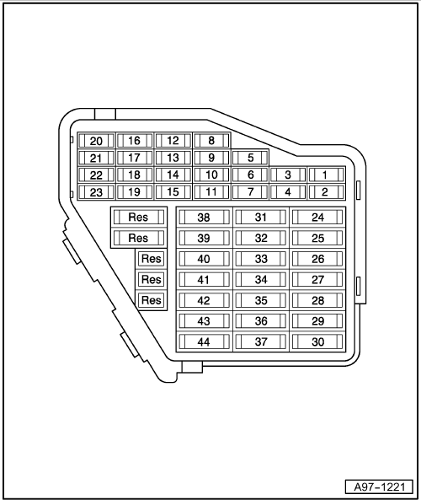

Fuse colours

40A orange

30A green

25A white

20A yellow

15A blue

10A red

7,5A brown

5A beige

3A purple

1A black

Audi A8 | Fitting Locations | No. 802 / 14

Fuses in fuse holder, right dash panel

No. |  | Current Flow Diagram designation | Nominal value |  | Function/component | Terminal
1 | - | SC1 - Fuse 1 on fuse holder C | 5 A | - | J540 - Electric park and handbrake control unit | 15
2 | - | SC2 - Fuse 2 on fuse holder C | 10 A | - | J255 - Climatronic control unit | 30
3 | - | SC3 - Fuse 3 on fuse holder C | 5 A | - | F189 - Tiptronic switch  F305 - Gear selector position P switch  N110 - Selector lever lock solenoid | 15
4 | - | SC4 - Fuse 4 on fuse holder C | 15 A | - | J217 - Automatic gearbox control unit 01J/01T | 87
5 | - | SC5-Fuse 5 on fuse holder C | 15 A | - | G70 - Air mass meter  J299 - Secondary air pump relay  J338 - Throttle valve module  J724 - Turbocharger 1 control unit  N18 - Exhaust gas recirculation valve  N112 - Secondary air inlet valve  N145 - Right electrohydraulic engine mounting solenoid valve  N382 - Torque rod valve  V157 - Intake manifold flap motor | 87
6 | - | SC6 - Fuse 6 on fuse holder C | 15 A | - | G39 - Lambda probe  G108 - Lambda probe 2 | 87
7 | - | SC7 - Fuse 7 on fuse holder C | 15 A  10 A | - | G130 - Lambda probe after catalytic converter  G131 - Lambda probe 2 after catalytic converter  N276 - Fuel pressure regulating valve  N290 - Fuel metering valve | 87

Audi A8 | Fitting Locations | No. 802 / 15

No. |  | Current Flow Diagram designation | Nominal value |  | Function/component | Terminal
8 | - | SC8 - Fuse 8 on fuse holder C | 10 A | - | N205 - Inlet camshaft control valve 1  N208 - Inlet camshaft control valve 2  N382 - Torque rod valve  N321 - Exhaust flap 1 valve  N213 - Exhaust gas recirculation valve 2  N144 - Left electrohydraulic engine mounting solenoid valve  J544 - Throttle valve module 2  J725 - Turbocharger 2 control unit  V51 - Continued coolant circulation pump  V275 - Intake manifold flap 2 motor | 87
9 | - | SC9 - Fuse 9 on fuse holder C | 5 A | - | G238 - Air quality sensor  E265 - Rear Climatronic operating and display unit  E128 - Heated left driver seat switch  E129 - Heated right driver seat switch  G65 - High-pressure sender  J255 - Climatronic control unit  E256 - TCS and ESP button | 15
10 | - | SC10 - Fuse 10 on fuse holder C | 10 A | - | J197 - Adaptive suspension control unit | 15
11 | - | SC11 - Fuse 11 on fuse holder C | 5 A | - | G397 - Rain and light detector sensor | 30
12 | - | SC12 - Fuse 12 on fuse holder C | 5 A | - | J523 - Front information display and operating unit control unit | 30
13 | - | SC13 - Fuse 13 on fuse holder C | 10 A | - | J528-Roof electronics control unit | 30

Audi A8 | Fitting Locations | No. 802 / 16

No. |  | Current Flow Diagram designation | Nominal value |  | Function/component | Terminal
14 | - | SC14 - Fuse 14 on fuse holder C | 5 A | - | R41 - CD changer  R92 - CD ROM drive  R129 - Video recorder and DVD player | 30
15 | - | SC15 - Fuse 15 on fuse holder C | 5 A | - | J644 - Energy management control unit | 30
16 | - | SC16 - Fuse 16 on fuse holder C | 5 A  7.5 A³) | - | N79 - Heater element for crankcase breather | 87
17 | - | SC17 - Fuse 17 on fuse holder C | 5 A¹) | - | - Vacant  V7 - Radiator fan  V177 - Radiator fan 2 | 87
18 | - | SC18 - Fuse 18 on fuse holder C | 5 A | - | - vacant (from January 2003)  J234 - Airbag control unit²)  J706 - Seat occupied recognition control unit (only USA)²)  L34 - Map reading light bulb (up to December 2002) | 15
19 | - | SC19 - Fuse 19 on fuse holder C | 5 A | - | G70 - Air mass meter | 15
20 | - | SC20 - Fuse 20 on fuse holder C | 5 A | - | J526 - Telephone and telematics control unit, telematics (USA)  J672 - Driver seat ventilation control unit  J673 - Front passenger seat ventilation control unit | 75
21 | - | SC21 - Fuse 21 on fuse holder C | 15 A  5 A | - | J248 - Diesel direct injection system control unit  J271 - Motronic current supply relay  J623 - Engine control unit | 30
22 | - | SC22 - Fuse 22 on fuse holder C | 10 A | - | J445 - Fuel cooling pump relay  V166 - Fuel cooling pump | 30

¹) from model year 2004

²) from model year 2005

³) from model year 2006

Audi A8 | Fitting Locations | No. 802 / 17

No. |  | Current Flow Diagram designation | Nominal value |  | Function/component | Terminal
23 | - | SC23 - Fuse 23 on fuse holder C | 5 A | - | F234 - Parking brake pressure switch | 30
24 | - | SC24 - Fuse 24 on fuse holder C | 20 A  10 A¹) | - | J520 - Onboard supply control unit 2 | 30
25 | - | SC25 - Fuse 25 on fuse holder C | 15 A | - | J217 - Automatic gearbox control unit | 30
26 | - | SC26 - Fuse 26 on fuse holder C | 15 A  10 A¹) | - | E265 - Rear Climatronic operating and display unit  J255 - Climatronic control unit | 30
27 | - | SC27 - Fuse 27 on fuse holder C | 20 A | - | J245 - Sliding sunroof adjustment control unit | 30
28 | - | SC29 - Fuse 29 on fuse holder C | 15 A  5 A¹) | - | J17 - Fuel pump relay  J49 - Electric fuel pump 2 relay  J248 - Diesel direct injection system control unit  J569 - Brake servo relay  J623 - Engine control unit | 15
29 | - | SC29 - Fuse 29 on fuse holder C | 20 A  15 A¹) | - | N30.. - Injector | 87
30 | - | SC30 - Fuse 30 on fuse holder C | 30 A | - | N...-Ignition coils with output stage  J623 - Engine control unit | 87
31 | - | SC31 - Fuse 31 on fuse holder C | 20 A  40 A | - | G23 - Right fuel pump  N115 - Activated charcoal filter solenoid valve 2 (USA)  V144 - Fuel system diagnostic pump (USA)  J538 - Fuel pump control unit | 87
32 | - | SC32 - Fuse 32 on fuse holder C | 15 A  10 A¹)  5 A²) | - | J217 - Automatic gearbox control unit 01J, 01T  J217 - Automatic gearbox control unit 09E, 09L | 15

¹) from model year 2004

²) from model year 2006

Audi A8 | Fitting Locations | No. 802 / 18

No. |  | Current Flow Diagram designation | Nominal value |  | Function/component | Terminal
33 | - | SC33-Fuse 33 on fuse holder C | 25 A | - | Z43-Rear right footwell heater element | 75
34 | - | SC34 - Fuse 34 on fuse holder C | 20 A | - | - Seat heating/rear seat ventilation  E265 - Rear Climatronic operating and display unit | 30
35 | - | SC35 - Fuse 35 on fuse holder C | 20 A | - | J255 - Climatronic control unit  J672 - Driver seat ventilation control unit  J673 - Front passenger seat ventilation control unit | 30
36 | - | SC36 - Fuse 36 on fuse holder C | 20 A | - | U1 - Cigarette lighter | 30
37 | - | SC37 - Fuse 37 on fuse holder C | 20 A  30 A  25 A³) | - | U9 - Rear cigarette lighter  U18 - 12 V socket -2-²)  U19 - 12 V socket 3²) | 30
38 | - | SC38 - Fuse 38 on fuse holder C | 20 A¹) | - | - Vacant  V284 - Radiator fan 3¹) | 30
39 | - | SC39 - Fuse 39 on fuse holder C | 15 A  7.5 A¹) | - | J387 - Front passenger side door control unit | 30
40 | - | SC40 - Fuse 40 on fuse holder C | 15 A | - | J569 - Brake servo relay  V192 - Vacuum pump for brakes | 30
41 | - | SC41 - Fuse 41 on fuse holder C | 15 A  7.5 A¹) | - | J389 - Rear right door control unit | 30

¹) from model year 2004

²) from model year 2005

³) from model year 2006

Audi A8 | Fitting Locations | No. 802 / 19

No. |  | Current Flow Diagram designation | Nominal value |  | Function/component | Terminal
42 | - | SC42 - Fuse 42 on fuse holder C | 20 A | - | J364 - Auxiliary heater control unit | 30
43 | - | SC43 - Fuse 43 on fuse holder C | 20 A  30 A¹) |  | J39 - Headlight washer system relay | 30
44 | - | SC44 - Fuse 44 on fuse holder C | 15 A  30 A¹) | - | U10 -Trailer socket  V2 - Fresh air blower (air conditioning)¹) | 15

¹) from model year 2004

Audi A8 | Fitting Locations | No. 802 / 20

Position of fuses on fuse holder, right dash panel, right-hand drive

No. |  | Current Flow Diagram designation | Nominal value |  | Function/component | Terminal
1 | - | SC1 - Fuse 1 on fuse holder C | 5 A | - | J540 - Electric park and handbrake control unit | 15
2 | - | SC2 - Fuse 2 on fuse holder C | 10 A | - | J255 - Climatronic control unit | 30
3 | - | SC3 - Fuse 3 on fuse holder C | 5 A | - | F189 - Tiptronic switch  F305 - Gear selector position P switch  N110 - Selector lever lock solenoid | 15
4 | - | SC4 - Fuse 4 on fuse holder C | 10 A | - | J431 - Headlight range control, control unit  V48 - Left headlight range control motor  V49 - Right headlight range control motor | 15
5 | - | SC5-Fuse 5 on fuse holder C | 5 A | - | J285 - Control unit in dash panel insert  J533 - Data bus diagnostic interface | 30
6 | - | SC6 - Fuse 6 on fuse holder C | 10 A | - | J527 - Steering column electronics control unit | 30
7 | - | SC7 - Fuse 7 on fuse holder C | 5 A | - | T16 - 16-pin connector, diagnostic connector | 30
8 | - | SC8 - Fuse 8 on fuse holder C | 5 A | - | G226 - Oil level and oil temperature sender  T16 - 16-pin connector, diagnostic connector | 15
9 | - | SC9 - Fuse 9 on fuse holder C | 5 A | - | E128 - Heated rear left seat switch with regulator  E129 - Heated rear right seat switch with regulator  E256 - TCS and ESP button  E265 - Rear Climatronic operating and display unit  G65 - High-pressure sender  G238 - Air quality sensor  J255 - Climatronic control unit | 15

Audi A8 | Fitting Locations | No. 802 / 21

No. |  | Current Flow Diagram designation | Nominal value |  | Function/component | Terminal
10 | - | SC10 - Fuse 10 on fuse holder C | 5 A | - | J533 - Data bus diagnostic interface | 15
11 | - | SC11 - Fuse 11 on fuse holder C | 5 A | - | G397 - Rain and light detector sensor | 30
12 | - | SC12 - Fuse 12 on fuse holder C | 5 A | - | F - Brake light switch | 30
13 | - | SC13 - Fuse 13 on fuse holder C | 10 A | - | J528-Roof electronics control unit | 30
14 | - | Vacant
15 | - | SC15 - Fuse 15 on fuse holder C | 5 A | - | J644 - Energy management control unit | 30
16 | - | SC16 - Fuse 16 on fuse holder C | 10 A | - | - Rear-Seat-Entertainment | 15
17 | - | SC17 - Fuse 17 on fuse holder C | 5 A | - | V7 - Radiator fan  V177 - Radiator fan 2 | 87
18 | - | SC18 - Fuse 18 on fuse holder C | 5 A | - | J234 - Airbag control unit  J706 - Seat occupied recognition control unit (only USA) | 15
19 | - | Vacant
20 | - | SC20 - Fuse 20 on fuse holder C | 5 A | - | J672 - Driver seat ventilation control unit  J673 - Front passenger seat ventilation control unit | 75
21 | - | Vacant
22 | - | SC22 - Fuse 22 on fuse holder C | 5 A | - | F47 - Brake pedal switch | 87
23 | - | SC23 - Fuse 23 on fuse holder C | 5 A | - | F234 - Parking brake pressure switch | 30
24 | - | SC24 - Fuse 24 on fuse holder C | 10 A | - | J520 - Onboard supply control unit 2 | 30
25 | - | SC25 - Fuse 25 on fuse holder C | 40 A | - | J400 - Wiper motor control unit | 30

Audi A8 | Fitting Locations | No. 802 / 22

No. |  | Current Flow Diagram designation | Nominal value |  | Function/component | Terminal
26 | - | SC26 - Fuse 26 on fuse holder C | 10 A | - | E265 - Rear Climatronic operating and display unit  J255 - Climatronic control unit | 30
27 | - | SC27 - Fuse 27 on fuse holder C | 20 A | - | J245 - Sliding sunroof adjustment control unit | 30
28 | - | Vacant
29 | - | SC29 - Fuse 29 on fuse holder C | 1 A | - | - Switch illumination | 58s
30 | - | Vacant
31 | - | SC31 - Fuse 31 on fuse holder C | 30 A | - | J519 - Onboard power supply control unit | 30
32 | - | Vacant
33 | - | SC33-Fuse 33 on fuse holder C | 25 A | - | Z43-Rear right footwell heater element | 75
34 | - | SC34 - Fuse 34 on fuse holder C | 20 A | - | - Seat heating/rear seat ventilation  E265 - Rear Climatronic operating and display unit | 30
35 | - | SC35 - Fuse 35 on fuse holder C | 20 A | - | J255 - Climatronic control unit  J672 - Driver seat ventilation control unit  J673 - Front passenger seat ventilation control unit | 30
36 | - | SC36 - Fuse 36 on fuse holder C | 20 A | - | U1 - Cigarette lighter | 30
37 | - | SC37 - Fuse 37 on fuse holder C | 20 A  25 A | - | U9 - Rear cigarette lighter  U18 - 12 V socket -2-  U19 - 12 V socket 3 | 30
38 | - | SC38 - Fuse 38 on fuse holder C | 30 A | - | J519 - Onboard power supply control unit | 30

Audi A8 | Fitting Locations | No. 802 / 23

No. |  | Current Flow Diagram designation | Nominal value |  | Function/component | Terminal
39 | - | SC39 - Fuse 39 on fuse holder C | 7.5 A | - | J387 - Front passenger side door control unit | 30
40 | - | SC40 - Fuse 40 on fuse holder C | 25 A | - | J519 - Onboard power supply control unit  V123 - Steering column vertical adjustment motor  V124 - Steering column axial adjustment motor | 30
41 | - | SC41 - Fuse 41 on fuse holder C | 7.5 A | - | J389 - Rear right door control unit | 30
42 | - | SC42 - Fuse 42 on fuse holder C | 20 A | - | J364 - Engine residual heat accumulator control unit | 30
43 | - | SC43 - Fuse 43 on fuse holder C | 30 A |  | J39 - Headlight washer system relay | 30
44 | - | SC44 - Fuse 44 on fuse holder C | 30 A | - | V2 - Fresh air blower (air conditioning) | 30

Audi A8 | Fitting Locations | No. 802 / 24

Fuse locations on fuse holder, in electronics box
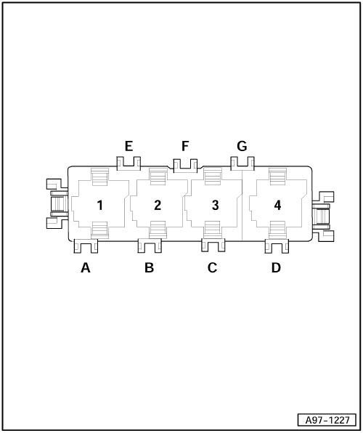
A - | Vacant

B - | Glow plug strip fuse -S39-, 60A

q | Engine code ASE only

q | from model year 2004

B - | Glow plug fuse -S125-, 80A

q | Engine codes ASB, BNG, ASE, BVN only

q | from model year 2004

B - | Secondary air pump fuse -S130-, 50A

C - | Glow plug fuse -S125-, 60A

q | Engine code ASE only

q | from model year 2004, 80A

C - | Glow plug fuse 2 -S189-, 80A

q | Engine codes ASE, BVN only

q | from model year 2004

C - | Secondary air pump fuse 2 -S284-, 50A

q | Engine code BHT only

D - | Vacant

F - | Vacant

G - | Vacant

H - | Vacant

Audi A8 | Fitting Locations | No. 802 / 25

Fuse locations on fuse holder, in electronics box, right-hand drive
A - | Vacant

B - | Vacant

C - | Vacant

D - | Vacant

E - | Engine glow plug strip fuse -S39-, 80 A

q | Engine code ASE only

- | Glow plug fuse -S125-, 80 A

q | Engine codes ASE, BVN, ASB, BNG only

- | Secondary air pump fuse -S130-, 50 A

F - | Vacant

G - | Glow plug fuse 2 -S189-, 80 A

q | Engine codes ASE, BVN only

- | Secondary air pump fuse 2 -S284-, 50 A

q | Engine code BHT only

Audi A8 | Fitting Locations | No. 802 / 26

Position of fuses on fuse holder, on left behind dash panel
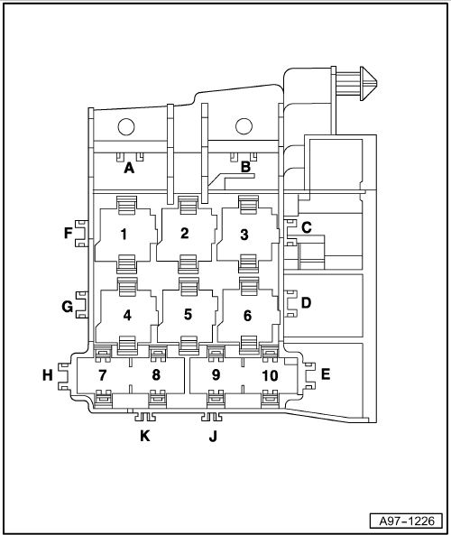
A - | ABS control unit fuse 1 -S123-, 60A

B - | Levelling system fuse -S110- 40A

C - | Window regulator thermal fuse -S43- 40A

q | from model year 2004, 30A

D - | Seat adjustment thermal fuse 1 -S44-, 30A

E - | Seat adjustment thermal fuse 2 -S45- 30A

F - | Vacant

G - | Vacant

H - | Vacant

Audi A8 | Fitting Locations | No. 802 / 27

Position of fuses on fuse holder, on right behind dash panel, right-hand drive
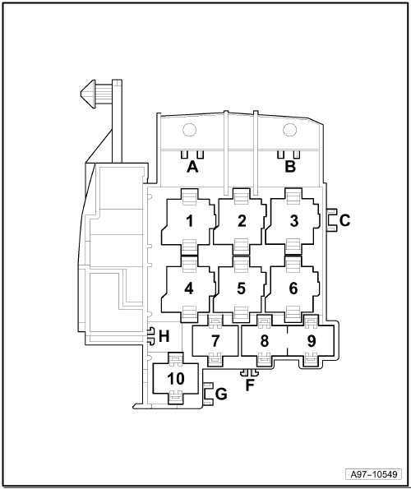
A - | Driver seat adjustment thermal fuse 1 -S44-, 30 A

B - | Window regulator thermal fuse -S43-, 30 A

C - | Vacant

F - | Vacant

G - | Driver seat adjustment thermal fuse 2 -S45-, 30 A

H - | Vacant

Audi A8 | Fitting Locations | No. 802 / 28

Fuses on fuse holder, in front right footwell
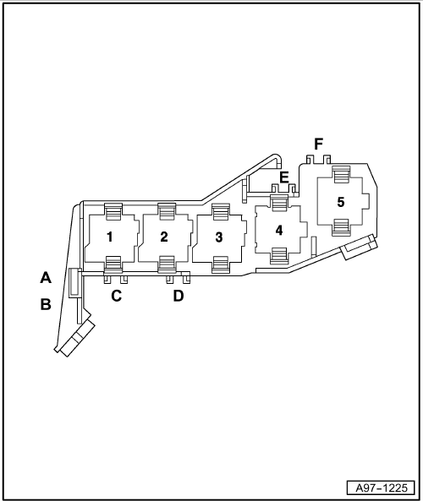
A - | Front passenger side window regulator fuse -S170-, 30 A

q | up to July 2006

B - | Front passenger seat adjustment thermal fuse 1 -S46- 30 A

C - | Hot air blower single fuse -S25-, 30 A

q | up to model year 2003

C - | Vacant

q | from model year 2004

C - | Front passenger side window regulator fuse -S170-, 30 A

q | from August 2006

D - | Front passenger seat adjustment thermal fuse 2 -S80-, 30 A

E - | Vacant

F - | Vacant

Audi A8 | Fitting Locations | No. 802 / 29

Fuses on fuse holder, in front right footwell, right-hand drive
A - | Window regulator thermal fuse -S43-, 30 A

q | up to October 2006

B - | Driver seat adjustment thermal fuse 1 -S44-, 30 A

C - | Vacant

q | up to October 2006

- | Window regulator thermal fuse -S43-, 30 A

q | from November 2006

D - | ABS control unit fuse 1 -S123-, 60 A

E - | Driver seat adjustment thermal fuse 2 -S45-, 30 A

F - | Levelling system fuse -S110-, 40 A

Audi A8 | Fitting Locations | No. 802 / 30

Position of fuses on main fuse carrier, right A-pillar
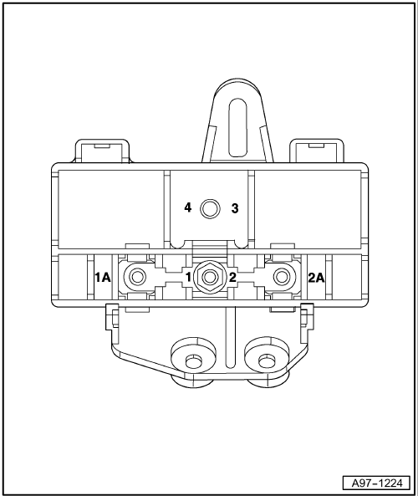
1 - | Radiator fan single fuse -S42-, 60A

1A - | Screw point radiator fan

2 - | Radiator fan fuse for 2nd speed -S104-, 60A

2A - | Screw point radiator fan fuse for 2nd speed

3 - | Terminal 30 screw point (battery)

4 - | Terminal 30 screw point (starter)

Audi A8 | Fitting Locations | No. 802 / 31

Position of fuses on fuse holder, in right luggage compartment
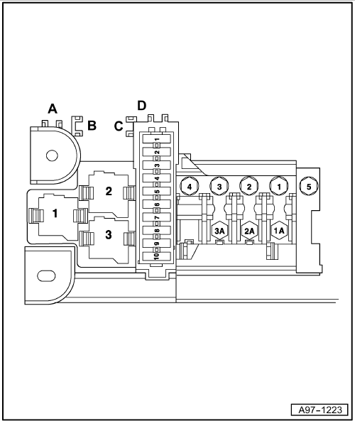
A - | Heated rear window single fuse -S41- 40A

B - | Rear seat adjustment thermal fuse 1 -S335- 30A

q | up to model year 2005

B - | Fuel pump fuse -S81- 40A

q | from model year 2006

C - | Rear seat adjustment thermal fuse 2 -S336- 30A

D - | Vacant

D - | Communications fuse -S254-, 15A

q | up to model year 2005

Audi A8 | Fitting Locations | No. 802 / 32

Fuses on fuse holder, on right in luggage compartment
1 - | Terminal 30, fuse 1 -S131- 110A, for heated windscreen - Z2

1A - | Terminal 30a screw point heated windscreen -Z2-

2 - | Terminal 30, fuse 2 -S132-, 60A for radio, navigation, TV tuner

2A - | Terminal 30a screw point

3 - | Terminal 30, fuse 3 -S133- 150A, for onboard supply

3A - | Terminal 30a screw point (onboard supply)

4 - | Terminal 30 screw point (fuse holder)

5 - | Terminal 30 screw point (battery)

Audi A8 | Fitting Locations | No. 802 / 33

Position of fuses (SF) on fuse holder, on right in luggage compartment, up to model year 2003
- | SF1 - Convenience system central control unit -J393-, left light, 20A

SF2 - | Convenience system central control unit -J393-, right light, 10A

- | SF3 - Convenience system central control unit -J393-, power latching system, 20A

- | SF4 - Electric park and handbrake control unit -J540-, left parking brake motor -V282-, 30A

- | SF5 - Electric park and handbrake control unit -J540-, right parking brake motor -V283-, 30A

- | SF6 - Trailer detector control unit -J345-, left light, 15A

- | SF7 - Trailer detector control unit -J345-, right light, 15A

- | SF8 - Trailer detector control unit -J345-, 10A

- | SF9 - Fuel pump -G23-, 20A

- | SF10 - Fuel system pressurisation pump -G6-, 20A

Audi A8 | Fitting Locations | No. 802 / 34

Position of fuses (SF) on fuse holder, on right in luggage compartment, from model year 2004
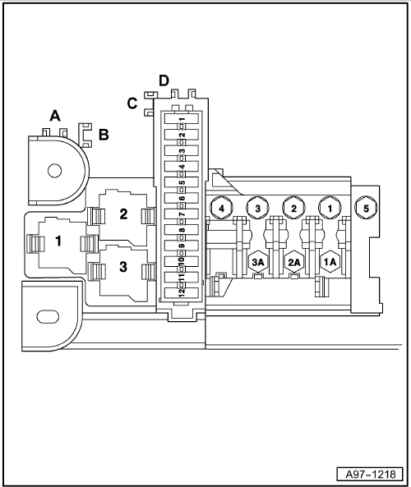
- | SF1 - Fuel pump -G23-, 20A

- | SF2 - Fuel system pressurisation pump -G6-, 20A

- | SF3 - Trailer socket - U10, terminal 15, 15A

q | vacant, from model year 2006

- | SF4 - Interface control unit for vehicle location system -J843-, 5A

q | from June 2008

- | SF5 - Convenience system central control unit -J393-, rear left light, 20A

- | SF6 - Convenience system central control unit -J393-, rear right light, 10A

- | SF7 - Convenience system central control unit -J393-, power latching system, 20A

- | SF8 - Control unit for electromechanical parking brake -J540-, left parking brake motor -V282-, 30A

Audi A8 | Fitting Locations | No. 802 / 35

- | SF9 - Electric park and handbrake control unit -J540-, right parking brake motor -V283-, 30A

- | SF10 - Trailer detector control unit -J345-, left light, 15A/ 20A

q | 15A up to August 2007

q | 20A from November 2007

- | SF11 - Trailer detector control unit -J345-, right light, 15A/ 20A

q | 15A up to August 2007

q | 20A from November 2007

- | SF12 - Trailer detector control unit -J345-, 15A

Audi A8 | Fitting Locations | No. 802 / 36

Position of fuses (SF) on fuse holder, in right luggage compartment, right-hand drive
1 - | Fuel pump -G23-, 20 A

2 - | Fuel system pressurisation pump -G6-, 20 A

3 - | Vacant

4 - | Vacant

5 - | Convenience system central control unit -J393-, 20 A (rear left light)

6 - | Convenience system central control unit -J393-, 10 A (rear right light)

7 - | Convenience system central control unit -J393-, 20 A (power latching system)

8 - | Control unit for electromechanical parking brake -J540-, left parking brake motor -V282-, 30 A

9 - | Control unit for electromechanical parking brake -J540-, right parking brake motor -V283-, 30 A

Audi A8 | Fitting Locations | No. 802 / 37

10 - | Trailer detector control unit -J345-, 20A (left light)

11 - | Trailer detector control unit -J345-, 20A (right light)

12 - | Trailer detector control unit -J345-, 15 A

Audi A8 | Fitting Locations | No. 802 / 38

Position of fuses (SD) on fuse holder, on left in luggage compartment, up to model year 2003
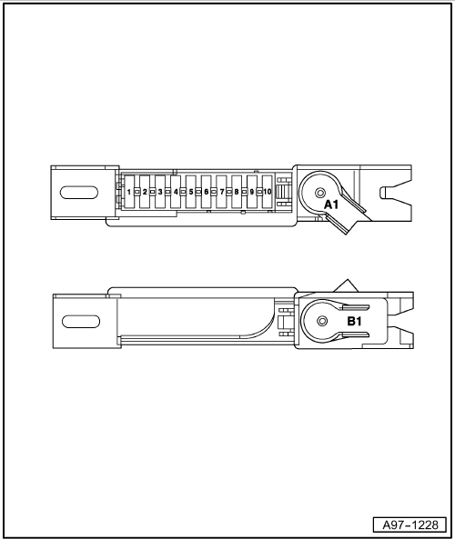
- | SD1 - Digital sound package control unit -J525-, 30A

- | SD2 - Navigation system with CD drive control unit -J401-, 5A

- | SD3 - TV-tuner -R78-, 10A

- | SD4 - Vacant

- | SD5 - Radio -R-, 5A

- | SD6 - Middle loudspeaker in rear shelf -R148-, 30A

- | SD7 - 12 V socket -U5-, 20A

- | SD8 - Remote control receiver for auxiliary heating -R64-, 5A

- | SD9 - Vacant

- | SD10 - Vacant

A1 - | Terminal 30 screw point (battery)

B1 - | Terminal 30 screw point

Audi A8 | Fitting Locations | No. 802 / 39

Position of fuses (SD) on fuse holder, on left in luggage compartment, from model year 2004
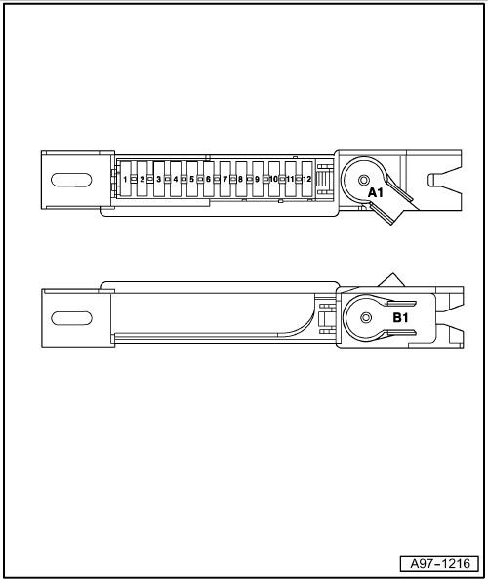
- | SD1 - Vacant

- | SD2 - Vacant

- | SD3 - Vacant

- | SD4 - Vacant

- | SD5 - Digital sound package control unit -J525-, 30A

- | SD6 - Navigation system with CD drive control unit -J401-, 5A

- | SD7 - TV-tuner -R78-, 10A

- | SD8 - Reversing camera system control unit -J772-, 5A

q | vacant, up to model year 2007

- | SD9 - Radio -R-, digital radio -R147-, satellite radio -R146-, 5A

q | -R146- only USA

- | SD10 - Middle loudspeaker -R148-, 15A

Audi A8 | Fitting Locations | No. 802 / 40

- | SD10 - Digital sound package control unit 2 -J787-, 30A

q | only BANG and OLUFSEN

- | SD11 - 12 V socket -U5-, 20A

- | SD12 - Remote control receiver for auxiliary heating -R64-, 5A

A1 - | Terminal 30 screw point (battery)

B1 - | Terminal 30 screw point (fuse holder)

Audi A8 | Fitting Locations | No. 802 / 41

Position fuse holder on left in luggage compartment, right-hand drive
1 - | Vacant

2 - | Vacant

3 - | Vacant

4 - | Vacant

5 - | Digital sound package control unit -J525-, 30 A

6 - | Navigation system with CD drive control unit -J401-, 5 A

7 - | TV tuner -R78-, 10 A

8 - | Reversing camera system control unit -J772-, 5 A

9 - | Radio -R-, 5 A

- | Satellite radio -R146-, 5 A

- | Digital radio -R147-, 5 A

Audi A8 | Fitting Locations | No. 802 / 42

10 - | Middle loudspeaker -R148-, 15 A

- | Digital sound package control unit 2 -J787-, 30 A

q | only BANG and OLUFSEN

11 - | 12 V socket -U5-, 20 A

12 - | Remote control receiver for auxiliary heating -R64-, 5 A

A1 - | Terminal 30 screw point (battery)

B1 - | Terminal 30 screw point (fuse holder)

