Front seat covers and upholstery
Removing and installing seat cover with sports seat
Removing
Important
Observe safety precautions for working on airbag =>
- ‒ Remove front seat => Page 72-3.

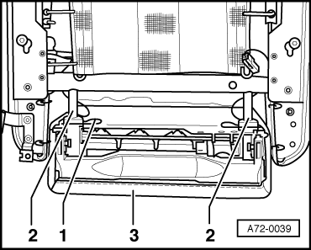
- ‒ → Detach fasteners -1- on left and right for seat extension.
- ‒ Pull seat extension -3- out of retaining rods -2-.
- ‒ Fold up seat extension with seat upholstery and lever out of clamping slot on back of seat frame.

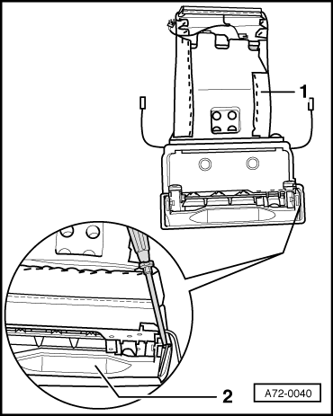
- ‒ → Lever seat cover -2- out of fastening strip of seat extension.
- ‒ Pinch off staples -1- and detach seat cover.

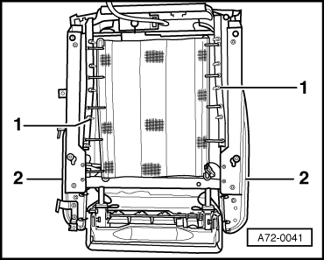
- ‒ → Lever seat cover -2- for side cushions out of clamping slot on side.
- ‒ Pinch off staples -1- and pull off seat cover over side cushions.
Installing
Installation is carried out in the reverse order; note the following:
- ‒ Use upholstery stapler V.A.G 1634 to attach staples to cover for side upholstery.
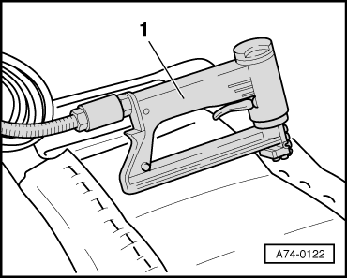
- ‒ → Use commercially available upholstery staple gun -1- to fasten cover.
- ‒ Make use of upholstery staples as specified by staple gun manufacturer.
Important
Observe seat installation instructions for vehicles with side airbag =>Page 72-5.

