Fuel supply system
Function of fuel system

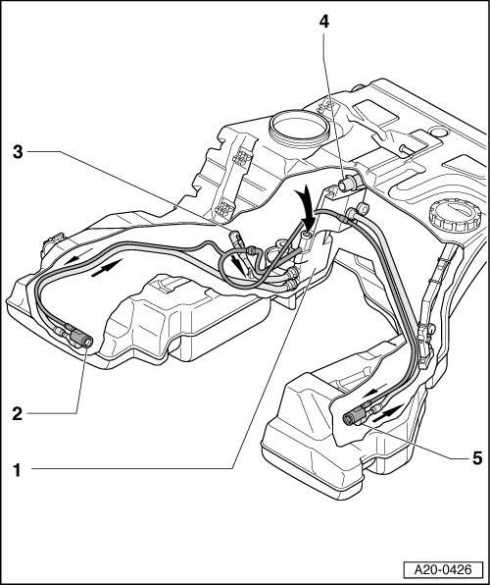
Note:
Fuel is drawn out of the baffle housing in the fuel tank by the diesel injection pump. The electric fuel pump only delivers fuel to the suction jet pumps in the tank.
The electric fuel pump is located in a baffle housing (not shown in illustration).
It produces a stream of fuel (large arrow in illustration) which is directed to the three suction jet pumps -2-, -3- and -5-, where it is passed through a nozzle and thus accelerated. The accelerated stream of fuel draws off the surrounding fuel in the individual chambers (fluid entrainment principle) and delivers it to the adapter plate -1- in the baffle housing via a system of pipes.

The electric fuel pump, the system of suction jet pumps and the baffle housing together form a closed circuit inside the fuel tank.
For reliable starting, there must be fuel in the baffle housing at all times. To ensure that this is the case, even when an empty tank is topped up with a small quantity of fuel, the fuel filler pipe -4- goes directly into the adapter plate -1- on the baffle housing. In this way the fuel is always supplied directly to the fuel delivery unit.

