Removing and installing aluminium wheel bearing housing
Servicing wheel bearing housing with bolted wheel bearing

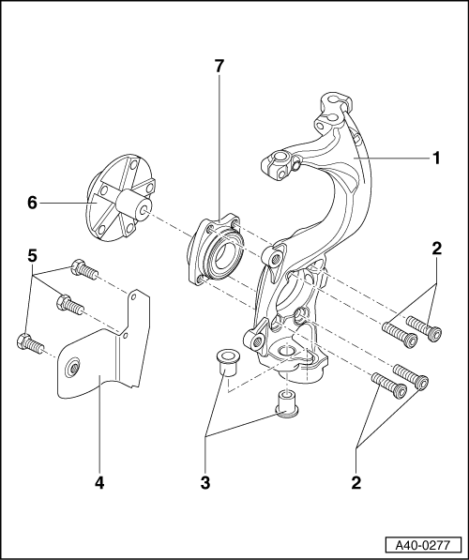
- Wheel bearing housing
  - ◆ Note the different running gear versions
  - ◆ Allocation
=> Parts Catalogue
- Hemispherical collared bolts:
80 Nm + further 90° turn.
- Bushes
- Cover plate
- Hexagon bolt, 10 Nm

- Wheel hub
  - ◆ Pressing out =>Fig.1
  - ◆ Pressing off bearing inner race
=>Fig.2
  - ◆ Stepped version
  - ◆ The bearing/wheel hub contact surfaces and threaded holes must be free of paint and dirt
  - ◆ Lightweight wheel hub
=> Page 40-58
- Ball bearing
  - ◆ Removing and installing with wheel bearing housing installed
=> Page 40-50
  - ◆ Installation position:
  - ‒ Large internal diameter of wheel bearing faces toward wheel hub
  - ◆ Pressing off bearing inner race
=>Fig.2
Removing
- ‒ Remove wheel trim; on light-alloy wheels, detach cover cap (puller in vehicle tool kit).
- ‒ Unscrew hexagon bolt for drive shaft. (Loosen only when vehicle is standing on wheels -danger of accident-.)
Note =>Page 40-105
- ‒ Remove wheel.
- ‒ Secure brake disc with a wheel bolt.

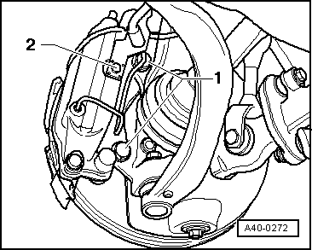
- ‒ Unscrew hexagon bolt -2-.
- ‒ Pull ABS speed sensor wiring out of retainer on wheel bearing housing.
- ‒ → Remove bolts -1- for brake caliper and remove brake caliper.
- ‒ Tighten hexagon bolt -2-.
Note:
The brake caliper must not be reattached to e.g. the body before the brake line holder has not yet been bolted on using bolt -2-.

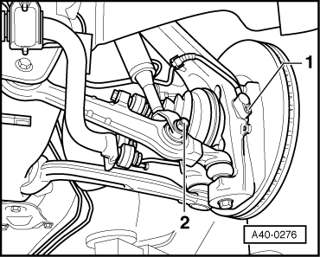
- ‒ → Unscrew bolt -1- for ABS speed sensor.

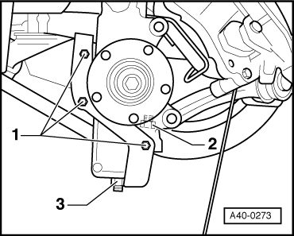
Notes:
- ◆ Fasten brake caliper to body using wire.
- ◆ Do not suspend the brake caliper from the brake hose.
- ‒ Remove brake disc.

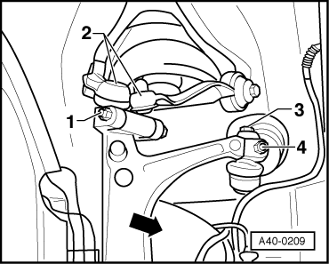
- ‒ → Unscrew nut -1-, remove hexagon bolt and pull out both links -2- in upwards direction.
The slots in the wheel bearing housing must not be widened using a chisel or similar.
- ‒ Swivel wheel bearing housing aside in direction of arrow while pulling drive shaft pin out of wheel hub in the process.
- ‒ Remove wheel bearing housing.

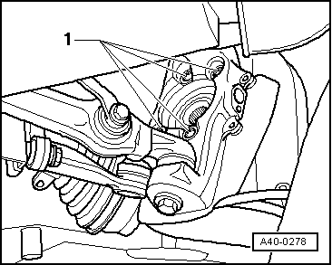
- ‒ Unscrew hemispherical collared bolts -1-.
- ‒ Remove wheel bearing unit.

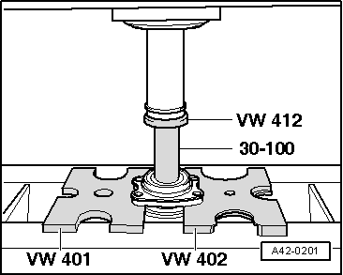
→ Fig.1 Pressing out wheel hub from wheel bearing

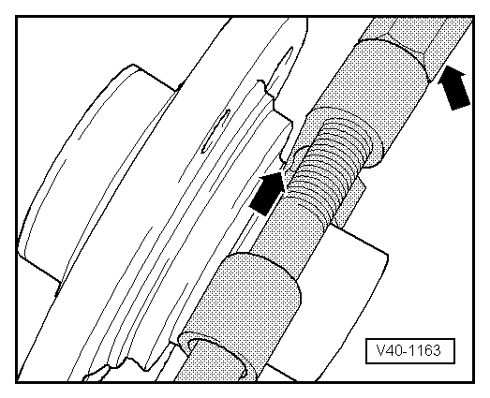
→ Fig.2 Pressing bearing inner race off wheel hub
- ‒ Attach separating tool into circular groove of bearing inner race -arrow- and pre-tension with spindle.
Note:
Use commercially available separating device e.g. Kukko 15-17.

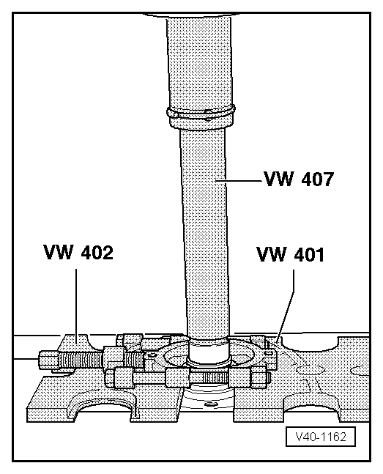
- ‒ → Press bearing inner race from wheel hub.

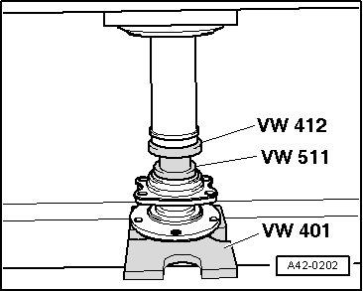
→ Fig.3 Pressing wheel hub into wheel bearing
- ‒ When pressing in, thrust pad -VW 511- must only make contact with inner race.
Installing

- ‒ → Hemispherical collared bolt tightening torque -1-:
80 Nm and turn +90° further
- ‒ Push outer joint of drive shaft into wheel hub and hand-tighten new hexagon bolt.
- ◆ Remove any adhesive residue from thread of joint pin.
- ‒ Insert both upper transverse link joint pins into wheel bearing housing.

- ‒ → Tighten new self-locking nuts -1- to 40 Nm.
  - ‒ When tightening, press down upper transverse link as far as possible.
- ‒ Install ABS speed sensor.
- ‒ Fit brake disc, bolt on brake caliper and tighten to 190 Nm.
- ‒ Fit wheel and tighten to 120 Nm.
- ‒ Tighten drive shaft hexagon bolt. Only tighten when vehicle is standing on wheels -danger of accident-.
  - Tightening torques:
  - Hexagon bolt, 190 Nm + 180° further turn
Note =>Page 40-107
The alignment of the front axle must be checked and if necessary adjusted using VW/Audi-approved wheel alignment equipment.

